Division:
ACTE Board Report - Spring 2025
Business Education

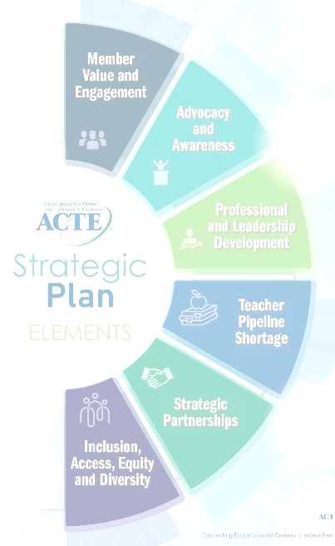
Submitted by: Sean Crevier Date Submitted: 5/30/2025

Strategic Plan
Provide the link to the Multi-year Strategic Planning Worksheet. Share any additional information about the implementation of the Strategic Plan you would like about the following:
  - Successes you have had
  - Support you still need
Link: Bus Ed Division: Multiyear Strategic Planning Worksheet

Additional Information:
- Met with eDynamic Learning Midwest Region Sales Director re: leveraging ACTE partnership
- Met with each of our division’s CTSO leader at NPS about our partnership & membership
- Attended April Workforce Development meeting as continued involvement with Frank Gerdeman & his team
- Met at NPS about our potential conference partnership with MBA Research
- Attended February Workforce Development meeting as follow up on conversation with Frank Gerdeman
- Met with FBLA competitions director re: topics and content
- Met with NASBE group for updates on all things business education

Contributions to Region and Division Members
Please remember the importance of engagement of members during this time and let ACTE know how we can help engaging your members with you! Please also let us know how you have engaged ACTE members within the past 4 months. Indicate if the work falls under any of the Strategic Plan.

- Prepared FY ‘26 budget w/ Jonathan (incoming Division President) and facilitated approval via email to policy committee (example linked here)
- Met with Division awards team and staff to improve the online application form and rubric
- Attended Region V conference & connected with division members

ACTE is working to communicate and disseminate innovation at the forefront of all Regions and Divisions as an effort to support other CTE professionals around the nation. We anticipate highlighting the innovations in ACTE’s publications, blogs, and webinars and other similar activities. Please highlight any recent innovative ideas within your Region or Division.
- We have moved our awards application/judging process into the ACTE portal. Not necessarily innovative, but a big shift that has growing pains.

Succession Planning
Do you have any information you wish you had been provided during your new Board Orientation (what you know now that you wish you had known then)? Do you have any suggestions on future Vice Presidents for your Region or Division? Or any suggestions on future ACTE President-Elect candidates?
- Met with Jonathan, board officers, and staff for a transition meeting

Region/Division Concerns

What are your concerns for your Region/Division specifically | What are the implications for ACTE? | In what capacity can ACTE assist in addressing this issue?
membership | growth | unsure
marketing emphasis
- Topics to be discussed during Division/Region Breakouts
- What are other divisions doing to try to increase membership?
- How do other divisions engage at the Regional and State levels?
- Does anyone collaborate with the executive directors?

- Items to be considered for placement on the Board Agenda
Topics to be placed on the board agenda for discussion. Give background information for the purpose of the discussion.

Action Items (those that will introduce a motion). Indicate item, rationale and possible wording for motion.

Request for Information
Questions to Officers, Exec. Committee, or Staff to be answered but don’t need discussion at the board meeting.
The business division would like to extend the President elect position to more of the last year of the President-elect's term. This term would potentially run from the July board meeting until he or she takes the position in July. This would increase the expenses at the national level. Currently only the National Seminar board meeting expenses are covered and I would think this would potentially extend to Vision expenses in the fall?

