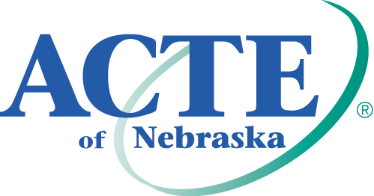
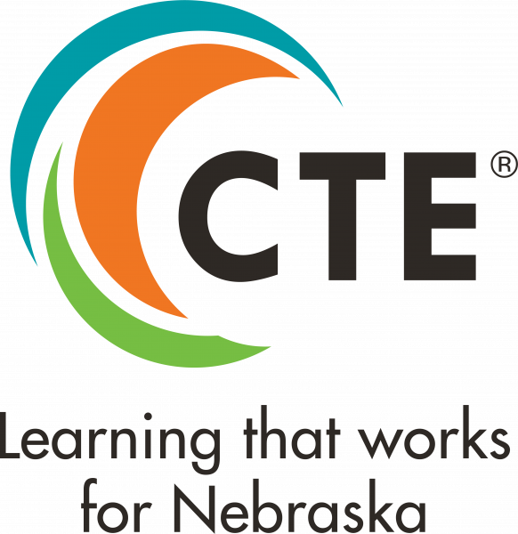
Counseling and Career Development
Professional Award

Purpose
This award recognizes school counselors and career development professionals who have demonstrated commitment to connecting students with opportunities for success, shown innovation in career exploration and development, and have advocated for CTE as a viable option for all students.

Eligibility
All candidates must be employed as school counselors and/or career development professionals at the time of initial nomination. Award nominees do NOT have to be ACTE/ACTEN members for the state award. However, state winners must be national ACTE members by July 31, 2023 to be considered at the Region level.

Criteria
Candidates will be evaluated on the following criteria:
- Contributions to student success
- Innovations in career exploration and development
- Leadership in advocating for CTE as a viable option for all students

All candidates must demonstrate at minimum one best practice in CTE as outlined in the High Quality CTE Framework in order to be eligible to receive the award.

Nomination Requirements
Each nomination must include the following (incomplete nominations will not be considered):
- Description of Candidate’s Qualifications for the Award
- Two (2) Letters of Support
- Photo/Headshot
- Interview (at region and national levels)

See below for more information on each component.

- Description of Candidate’s Qualifications for the Award (1500 words total)
Address the following:
- How has the candidate utilized components of high-quality CTE to connect students with opportunities for success? Please refer to the High Quality CTE Framework as a guide/reference. (Ex. Sequencing and articulation; work-based learning opportunities; ensuring access and equity to CTE programs) (500 words max)

- How has the candidate demonstrated innovation in career exploration and development? (Ex. improvements implemented; new activities or initiatives spearheaded; creative or cutting-edge practices) (500 words max)

- How has the candidate demonstrated leadership in advocation for CTE as a viable option for all students? (Ex. Communicating the value of CTE to students, parents, educators, community leaders, business & industry partners; leadership in professional organizations). (500 words max)

- Letters of Support
Each nomination should include two (2) letters of support recommending the candidate as relates to the above areas. Please submit letters from two of the following: a supervisor, a parent/guardian, a student, an employee, or a community leader.

- Photo/Headshot
Each nomination should include a photo/headshot of the candidate. Photos should be digital, high resolution (at least 300dpi), and submitted in .jpg format. Files 2MB or larger are preferred. (Note: photographs will be used for publicity purposes only.)

Nominations should be submitted electronically on the ACTE Awards Portal by March 1, 2023. Candidates for the ACTE Excellence Awards may nominate themselves for an award or be nominated by a third party. States must choose and submit their winners for regional consideration by March 1. National winners will be selected by the ACTE Awards Committee. Region and national winners will be recognized at the ACTE Awards Banquet during CareerTech VISION. Winning candidates permit ACTE to use and edit content of the application for promotional activities. Non-winning candidates may be re-nominated for the same or another Excellence Award the following year. Winning candidates at the national level may not be nominated for the same or another national ACTE Excellence Award within 3 years of their win.

Are you the best in CTE? Do you know someone who is?

To learn more and submit a nomination, visit www.acteonline.org/awards

