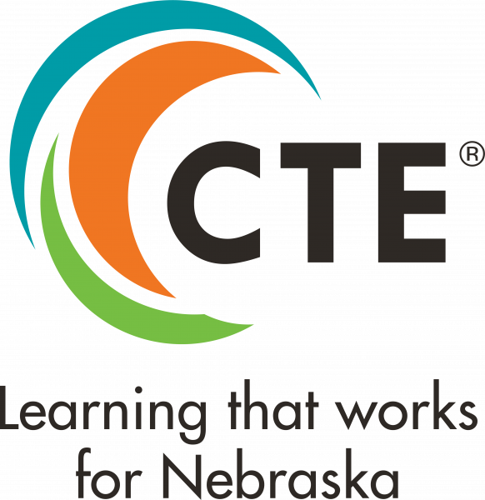
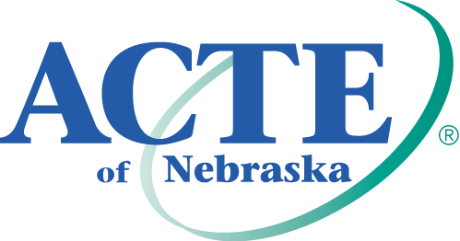
Carl Perkins Community Service Award

Purpose
This award recognizes individuals who have used CTE to make a significant impact on their community and demonstrated leadership in programs and activities that promote student involvement in community service.

Eligibility
All candidates must be current or retired CTE professionals at the initial nomination. Candidates do NOT have to be ACTE/ACTEN members for the state award. However, state winners must be national ACTE members by July 31, 2023 to be considered at the Region level.

Criteria
Candidates will be evaluated on the following criteria:
- Leadership in furthering community service or improvement
- Innovations in integrating community service into their CTE program
- Contributions to student learning and success

All candidates must demonstrate at minimum one best practice in CTE as outlined in the High Quality CTE Framework in order to be eligible to receive the award.

Nomination Requirements
Each nomination must include the following (incomplete nominations will not be considered):
- Description of Candidate’s Qualifications for the Award
- Two (2) Letters of Support
- Photo/Headshot
- Interview (at region and national levels)

See below for more information on each component.

- Description of Candidate’s Qualifications for the Award (1500 words total)
Address the following:
- How has the candidate demonstrated leadership in furthering community service or improvement? (Ex. Partnerships with business or community groups; community service initiatives spearheaded, etc.) (500 words max)

- How has the candidate demonstrated innovation in furthering student learning through community service? (Ex. improvements implemented to program or institution through community service, creative or cutting-edge practices implemented in service projects) (500 words max)

- How has the candidate contributed to implementing high-quality CTE programs that ensure student success? Please refer to the High Quality CTE Framework as a guide/reference. (Ex. Development of standards-aligned and integrated curriculum; contributions that resulted in student achievements, opportunities and innovations; CTSO successes; etc.) (500 words max)

- Letters of Support
Each nomination should include two (2) letters of support recommending the candidate as relates to the above areas. Please submit letters from two of the following: a supervisor, a parent/guardian, a student, an employee, or a community leader.

- Photo/Headshot
Each nomination should include a photo/headshot of the candidate. Photos should be digital, high resolution (at least 300dpi), and submitted in .jpg format. Files 2MB or larger are preferred. (Note: photographs will be used for publicity purposes only.)

Nominations should be submitted electronically on the ACTE Awards Portal by March 1, 2023. Candidates for the ACTE Excellence Awards may nominate themselves for an award or be nominated by a third party. States must choose and submit their winners for regional consideration by March 1. National winners will be selected by the ACTE Awards Committee. Region and national winners will be recognized at the ACTE Awards Banquet during CareerTech VISION. Winning candidates permit ACTE to use and edit content of the application for promotional activities. Non-winning candidates may be re-nominated for the same or another Excellence Award the following year. Winning candidates at the national level may not be nominated for the same or another national ACTE Excellence Award within 3 years of their win.

Are you the best in CTE? Do you know someone who is?

To learn more and submit a nomination, visit www.acteonline.org/awards

