ACTE of Nebraska

Leadership Handbook

2022-23

Table of Contents
Page #
Section A – About ACTE of Nebraska

General Information A1

ACTEN Board of Directors A2

Mission Statement and Program of Work A7

Strategic Plan 2020-2024 A10

Calendar of Events A15

2021-22 Budget A16

2021-22 Committee List A17

National and State Elected Officials A18
and State Board of Education

Section B – Job Description/Duties

Your role as an ACTEN Board Member A19

Tips for Board Members A20

President - See also Strategic Plan (A9-A14) and Committee List (A17) A21

President Elect - See also Strategic Plan (A9-A14) and Committee List (A17) A22

Past President - See also Strategic Plan (A9-A14) and Committee List (A17) A22

Secretary - See also Strategic Plan (A9-A14) and Committee List (A17) A23

Treasurer - See also Strategic Plan (A9-A14) and Committee List (A17) A23

Division Representatives - See Strategic Plan (A9-A14) & Committee List (A17) A24

Newsletter Editor - See also Strategic Plan (A9-A14) and Committee List (A17) A24

Webmaster - See also Strategic Plan (A9-A14) and Committee List (A17) A25

Affiliate Organization Presidents - See also Strategic Plan (A9-A14) A25

Committees - See also Strategic Plan (A9-A14) and Committee List (A17) A25

ACTEN Executive Director Position Description A27

The following documents are located in separate PDF
entitled "Governing Documents"

Section C – Governing Documents
Page #

Articles of Incorporation & Amendments

Articles of Incorporation - Nebraska Vocational Association C1

Articles of Amendment to Articles of Incorporation C8
- Changes name to Association for Career and
Technical Education of Nebraska

Articles of Amendment to Articles of Incorporation C11
- Deletes reference to 501(c)(6)

Articles of Amendment to Articles of Incorporation C13
- Adds language required by IRS for 501(c)(3) organizations

Bylaws

Bylaws as amended on June 9, 2016 C17

Policies

Anti-Harassment/Discrimination Policy (adopted June 6, 2006) C27

Conflict of Interest Policy (adopted June 10, 2009) C28

Whistleblower Policy (adopted June 10, 2009) C29

Document Retention Policy (adopted June 10, 2009) C31

ACTE/State Association Affiliation

Affiliation Process Document (including Statement of C32
Understanding, Principles of Affiliation and Operating Framework)

About ACTE of Nebraska

General Information

The Association for Career and Technical Education of Nebraska (ACTEN) is affiliated with the national organization Association for Career and Technical Education (ACTE). Nebraska is a unified state, which means that members who join one organization must also join the other. Unified dues are currently $110.00 per year ($80 for ACTE dues and $30 for ACTEN dues). See page C32 (ACTE-ACTEN Affiliation Process Document)

ACTEN’s office is located at 14330 Danvers St., Waverly, Nebraska, at the home of Executive Director, Murleen Bellinger. The office telephone number is 402-525-8742. Murleen is usually available to take your daytime, evening and/or weekend calls, so please don’t hesitate to call her when you need assistance or information. If she is unavailable, please leave a message and she will return your call. She can also be contacted by e-mail at actenebraska@gmail.com.

The mailing address is:
ACTE of Nebraska
P.O. Box 89
Waverly, Nebraska 68462

ACTEN’s website address is www.actenebraska.org. Archives of our newsletter, The Communiqué, ACTEN award information, and other information of interest to our members is posted on the website. An e-mail message is sent to Nebraska members when the news items have been posted.

LeAnn Wilson serves as the Executive Director for ACTE. The national office is located at 1410 King Street, Alexandria, Virginia, 22314. ACTE’s toll free telephone number is 800-826-9972. The ACTE website address is www.acteonline.org.

ACTEN was included in the Group Exemption for 501(c)(3) tax exempt status that ACTE filed with the Internal Revenue Service in May or June of 2009. The application was approved by the IRS on October 15, 2010.

ASSOCIATION FOR CAREER AND TECHNICAL EDUCATION OF NEBRASKA

Board of Directors and Ex-Officio Members 2022-23
(Term begins October 1, 2022)

OFFICERS

PRESIDENT
Jon Cerny
Bancroft-Rosalie Schools
P.O. Box 129
Bancroft, NE 68004
Telephone: (402) 648-3336
Email: jcerny@esu2.org

PRESIDENT ELECT
Jean Condon
Mid-Plains Community College
601 W. State Farm Rd.
North Platte, NE 69101
Telephone: (308) 535-3740
Email: condonj@mpcc.edu

SECRETARY
Ronda Ras
Bancroft-Rosalie Schools
P.O. Box 129
Bancroft, NE 68004
Telephone: (402) 648-3336
Email: rras@esu2.org

TREASURER
DeLayne Havlovic
Omaha Public Schools
3215 Cuming Street
Omaha, NE 68131-2024
Telephone: (531) 299-9503
Email: delayne.havlovic@ops.org

PAST PRESIDENT
Samantha Lavene
Bertrand-Loomis High School
P.O. Box 250
Loomis, NE 68958
Telephone: 308-876-2111
Email: Samantha.lavene@loomiswolves.org

DIVISIONAL REPRESENTATIVES

ADMINISTRATION
Dan Phillips
Grand Island Public Schools
P.O. Box 4904
Grand Island, NE 68801
Telephone: 308-385-5900, EXT 1179
Email: dphillips@gips.org

AGRICULTURE EDUCATION
Alex Cumming
St. Edward High School
P.O. Box C
St. Edward, NE 68660
Telephone: 402-578-2282
Email: acummings@sted.esu7.org

Chrisinda Scheideler
Arcadia High School
P.O. Box 248
Arcadia, NE 68815
Telephone: 308-789-6522
Email: chrisinda.scheideler@apshuskies.org

BUSINESS EDUCATION
Angie Chittick
Mid-Plains Community College
601 W. State Farm Rd.
North Platte, NE 69101
Telephone: 308-658-4308
Email: chitticka@mpcc.edu

FAMILY & CONSUMER SCIENCES EDUCATION
Alicia Beck
Lincoln High School
2229 J Street
Lincoln, NE 68510
Telephone: 402-436-1301
Email: abeck@lps.org

Miranda Bright
Crete High School
1750 Iris Ave.
Crete, NE 6833
Telephone: 402-826-5811
Email: miranda_w@live.com

COUNSELING AND CAREER DEVELOPMENT
Rick Painter
Paddock Road Elementary School
3535 Paddock Road
Omaha, NE 68124
Telephone: (402) 390-6465
Email: painter.richard@westside66.net

HEALTH SCIENCE TECHNOLOGY EDUCATION
Michelle Galles
Wakefield Schools
802 Highland St.
Wakefield, NE 68784
Telephone: (402) 287-2012
Email: mgalles@wakefieldschools.org

ENGINEERING AND TECHNOLOGY EDUCATION
Adam Whitmore
Columbus High School
3434 Discoverer Drive
Columbus, NE 68601
Telephone: (402) 563-7050
Email: whitmorea@discoverers.org

NEW & RELATED SERVICES
Jodi Dierks
Omaha Central High School
124 N. 20th St.
Omaha, NE 68101
Telephone: (531) 299-5621
Email: jodi.dierks@ops.org

POSTSECONDARY, ADULT AND CAREER EDUCATION
Vacant

TRADE AND INDUSTRIAL EDUCATION
Stan Haas
Lincoln Public Schools
5905 O Street
Lincoln, NE 68510
Telephone: (402) 436-1857
Email: shaas@lps.org

EX OFFICIO MEMBERS

EXECUTIVE DIRECTOR
Murleen Bellinger
ACTEN Office
P.O. Box 89
Waverly, NE 68462
Telephone: (402) 525-8742
Email: actenebraska@gmail.com

NE DEPARTMENT OF EDUCATION
Katie Graham Sydney Kobza
500 S. 84th St., 2nd Floor 500 S. 84th St., 2nd Floor
Lincoln, NE 68510 Lincoln, NE 68510
Telephone: (402) 937-2809 Telephone: (402) 937-3389
Email: katie.graham@nebraska.gov Email: Sydney.kobza@nebraska.gov

SPOTLIGHT SCHOOLS/NEWSLETTER
Murleen Bellinger
Board Members

WEBMASTER
Deb Wolken
Telephone: (402) 806-0531
Email: debwolken@gmail.com
STATE DISCIPLINE ASSOCIATION PRESIDENTS

Nebraska Agriculture Educators Association
Melissa Bonifas
Blue Hill High School
P.O. Box 217
Blue Hill, NE 68930
Telephone: (402) 756-3043
Email: mbonifas@esu9.org

Nebraska State Business Educators Association
Jodi Dierks
Omaha Central High School
124 N. 20th St.
Omaha, NE 68101
Telephone: (531) 299-5621
Email: jodi.dierks@ops.org

Family and Consumer Sciences Teachers of Nebraska
Angie Ehlers
Overton Public Schools
401 7th St.
Overton, NE 68863
Telephone: (308) 987-2424
Email: angie.ehlers@overtoneagles.org

Nebraska Association of Skilled and Technical Sciences Educators
Matt Bova
Westside Middle School
8601 Arbor St.
Omaha, NE 68124
Telephone: (402) 390-6464
Email: bova.matt@westside66.net

ACTEN
PROGRAM OF WORK
2022-23

MISSION
The mission of the Association for Career and Technical Education of Nebraska (ACTEN) is to educate, advocate, and lead with a unified voice for Nebraska Career and Technical Education.
GOALS
● Educate: ACTEN will increase membership through professional development opportunities, teacher recruitment and public awareness.
● Advocate: ACTEN will create a unified voice for Nebraska through legislative advocacy, agency partnerships and collaboration, and the continued promotion of ACTE.
● Lead: ACTEN will promote CTE by creating a presence with stakeholders including recognition of performance, and professional development.

PERFORMANCE INDICATORS, ACTIVITIES, and TIMELINES

EDUCATE
 | Performance Indicator | Activities | Timeline
1 | Professional Development | Co-sponsor the Nebraska Career Education Conference with the Nebraska Department of  Education | June 2023
2 | Public Awareness | Promote the importance of career and technical education during CTE Month | February 2023
 |  | Engage in stakeholder meetings (Assembly of Delegates, Nebraska Department of Education stakeholder groups) using available resources | Ongoing
 |  | Collaborate with division leadership to share CTE program stories and successes in ACTEN communications and social media spotlights that “tell the NOW story” of Nebraska CTE programs and ReVISION schools | Ongoing
 |  | Emails from leadership to ACTEN membership alerting them of items of mutual interest | Ongoing

3 | Membership | Survey membership every 3-5 years to gather feedback on topics of mutual interest in support of membership and continuous improvement of ACTEN | 2025-26

ADVOCATE
 | Performance Indicator | Activities | Timeline
1 | Unified Voice | Promote the importance of career and technical education to NE Legislature, State Board of Education, Board of Education, School Administrators, policy and decision makers during CTE Month | February 2023
2 | CTE Month | Partner with NDE to support a statewide initiative promoting CTE during CTE Month | February 2023
 |  | Promote CTE career student organizations in one philanthropic effort including the “CSO Legislative Day” proclamation signing | February 2023
3 | Voice for CTE with Policy Makers including Legislation | Maintain active file of resources, data, success stories at the ready to share on demand | Ongoing
 |  | Communicate with legislators at the state and national level on matters key to CTE | Ongoing
 |  | Present or sponsor a rotation session on Legislative Advocacy at the NCE conference (ACTE presenter) | June 2023
 |  | Financially Support representation at the Career Tech VISION conference and the National Policy Seminar | December 2022 March 2023

LEAD
 | Performance Indicator | Activities | Timeline
1 | Grow CTE Leadership | Sponsor leadership workshops and trainings (ACTE Statewide Leadership Training Series) | Ongoing
 |  | Conduct Fall and Winter Board meetings following established protocol and agenda items | October 22, 2022  January 28, 2023
2 | Presence with Stakeholders | Communication to stakeholders on topics of common interest including opportunities for ACTEN board members to present at the state level (legislative, public policy) and with pre-service teachers at local colleges encouraging membership and participation in NCE activities | Ongoing
3 | Membership Recognition | Annually recognize ACTEN members as part of the awards program at NCE | June 2023
4 | Increase Membership | Increase membership in ACTEN by advocating for schools to pay ACTEN membership fees for CTE teachers and administrators | Ongoing

2020-2024 ACTEN Strategic Plan
Mission: The mission of the ACTEN is to educate, advocate, and lead with a unified voice for Nebraska Career and Technical Education (CTE).
Goal 1: Educate – ACTEN will increase our membership through Professional Development opportunities, teacher recruitment, and public awareness.
KEY PERFORMANCE INDICATORS | STRATEGIES | PERSON(S) RESPONSIBLE
1.1 Professional Development | 1.1.1 NCE Conference (co-sponsor with NDE) | Executive Director; President; NDE
 | 1.1.1a Prominent presence for booth
 | 1.1.1b Handout/Infographic with Why?
 | 1.1.1c Promotional banners or roll-ups (multiple to travel to other conferences or promotions)
 | 1.1.1d ACTEN at Opening Session
 | 1.1.1e Presentation/Luncheon for Awards and Recognition
 | 1.1.1f Communication with Divisions to establish award application process
 | 1.1.1g Explore discount rate for conference based on membership status
 | 1.1.1h ACTEN dedicated sessions
 | 1.1.2 Webinar | Executive Director; Executive Board
 | 1.1.3 Opportunities for tours, externships, experiences | Executive Director; President; NDE
1.2 Public Awareness | 1.2.1 Marketing Campaign (employers, industry, community, school board, peers) | Executive Director; Executive Board
 | 1.2.2 Capture stories and successes (collaborate specifically with Divisions) | Executive Director; Executive Board
 | 1.2.3 Presence at stakeholder meetings using available resources | Executive Director; Executive Board
 | 1.2.4 Newsletter spotlights that “tell the NOW story” (start with board members schools; schools who have participate in ReVISION) | Executive Director; Executive Board; NDE
 | 1.2.5 Utilize social media to “tell the NOW story” | Executive Director; Executive Board
 | 1.2.6 Monthly articles in local newspapers | Executive Director; Executive Board
 | 1.2.7 Use e-mails to keep members alert | Executive Director; Executive Board
1.3 Membership | 1.3.1 Collection of membership feedback | Executive Director; Executive Board
Goal 2: Advocate – ACTEN will create a unified voice for Nebraska through legislative advocacy, agency partnerships and collaboration, and the continued promotion of ACTE.
KEY PERFORMANCE INDICATORS | STRATEGIES | PERSON(S) RESPONSIBLE
2.1 Unified Voice | 2.1.1 Marketing Campaign (NE legislature, State board, administrators, school board, policy makers, decision makers) | Executive Director; Executive Board
 | 2.1.1a Customizable resources available for use
 | 2.1.2 Invitations to visit schools for legislators, partners (how-to guide) | Executive Director; Executive Board
 | 2.1.3 Utilization of social media | Executive Director; Executive Board
2.2 CTE Month (partner with NDE) | 2.2.1 Statewide Initiative for CTE Month | Executive Director; Executive Board; NDE
 | 2.2.1a “CSO Day” Legislative Day focused on CSO students from all areas interacting with Senators: proclamation signing
 | 2.2.1b Promote collaboration of all CTE CSOs in one philanthropic effort
2.3 Foundations for Funding | 2.3.1 Continue collaboration with NCEIF and NDE | Executive Director; NCEIF Board Representative; NCEIF Board; NDE State CTE Director
 | 2.3.2 Funding Needs Providing: | Executive Director; NCEIF Board Representative; NCEIF Board
 | 2.3.2a Externships
 | 2.3.2b Mentorships
 | 2.3.2c Scholarships (CTE candidates Junior/Senior college years; CTE professional development or conference attendance)
 | 2.3.2d Loan Forgiveness
2.4 For CTE with Policy Makers including Legislation | 2.4.1 Resources, data, success stories at the ready | Executive Director; Executive Board; Members
 | 2.4.2 Contact Legislators at state and at national level | Executive Director; Executive Board
 | 2.4.3 Present or provide a rotational session on Legislative Advocacy at NCE Conf. | Executive Director; Executive Board; NDE
 | 2.4.4 Encourage attendance at National Policy Seminar and CareerTech VISION | Executive Director; Executive Board
Goal 3: Lead – ACTEN will promote CTE leadership by creating a presence with stakeholders, recognition of performance, and professional development.
KEY PERFORMANCE INDICATORS | STRATEGIES | PERSON(S) RESPONSIBLE
3.1 Grow CTE Leadership | 3.1.1 Hold Leadership Workshops and Trainings | Executive Director; Executive Board; NDE; Division Representatives
 | 3.1.1a Collaboration with NDE to hold ACTEN NEXUS Leadership Conference (as funds are available)
 | 3.1.1b Collaborate with NDE in planning NCE Conference
 | 3.1.1c Collaborate with NDE in establishing digital presentations/webinars
 | 3.1.2 Fall Board Meeting Agenda Items | Executive Director; Executive Board
 | 3.1.2a Review Leadership Handbook
 | 3.1.2b Board Training
 | 3.1.2c Review of Bylaws
 | 3.1.2d Review/Progress of Strategic Plan
 | 3.1.2e Survey Finalization/Distribution
 | 3.1.3 Provide/Create Leadership Opportunities
 | 3.1.3a Funding for attendance at National Conference for ACTEN members and board members (separate funding sources)
 | 3.1.3b Committee participation for ACTEN members
 | 3.1.3c Establish mentoring program
3.2 Presence with Stakeholders | 3.2.1 Communication with stakeholders | Executive Director; Executive Board
 | 3.2.1a Provide opportunities for ACTEN board members to present at state level (legislative, public policy)
 | 3.2.1b Provide opportunities for ACTEN members to communicate with pre-service teachers at local colleges, encouraging membership and NCE participation
3.3 Member Recognition | 3.3.1 Recognize ACTEN members with Awards Program at NCE | Executive Director; Executive Board; NDE;

Calendar of Events
2022-23

ACTEN Board of Directors' Fall Meeting October 22, 2022
Grand Island

CareerTech VISION 2022 November 30-December 3, 2022
Las Vegas, NV
Las Vegas Convention Center

State Leadership Training November 30, 2022
Las Vegas, NV

ACTEN Board of Directors' Winter 2023 Meeting January 2023

Career and Technical Education Month February 2023

National Policy Seminar March 20-22, 2023
Crystal Gateway Marriott
Arlington, VA

State Leadership Training March 19, 2023
Arlington, VA

2023 ACTE Region V Conference, April 12-15, 2023
Fargo, North Dakota

Nebraska Career Education Conference June 5-8, 2023
Younes Convention Center in Kearney, NE

ACTEN Annual Board of Directors’ Meeting June 5, 2023
Younes Convention Center in Kearney, NE

ACTEN Assembly of Delegates June 7, 2023
Convention Center in Kearney, NE

ACTEN OPERATING ACCOUNT
BUDGET FOR FISCAL YEAR 2022-23

Presented at Assembly of Delegates on June 8, 2022

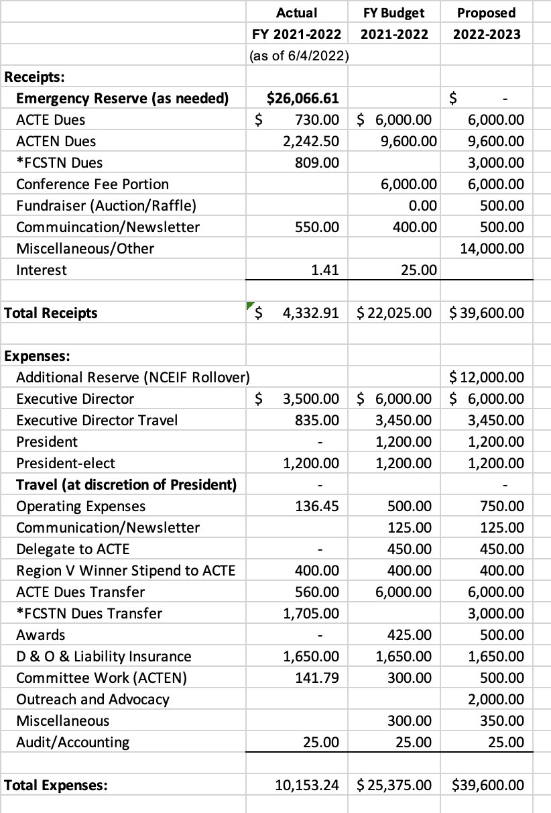
ACTEN Committee List for 2022-23

Committee chairs need to refer to the strategies listed under each assigned goal so their committee can make appropriate contributions. Committees are asked to reference the Strategic Plan and provide the board with updates to be documented within the plan.
Public Relations: Miranda Bright – Chairperson; Rick Painter, Alex Meyer, Dan Phillips
Membership: DeLayne Havlovic, Chairperson
(one representative from each discipline area – does not have to be a board member):
(ADM) Jon Cerny (AGR) Chrisinda Ritz
(BUS) Angie Chittick (FAM) Miranda Bright
(COU) Rick Painter (HEA) Michelle Galles
(N&R) Jodi Dierks (PACE) No Rep
(TGY) Adam Whitmore (TRA) Stan Haas
* This committee may contact division presidents to help with membership drive.
Bylaws: Vacant – Chairperson
Jon Cerny, Jean Condon (Per the Bylaws – President Elect serves as a Committee Member)
Legislation and Resolutions: Katie Graham/Sydney Kobza, Chairs; Jon Cerny
Budget: (Executive Board) DeLayne Havlovic – Chairperson
Jon Cerny, Ronda Ras, Jean Condon, and Samantha Lavene
Program of Work/Professional Development: Jon Cerny, Chairperson
Angie Chittick (Audit Committee Chairperson)
DeLayne Havlovic (Budget Committee Chairperson)
NDE (Legislation & Resolutions Committee Chairperson)
DeLayne Havlovic (Membership Committee Chairperson)
Samantha Lavene (Nomination & Awards Committee Chairperson)
Miranda Bright (Public Relations Committee Chairperson)
Vacant (Bylaws Committee Chairperson)
Jean Condon (President-elect)
Audit: Angie Chittick, Chairperson
Nominating and Awards: Samantha Lavene, Chairperson
(one representative from each division – does not have to be a board member)
(ADM) Dan Phillips (AGR) Alex Meyer
(BUS) Angie Chittick (FAM) Alicia Beck
(GUI) Rick Painter (HEA) Michelle Galles
(N&R) Jodi Dierks (PACE) No Rep
(TGY) Adam Whitmore (TRA) Stan Haas
News Items:
Executive Director and Board Members
Webmaster:
Deb Wolken
NOTE: The Budget Committee and Program of Work Committee should meet prior to or following the winter meeting in order to prepare their proposals for 2023-24.
ACTEN Delegates to 2022 ACTE Assembly of Delegates:
Jon Cerny, Jean Condon, Angie Ehlers

Nebraska’s Elected Officials -

Senator Deb Fischer Senator Ben Sasse
454 Russell Senate Office Bldg. 107 Russell Senate Office Bldg.
Washington, DC 20510 Washington, DC 20510
Phone: 202-224-6551 Phone: 202-224-4224
https://www.fischer.senate.gov https://www.sasse.senate.gov

Congressman Mike Flood – District 1 Congressman Don Bacon – District 2
1514 Longworth House Office 1024 Longworth House Office Bldg.
Washington, DC 20515 Washington, DC 20515
Phone: 202-225-4806 Phone: 202-225-4155
https://www.flood.house.gov https://www.bacon.house.gov

Congressman Adrian Smith – District 3 Governor Pete Ricketts
502 Cannon House Office Bldg. P.O. Box 94848
Washington, DC 20515 Lincoln, NE 68509-4848
Phone: 202-225-6435 Phone: 402-471-2244
Fax: 202-225-0207 https://governor.nebraska.gov
https://www.adriansmith.house.gov

Nebraska Legislature:
Clerk of the Legislature - Patrick J. O’Donnell – 402-471-2271
Legislature Website – http://www.nebraskalegislature.gov

State Board of Education

District 1 District 2 District 3
Patsy Koch Johns, President Lisa Fricke Patty Gubbels
411 Cottonwood Dr. 13584 Margo St. P.O. Box 94987
Lincoln, NE 68510 Omaha, NE 68138 Lincoln, NE 68509
402-416-3374 402-670-2474 402-649-1265
patsy.kochjohns@nebraska.gov lisa.fricke@nebraska.gov patti.gubbels@nebraska.gov

District 4 District 5 District 6
Jacquelyn Morrison Kirk Penner Maureen Nickels
P.O. Box 94987 P.O. Box 94987 1275 10th Rd.
Lincoln, NE 68509 Lincoln, NE 68509 Chapman, NE 68827
817-247-4563 402-694-2196 308-986-2462
jacquelyn.r.morrison kirk.penner@nebraska.gov maureen.nickels
@nebraska.gov @nebraska.gov

District 7 District 8 Commissioner of Education
Robin Stevens, Vice President Deborah Neary Matthew L. Blomstedt, Ph.D.
2220 Avenue H 301 Centennial Mall P.O. Box 94987
Gothenburg, NE 69138 Lincoln, NE 68509 Lincoln, NE 68509-4987
402-615-4095 402-215-9139 402-471-5020
robin.stevens@nebraska.gov deborah.neary@nebraska.gov matt.blomstedt@nebraska.gov
Section B – Job Description/Duties

Your Role as an ACTEN Board Member

The ACTEN (Association for Career and Technical Education of Nebraska) Board determines and sets goals aimed at improving the well being of career and technical education. As the policy-forming branch of the association, the Board:

- Authorizes the organization’s program of work
- Approves the organization’s budget
- Hears and acts on committee recommendations
- Directs the organization’s general operations
- Promotes membership to non-members of our organization

As a member of the Board, you are responsible for considering the needs for the entire profession. You must work with other directors in developing a program of work that gives the association the greatest opportunity for growth and prosperity. You should not only recognize the democratic character of the organization but also believe strongly in voluntary, cooperative effort in solving occupational problems. You should respect the collective judgment of interested educators/practitioners and should recognize the unique decision-making and problem solving powers that are created when these people are mobilized.

The Board is not expected to “do all the thinking” for ACTEN. Its function is to see that:

- Members actively participate in association committees or action groups
- Committees and other groups are given clearly defined objectives
- Committees are given responsibility and challenges
- Groups are brought into the decision-making process
- ACTEN accomplishes its goals
- ACTEN is adequately financed

The association bylaws authorize the president to appoint committees and the president usually consults with the Board. All Board members should take an active interest in the organization and operation of the committees.

As a director, you may have to serve as your association’s official or unofficial spokesperson. This requires that you use careful judgment and express the views of the entire membership as opposed to your own.

During your term of office, you may also encounter criticism of ACTEN. You have an obligation to defend it against unjust criticism or to initiate appropriate action if the criticism is justified. You can make a distinct contribution by bringing both the critical and constructive suggestions to the attention of the Board.

As a director, you will want to maintain a close working relationship between ACTEN and the Association for Career and Technical Education (ACTE). You and your fellow directors should develop understanding and support of national career and technical education issues.

Tips for Board Members – New or Experienced

Be an active listener – Try to restate in your own mind what the other members are saying. Listen without trying to formulate your own response at the same time. When in doubt, try restating in your own words, what you think the speaker said and see if you get agreement from the speaker. Then form your response after you have a clear understanding of the other members’ positions on an issue.

Be specific in your communication – Avoid generalizations. Words like “always, never, everybody” just cloud clear communication.

Build on other members’ ideas – It is easy to criticize. Be open and receptive. Try to use something out of other members’ ideas in your proposal so that an agreement can be reached which incorporates the best ideas available and which the Board will support. A good board member is a team player, not a superstar.

Try to develop a broad perspective on the issues facing the profession and being addressed by the Board – Know the goals of the organization and work toward their achievement. Keep these goals in mind when addressing issues facing the Board and make decisions that will further the attainment of the organization’s goals. Think in terms of the organization’s welfare rather than your own narrow interests. Your constituency, as a member of the Board, is the full membership of the organization. Your personal interests and needs must take a back seat to the needs of the profession as a whole.

Give the time it takes to be a knowledgeable board member – Come to the meetings prepared. Read the support materials provided to you for use in the meeting. Make the maximum effort to attend all meetings of the Board and any committees that you are asked to serve on. Accept and follow through on assignments that you are given.

Become a futurist – The single greatest responsibility of a Board is to set the direction for the organization’s future. Look at the successes and failures of the past and use this information to plot the future course. Try to gain an understanding of how national and global issues may affect the ability of the organization to achieve its goals. Know the aspirations of the membership and incorporate this in the planning. Avoid becoming bogged down in minutiae. Keep the big picture in mind as you plan for the future.

Gain an understanding of the politics of the Board and the organization – No board member can be effective without this insight. This will help you gain support for your ideas and learn when and how to give support so that it is most effective.

Sell the association, its programs and its positions – As a board member, you have a responsibility to actively support the policies and positions even though they may not reflect your personal preferences. Your opportunity to influence decisions is when they are being made. Once the votes have been counted, your obligation is to support the Board’s decisions.

Get to know your fellow board members – Learn what gives them pleasure and what makes them angry. Strive to find positive ways to relate to each member for the sake of the organization.

Help develop new talent and leadership within the organization – Encourage the best people to get involved and make a commitment. Serve as a mentor to young members.
Share your experience and knowledge with these people so that they can develop into the future leaders within the organization and the profession.

Duties of the President
(As set forth in the ACTEN Bylaws)
The President shall be the chief executive officer of the ACTEN and shall exercise general
supervision over the interest and welfare of the organization. The President shall be
chairperson of the Assembly of Delegates and Board of Directors. The President shall:

- Be responsible for implementing and directing the Program of Work Committee.
- Appoint chairpersons to committees from the Board of Directors.
- Instruct committee chairpersons about their assignments, assist them in carrying out their tasks, and check with the committee during the year to make certain that progress is being made.
- Serve as ACTEN delegate to the ACTE Assembly of Delegates.
- Participate or appoint a representative to participate in Region V activities.
- Meet with newly elected members of the Board of Directors to acquaint them with their responsibilities.
- Provide articles for each ACTEN Newsletter.
- Act as an ex-officio member of all committees except nominating.
- Collect committee reports and keep on file.
- Attend one yearly function of each division or send a representative. The representative may be the Past-President, President-Elect, Secretary or Treasurer

* * * * *

Other Responsibilities of the President

- Coordinate with Katie Graham or Dawn Lindsley on ACTEN’s role at NCE Conference and ACTEN’s conference fee and any other opportunities for joint ventures that occur.
- Participate in the NCE Leadership Cadre to represent ACTEN.
- Sign legal documents (i.e. the Form 990 tax return and Form 1096) and correspondence or forms (i.e. the insurance renewal form and the Quality Association Standards award application) that require the signature of an officer.
- Serve as a signer on the ACTEN bank accounts, certificate of deposit and the rental agreement for the safety deposit box.
- Serve on the Budget Committee.
- Prepare a State of the States report for inclusion in book at the Region V Conference.
- Provide direction and guidance to the executive secretary.
- Participate in the ACTEN fundraiser at NCE Conference by soliciting, purchasing or going together with other members to provide a prize, selling tickets and promoting the fundraiser.

Duties of the President Elect
(As set forth in the ACTEN Bylaws)
The President-Elect shall:
- Be chairperson of Program of Work Committee.
- Assume the duties of the President when the President is absent.
- Serve as a member of the Bylaws Committee.
- Serve as ACTEN delegate to the ACTE Assembly of Delegates.
- Assist the President in carrying out the Program of Work.
- Provide articles for each of the ACTEN Newsletters.

* * * * *

Other Responsibilities of the President Elect Include:
- Assist the Executive Director on news items to be sent to the members
- Participate in the NCE Leadership Cadre to represent ACTEN.
- Serve on the Budget Committee.
- Serve as a signer on the ACTEN bank accounts, certificate of deposit and the rental agreement for the safety deposit box.
- Participate in the ACTEN fundraiser at NCE Conference by soliciting, purchasing or going together with other members to provide a prize, selling tickets and promoting the fundraiser.

Duties of the Past President
(As set forth in the ACTEN Bylaws)
The Past-President shall:
- Assist and guide the President and President-Elect in carrying out their duties.
- Act as consultant to the Program of Work Committee.
- Select and obtain appropriate plaque for the outgoing ACTEN President.
- Serve as chairperson for the Nominating and Awards Committee.
- Serve as consultant to the Legislative Committee.
- Serve as Co-chair of the Annual Career and Technical Conference Planning Committee.

* * * * *
Other Responsibilities of the Past President include:
- Serve on the Budget Committee.
- Participate in the ACTEN fundraiser at NCE Conference by soliciting, purchasing or going together with other members to provide a prize, selling tickets and promoting the fundraiser.

Duties of the Secretary
(As set forth in the ACTEN Bylaws)
The Secretary shall:
- Be responsible for the minutes of all business meetings.
- Keep all minutes and committee reports on file.
- Send out minutes of every meeting within fifteen (15) days following the meeting and notice of upcoming meeting to the Board of Directors and state affiliate organization presidents at least ten (10) days in advance of the upcoming meeting.
- Keep records and handle correspondence of all ACTEN business.
- Serve as an ACTEN representative to an ACTE function.

* * * * *

Other Responsibilities of the Secretary include:
- Serve on the Budget Committee.
- Sign Corporate Resolution bank forms.
- Take roll call at Assembly of Delegates.
- Participate in the ACTEN fundraiser at NCE Conference by soliciting, purchasing or going together with other members to provide a prize, selling tickets and promoting the fundraiser.
Duties of the Treasurer
(As set forth in the ACTEN Bylaws)
The Treasurer shall:
- Arrange for the collection of dues.
- Provide a list of members to the Board of Directors.
- Serve as financial custodian of all ACTEN funds and prepare an annual financial report.
- Serve as an ACTEN representative to an ACTE function.

* * * * *

Other Responsibilities of the Treasurer include:
- Maintain custody of the checkbook and write needed checks.
- Review and approve the financial reports.
- Sign letters to the bank to make changes regarding the checking accounts or the certificate of deposit.
- Serve on the Budget Committee.
- Participate in the ACTEN fundraiser at NCE Conference by soliciting, purchasing or going together with other members to provide a prize, selling tickets and promoting the fundraiser.

Duties of the Division Representatives
(As set forth in the ACTEN Bylaws)
The Division Representative shall:
- Attend Board of Directors meetings and Assembly of Delegates as voting delegates for the Board of Directors. Division Representatives will be required to resign their position after two unexcused board meeting absences per year. The ACTEN President can grant an excused absence prior to the meeting.
- Provide leadership and promote membership in their respective divisions.
- Serve as chairpersons and assist in carrying out the responsibilities of the various committees.
- Have a responsibility to provide articles for ACTEN newsletter.
- Communicate information to their divisions concerning ACTEN matters.
- Appoint and notify members of their respective divisions to serve as delegates to the annual Assembly of Delegates.
- Appoint a voting representative in the event the elected Division Representative cannot attend a Board of Directors meeting.
- Have a responsibility to secure applicants, from their division, for ACTEN/ACTE awards.
* * * * * *

Other Responsibilities of Division Representatives:
- Represent ACTEN at NCE Conference
- Participate in the ACTEN fundraiser at NCE Conference by soliciting, purchasing or going together with other members to provide a prize, selling tickets and promoting the fundraiser.

Duties of the Newsletter Editor

The Newsletter Editor shall:
- Collect and organize articles for the newsletter and submit to the executive director to be posted on the ACTEN web site.
- Attend ACTEN Board meetings as an ex officio member, when possible.

Note: The executive director will assist by sending an ad mailing to vendors, notifying board members and CSO State Advisers of deadline to submit articles and photos, with proofreading and sending an email of the articles to the members.

Duties of the Webmaster

The Webmaster shall:
- Maintain the ACTEN website by posting new information, remove outdated information and suggest changes that will keep the site fresh and interesting for our members.
- Provide basic training to other board members so they will be able to update the website when their assistance is needed.
- Attend ACTEN Board meetings as an ex officio member, when possible.

Affiliate Organization Presidents
(As set forth in the ACTEN Bylaws)
Affiliate Organization Presidents shall:

- Receive notice of the time and location of all scheduled ACTEN Board of Directors meetings and is encouraged to attend as ex-officio board members.
- Inform the ACTEN Board of Directors of their respective affiliate organization functions.

Committees
(As set forth in the ACTEN Bylaws)

The committees shall consist of active ACTEN members. The chair of each committee shall be a Board of Directors member who will prepare a summary report for each meeting and a yearly report on activities of each committee for the ACTEN Assembly of Delegates, to be given to the new Chairperson, the President-Elect, and the Secretary.

Audit Committee

The Audit Committee shall annually audit the financial records of the Association and submit a written report to the Assembly of Delegates.
Per the Whistleblower Policy: The chairperson of the audit committee also serves as the Compliance Officer. “The audit committee of the board of directors shall address all reported concerns or complaints regarding corporate accounting practices, internal controls or auditing. The Compliance Officer shall immediately notify the audit committee of any such complaint and work with the committee until the matter is resolved.”

Budget Committee

The Budget Committee shall assess the operational needs of the Association and submit a proposed budget for the ensuing year to the Assembly of Delegates.

Legislation and Resolutions Committee

The Legislative and Resolutions Committee shall maintain the state and national level legislative networks in each career and technical division for:

- Informing legislators of needs and accomplishments of vocational, career and technical education.
- Establishing and maintaining a good relationship with legislators.
- Monitor state and national legislation and notify appropriate network members when action is required. Follow through to see that action is taken.
- Keep members informed of all legislation, state and national, which would affect vocational, career and technical education, via regular articles in the ACTEN Newsletter.
- Contact representatives of each ACTEN division and standing committees for resolutions vital to ACTEN.
- Solicit resolutions prior to the annual Assembly of Delegates.
- Upon recommendations of the Board of Directors, present resolutions to the Assembly of Delegates for action.

Membership Committee

The Membership Committee shall consist of a representative from each career and technical education division, and they shall solicit membership from their respective division.

Nominating and Awards Committee

This committee shall be chaired by the Past-President. It shall consist of one representative from the members of each division. It shall:

- Serve in an advisory capacity to the President.
- Select candidates for elected offices and report to the Board of Directors.
- Be responsible for selecting suitable recipients for each ACTEN award to be presented at a time decided by the Board of Directors.

Program of Work Committee

The Program of Work Committee shall consist of the chairpersons from each standing committee. It shall develop specific goals, activities on how to reach them, and provisions for evaluation. The Program of Work shall be based on a strategic plan developed by the ACTEN Board of Directors. The Program of Work shall be submitted to the Board of Directors at least sixty (60) days before being submitted to the Assembly of Delegates for final approval.

Public Relations Committee

The Public Relations Committee shall arrange ways and means of interpreting vocational, career and technical education to the public and to leaders in general education.

Bylaws Committee

The Bylaws Committee shall receive proposed Bylaws changes from ACTEN members sixty (60) days prior to the Assembly of Delegates and shall evaluate the Bylaws for any proposed changes.

ACTEN EXECUTIVE DIRECTOR
POSITION DESCRIPTION

Responsible to: Association for Career and Technical Education of Nebraska Board of Directors

BASIC RESPONSIBILITIES:

The Executive Director shall perform those duties required by the Association for Career and Technical Education of Nebraska (ACTEN) to plan, coordinate, develop, conduct, and evaluate activities in the following general areas: membership services, governmental and legislative services, public relations, professional development, fundraising and administrative services. The Executive Director will serve as the registered agent for the Association for Career and Technical Education of Nebraska. The Executive Director will be the main contact with the Association for Career and Technical Education (ACTE).

SPECIFIC RESPONSIBILITIES FOR ACTEN:

These responsibilities are carried out with guidance and support from ACTEN Officers, or
ACTEN Committees:

Membership Services:

- Maintain membership records and database.
- Process membership applications and renewals and submit information electronically to ACTE via State Import Module reports.
- Deposit all membership dues collected in the ACTEN Operating account.
- Update ACTEN membership database per ACTE monthly reports.
- Send welcome letters or messages to new members.
- Send renewal messages to non-renewing members.
- Prepare membership lists for ACTEN Board of Directors upon request.

Governmental and Legislative Services:

- Maintain records for the ACTEN Operating account.
- Prepare financial reports for the approval of the ACTEN Treasurer.
- Copy all financial records (financial reports, bank statements, checking ledgers) for the accountant. Provide any additional information needed in order for him/her to prepare Form 990.
- Coordinate with the ACTEN President to obtain signatures and file required governmental documents, i.e. Form 990 (ACTEN), tax documents, and Biennial Reports for the State of Nebraska.

Public Relations:

- Assist in collecting material for the ACTEN newsletter. Prepare and send electronic mailings to vendors re advertising in the newsletter. Forward articles and ad artwork to the newsletter editor. Deposit ad fees in the ACTEN operating account.
- Forward newsletter to ACTE’s webmaster to post on the Nebraska State Association page of ACTE’s website or to a separate ACTEN website. Submit request to ACTE for e-blast notification to Nebraska members when newsletter is available for viewing.
- Keep a copy of past newsletters and old photos for historical purposes.
- Update award information and submit to Nominating & Awards Committee Chairperson for review/approval. Submit award information to ACTE Webmaster to post on Nebraska State Page or on separate ACTEN website.
- Collect award nominations and forward to ACTEN Nominating/Awards Chairperson and then distribute to selection committee (one representative from each discipline).
- If necessary, write bios and send photos to NCE Conference Coordinator. Order award plaques.
- Prepare and distribute press releases relative to ACTEN Award winners.
- Assist ACTEN award winners in applying for Region V awards.
- Research to find names and addresses of principals and/or superintendents of ACTEN Board members. Assist Public Relations Committee in sending letters to the principals and/or superintendents of ACTEN Board members to recognize the member for their service.
- Take photographs at ACTEN meetings and NCE Conference.

Professional Development: (Conference, Workshops, Annual Meetings)

- Assist NCE Conference Coordinator as necessary, i.e. scheduling facilitators, submitting information for program, proofreading program.
- Make arrangements for ACTEN Annual Board of Directors Meeting and Assembly of Delegates.
- Prepare and distribute memo from ACTEN President, delegate count document, delegate certification forms, and discipline membership lists to discipline representatives. Collect delegate certification forms, certify eligibility, prepare check-in list for Assembly of Delegates.
- Order materials for ACTEN Membership tables from ACTE and/or other vendors.
- Oversee ACTEN Raffle/Fundraising at NCE Conference.
- Prepare and/or copy meeting handouts (agendas, memos, minutes, financial reports, and committee reports (as provided).
- Attend annual national ACTE conference and one additional conference as representative of ACTEN.

Administrative Services:

- Maintain “office” for ACTEN, including (but not limited to):
  - Provide computer, software programs, and printer.
  - Provide telephone, fax and e-mail capabilities. Set up conference calls.
  - Forward correspondence, messages, or questions to appropriate ACTEN Board member.
  - Provide ordinary office supplies (i.e., paper, file folders, staples, clips, etc.). Executive Director will be reimbursed for expensive items such as toner for the laser printer/copier, large envelopes and mailing labels upon itemized listing of use of such items on monthly statement. ACTEN is responsible for providing payment for ACTEN letterhead, envelopes and other printed materials.
  - Executive Director will pay copier rental bill and submit copy of invoice for reimbursement on next monthly statement to ACTEN as needed.
  - Provide ordinary postage and long distance service for ACTEN related calls or faxes, to be reimbursed by ACTEN on a monthly basis.
  - Collect, review, process and distribute mail from the post office box.
  - Provide storage for ACTEN records, files and other materials.
- Maintain ACTEN financial records and prepare financial reports for all accounts. Coordinate with bank and ACTEN Officers to update Corporate Authority signature forms. Provide documents and materials needed for tax filings and audits. Provide information needed to prepare proposed annual budget. Provide copies of Holcombe and NSBEA scholarship reports to FCSTN and NSBEA treasurers as needed.
- Maintain and keep up-to-date records for the Corporate Book, i.e. Articles of Incorporation, Bylaws and Amended Bylaws, Program of Work, board lists, committee lists, minutes, financial reports and audit reports, etc.
- Prepare draft election ballot and provide to Nominating/Awards Committee Chair in Nov/Dec prior to the election. Prepare and distribute ACTEN election ballots. Notify Nominating/Awards Committee Chairperson of the number of ballots sent, the number of voted ballots returned, and any information on write in candidates. Provide ACTEN notebook materials for new board members.
- Provide periodic reports to ACTEN President and/or Executive Board regarding current activities, problems, correspondence or any relevant information.
- Maintain ACTEN checking account. Facilitate payment of ACTEN outstanding bills. Record and deposit all monies received. Reconcile bank statements for all bank accounts.
- Prepare and submit reports, correspondence or documents as needed by ACTEN, ACTE or other appropriate agencies, i.e. ACTEN Award brochure.
- Provide ACTEN with detailed monthly statement for services and reimbursement for expenses incurred during previous month.
- Coordinate with the ACTEN President for to set agenda for meetings and make arrangements for meeting facilities for ACTEN meeting.
- Other responsibilities as assigned and agreed upon by Board of Directors and Executive Director.
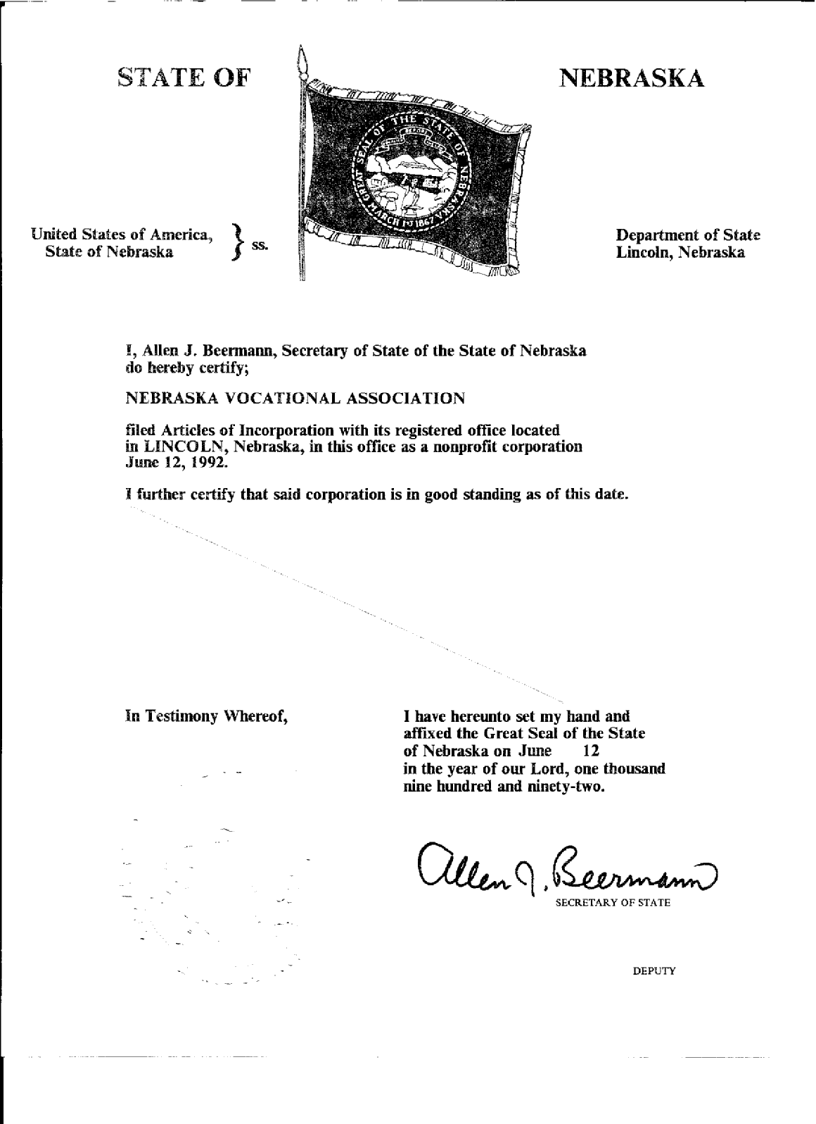
Original Articles of Incorporation – Nebraska Vocational Association
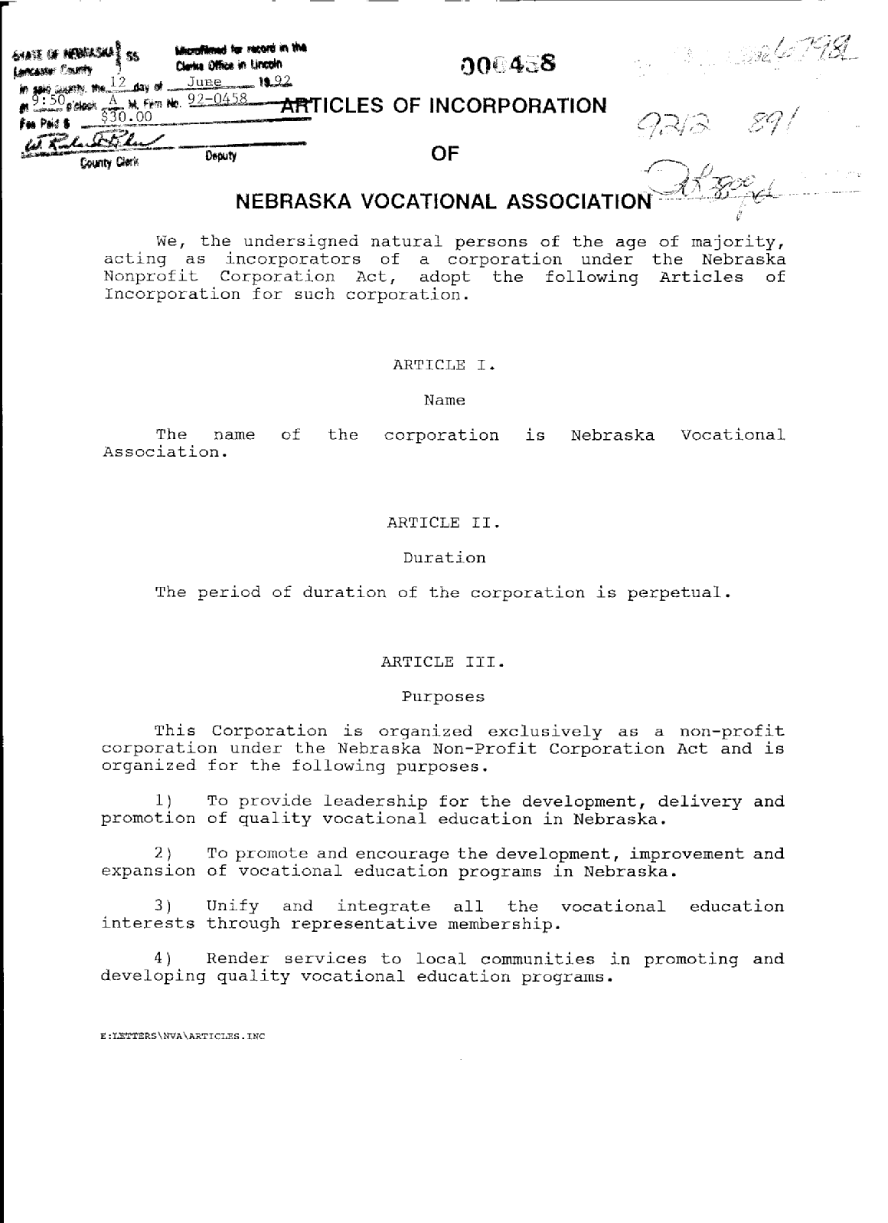

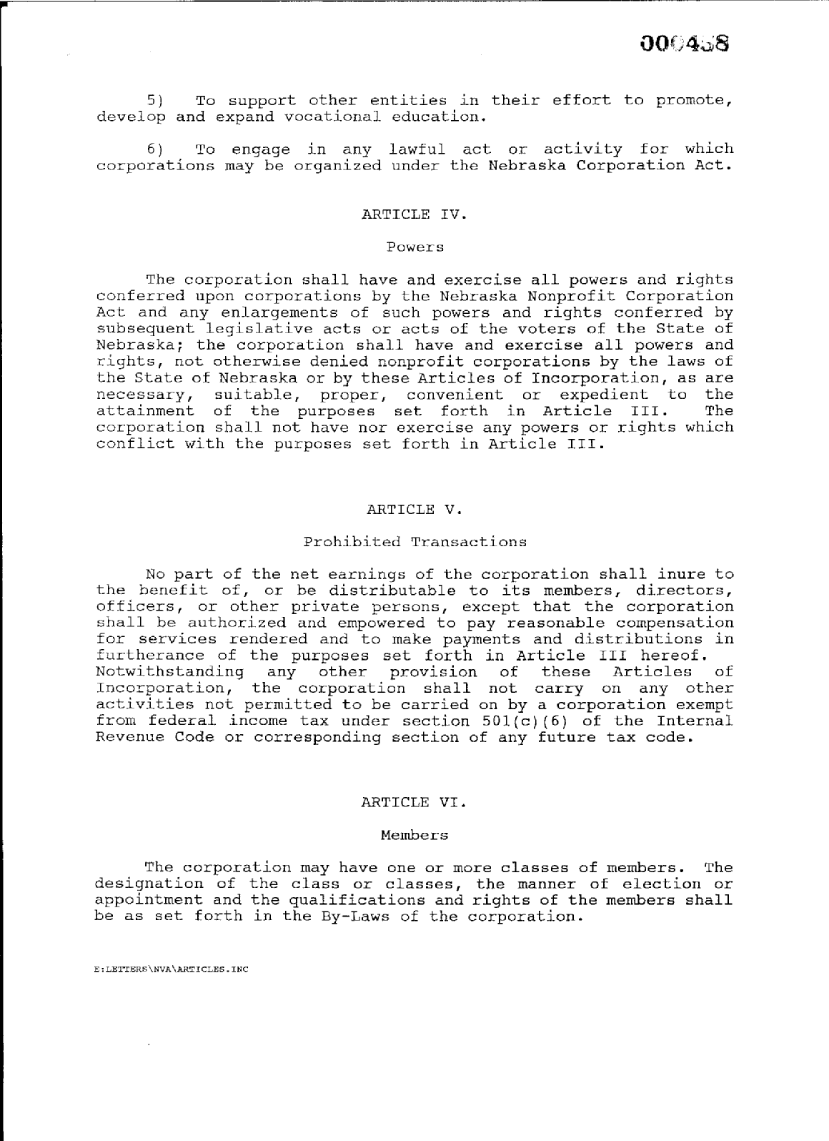
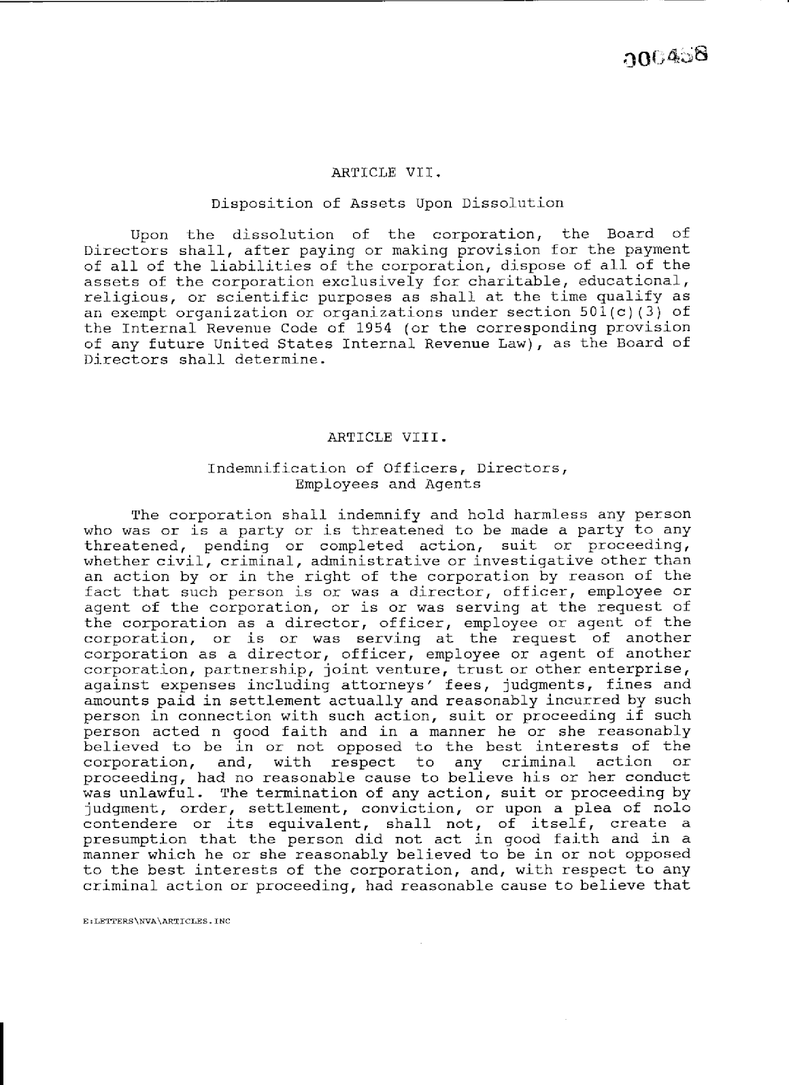

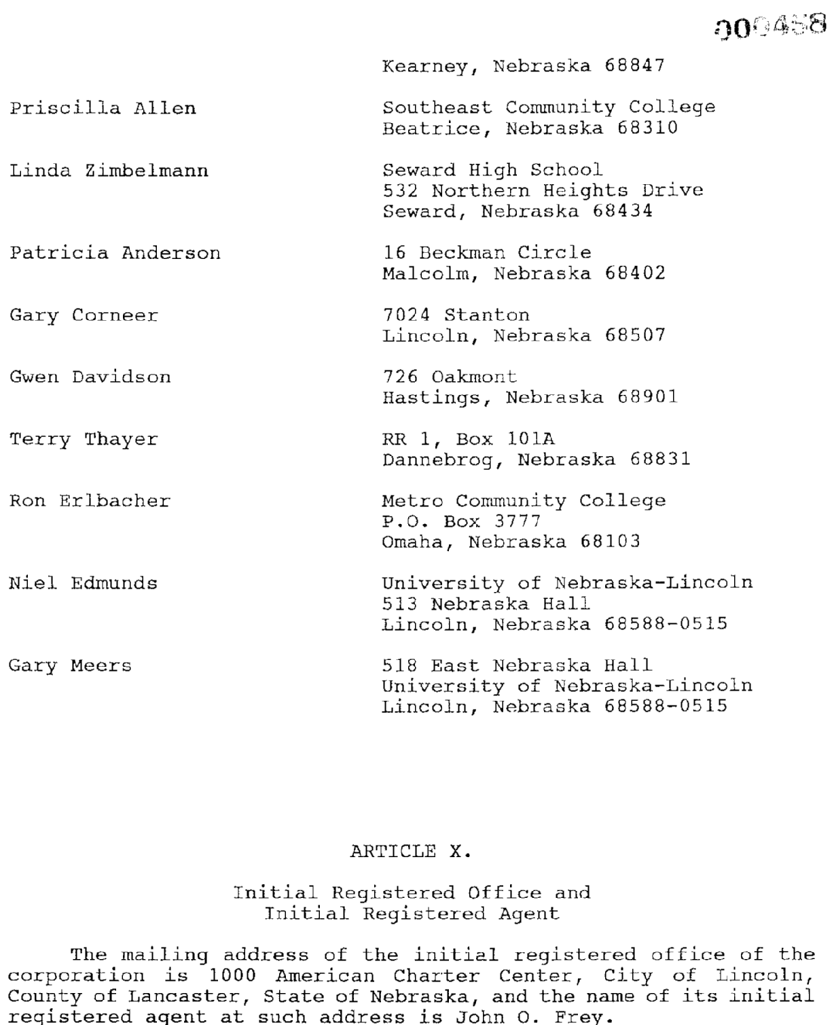

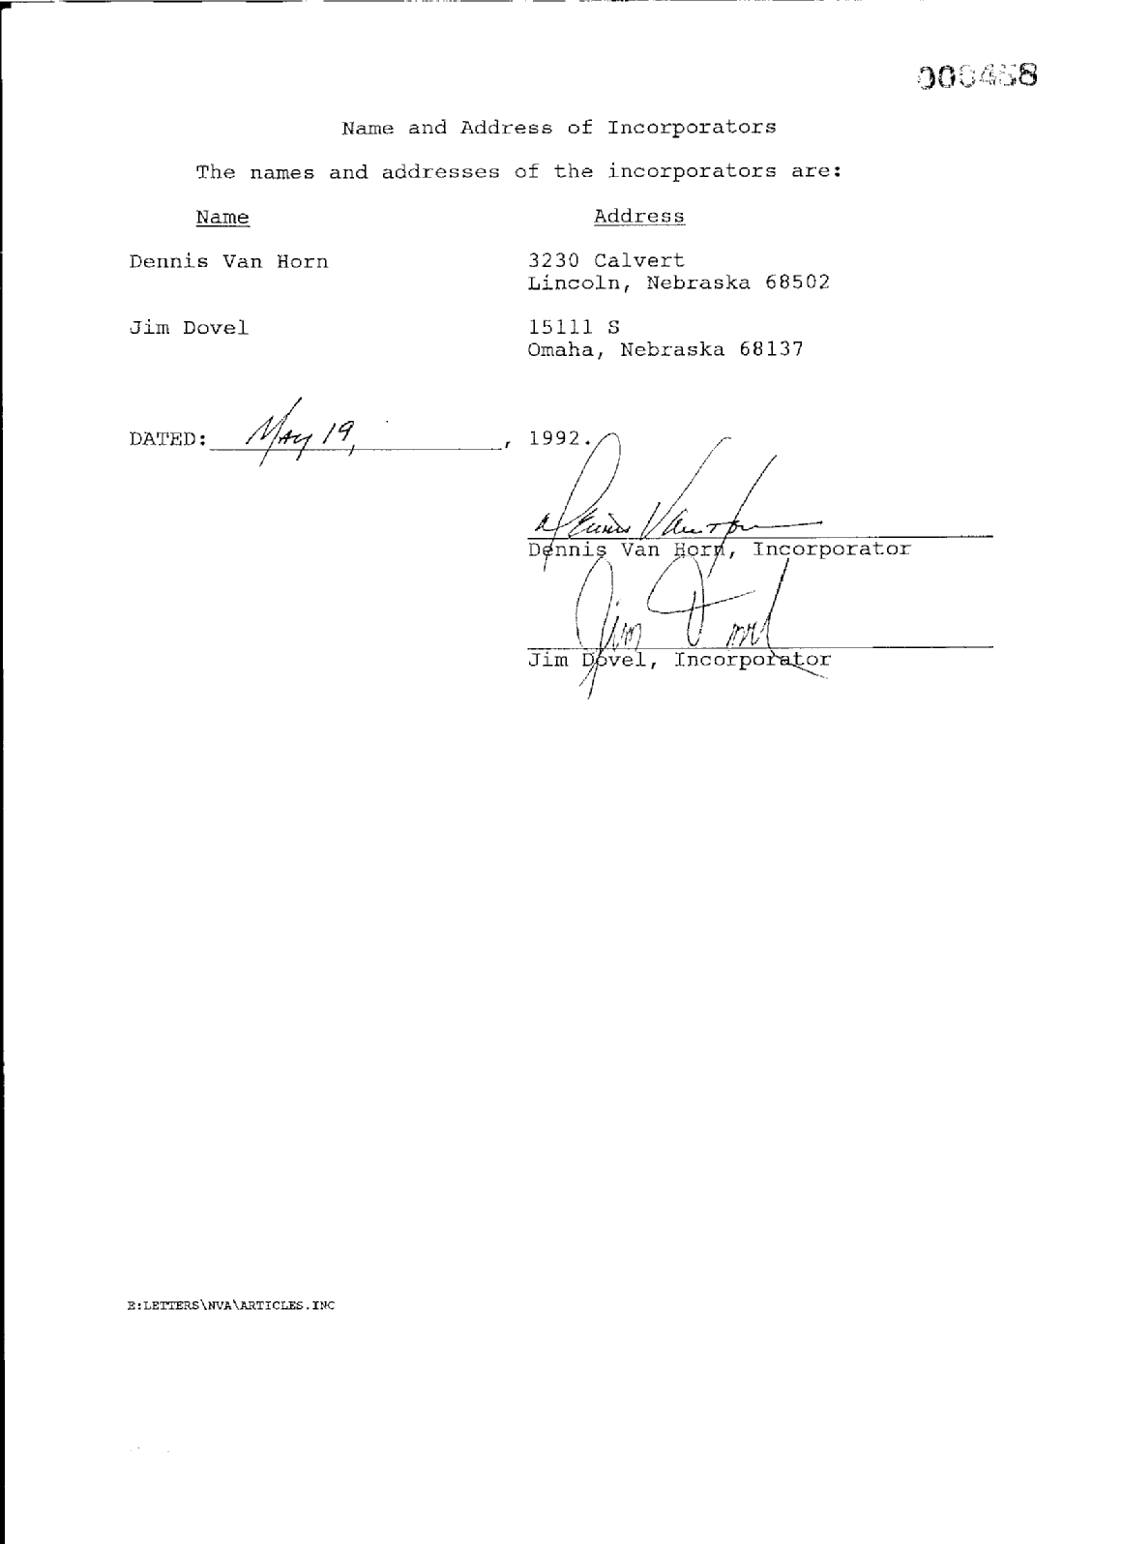
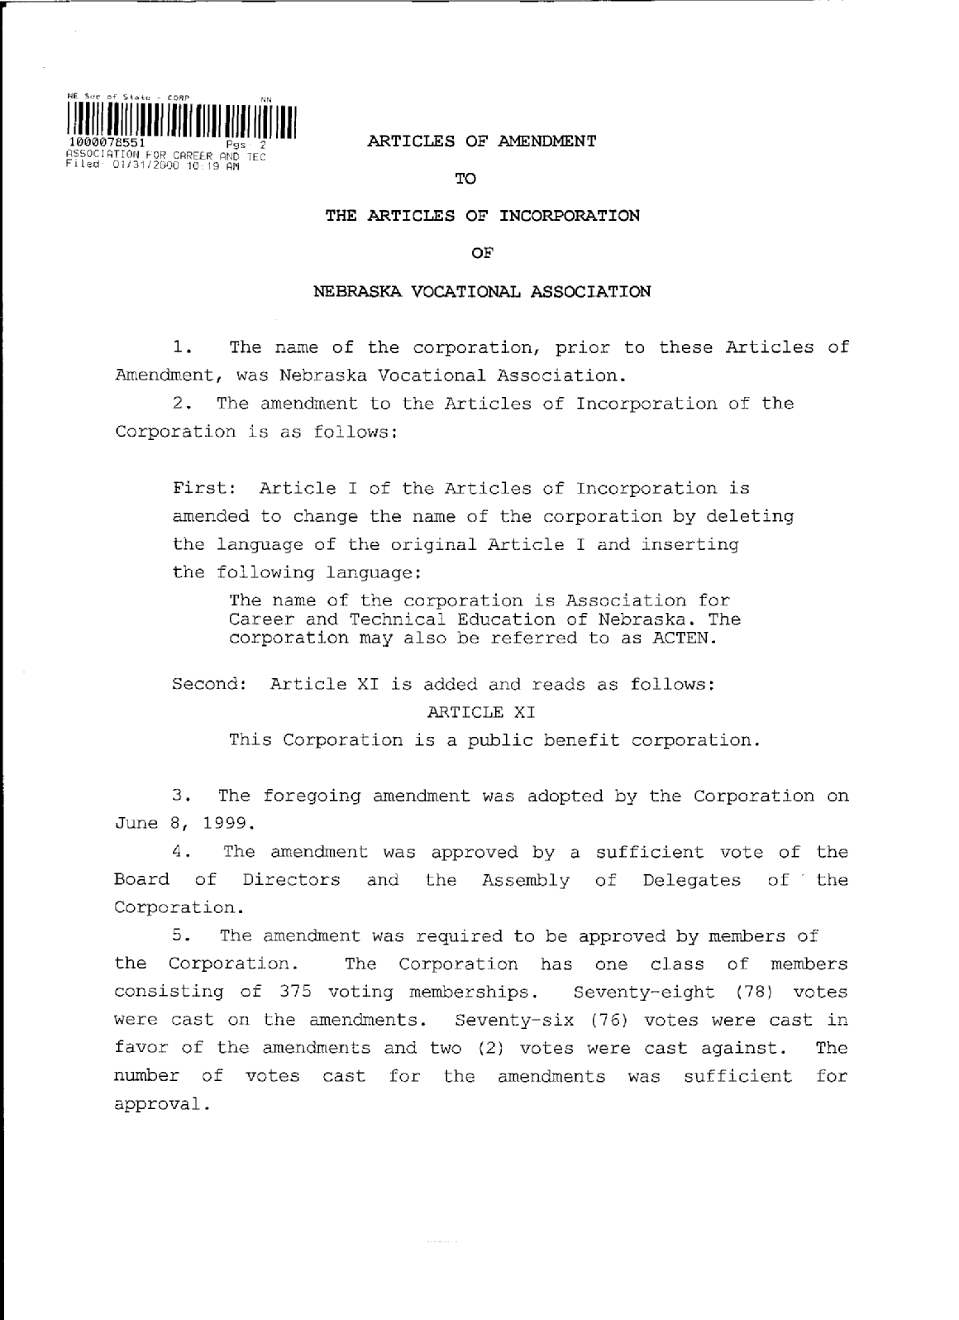
Articles of Amendment to Articles of Incorporation – Name Change To ACTEN
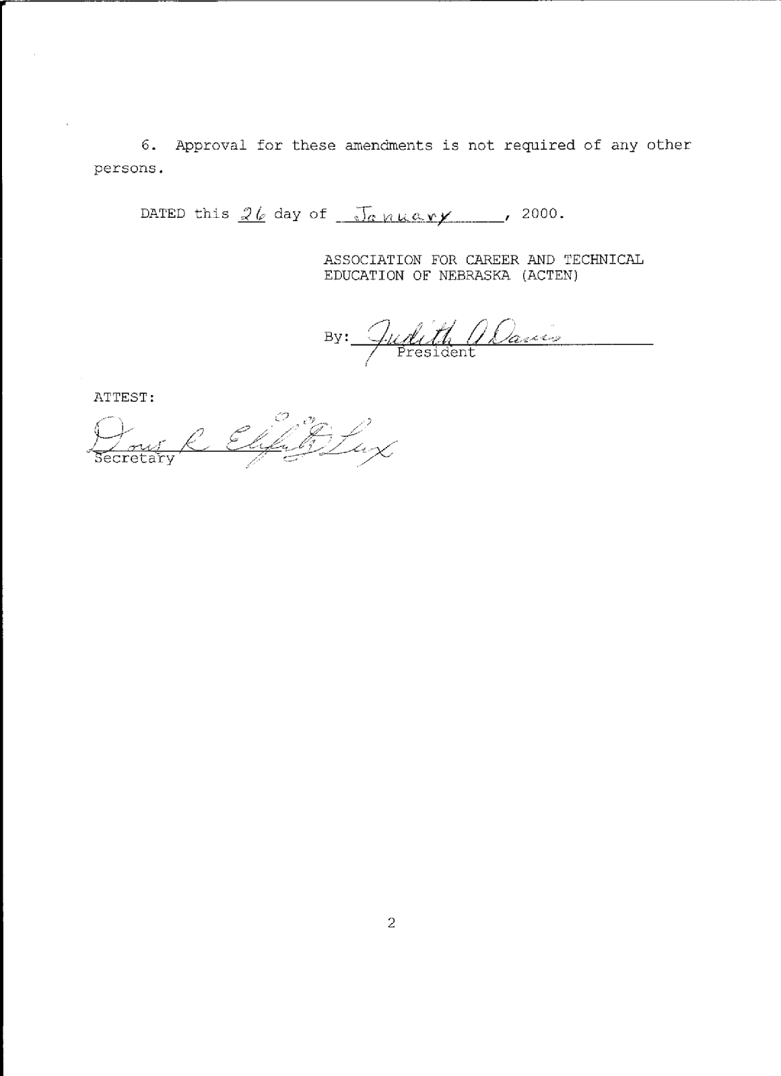
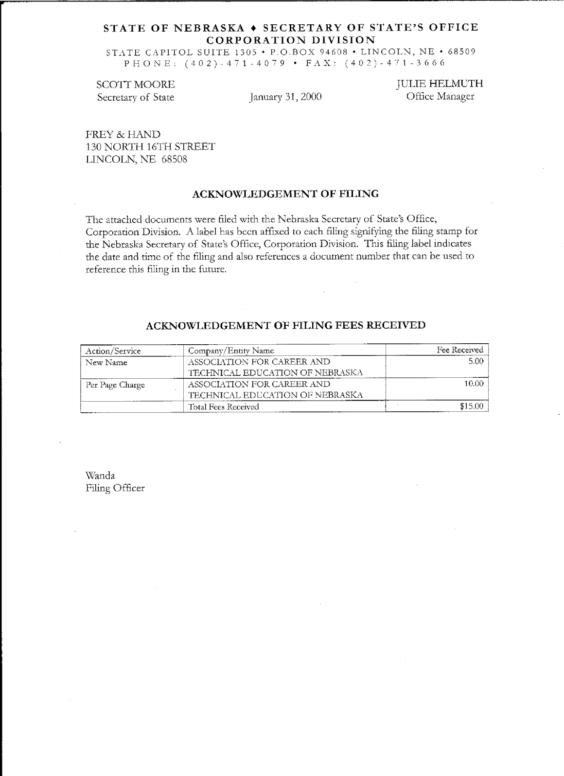
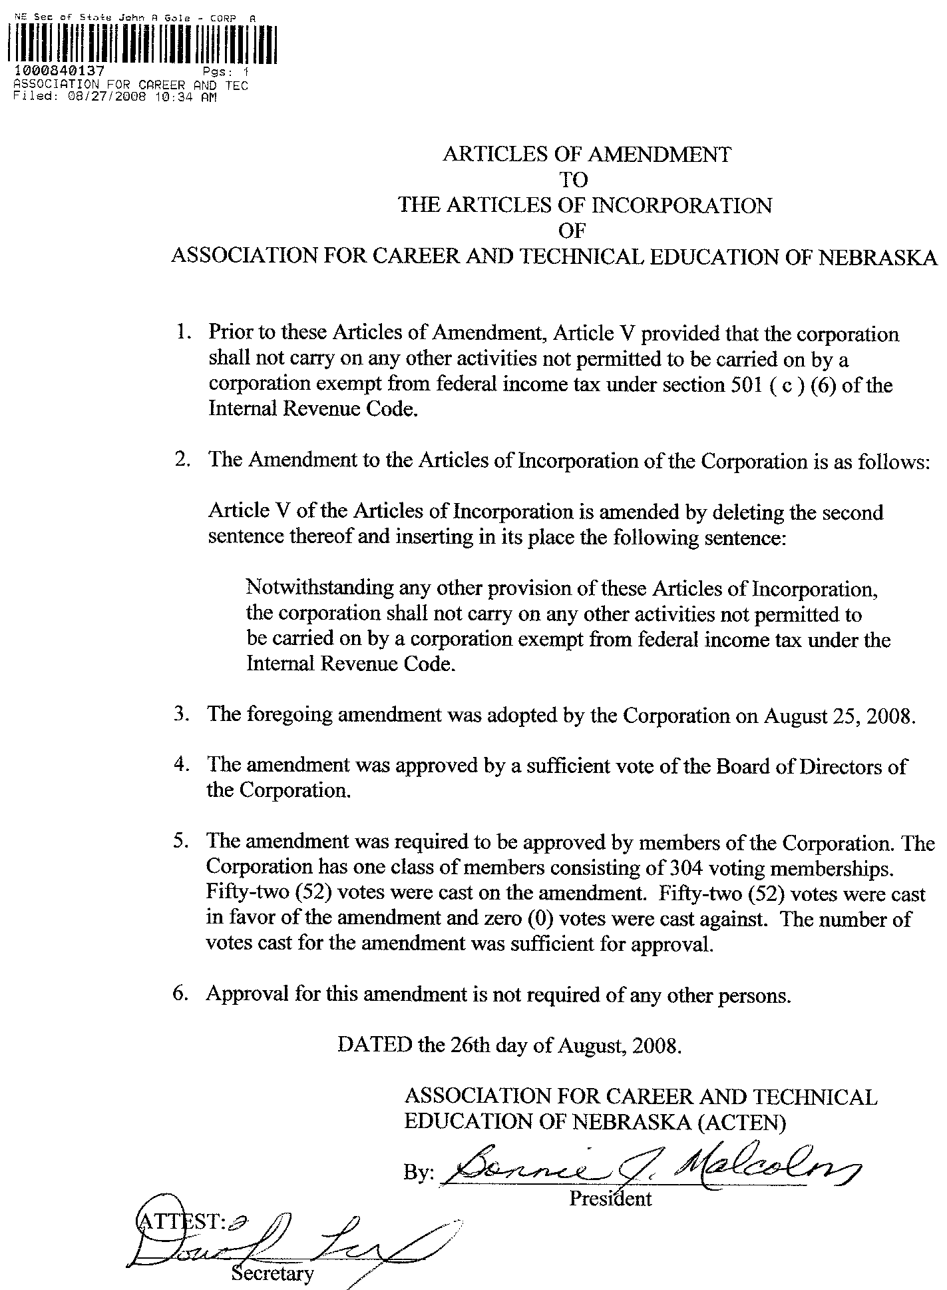
Articles of Amendment to Articles of Incorporation –
Deletes reference to 501(c)(6)

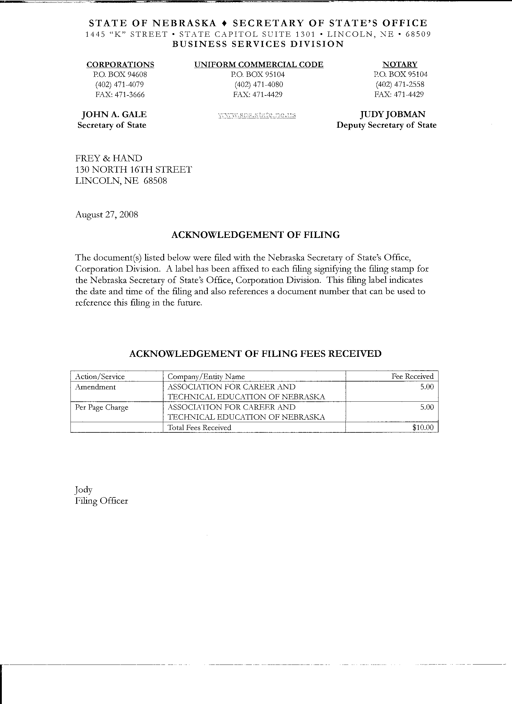

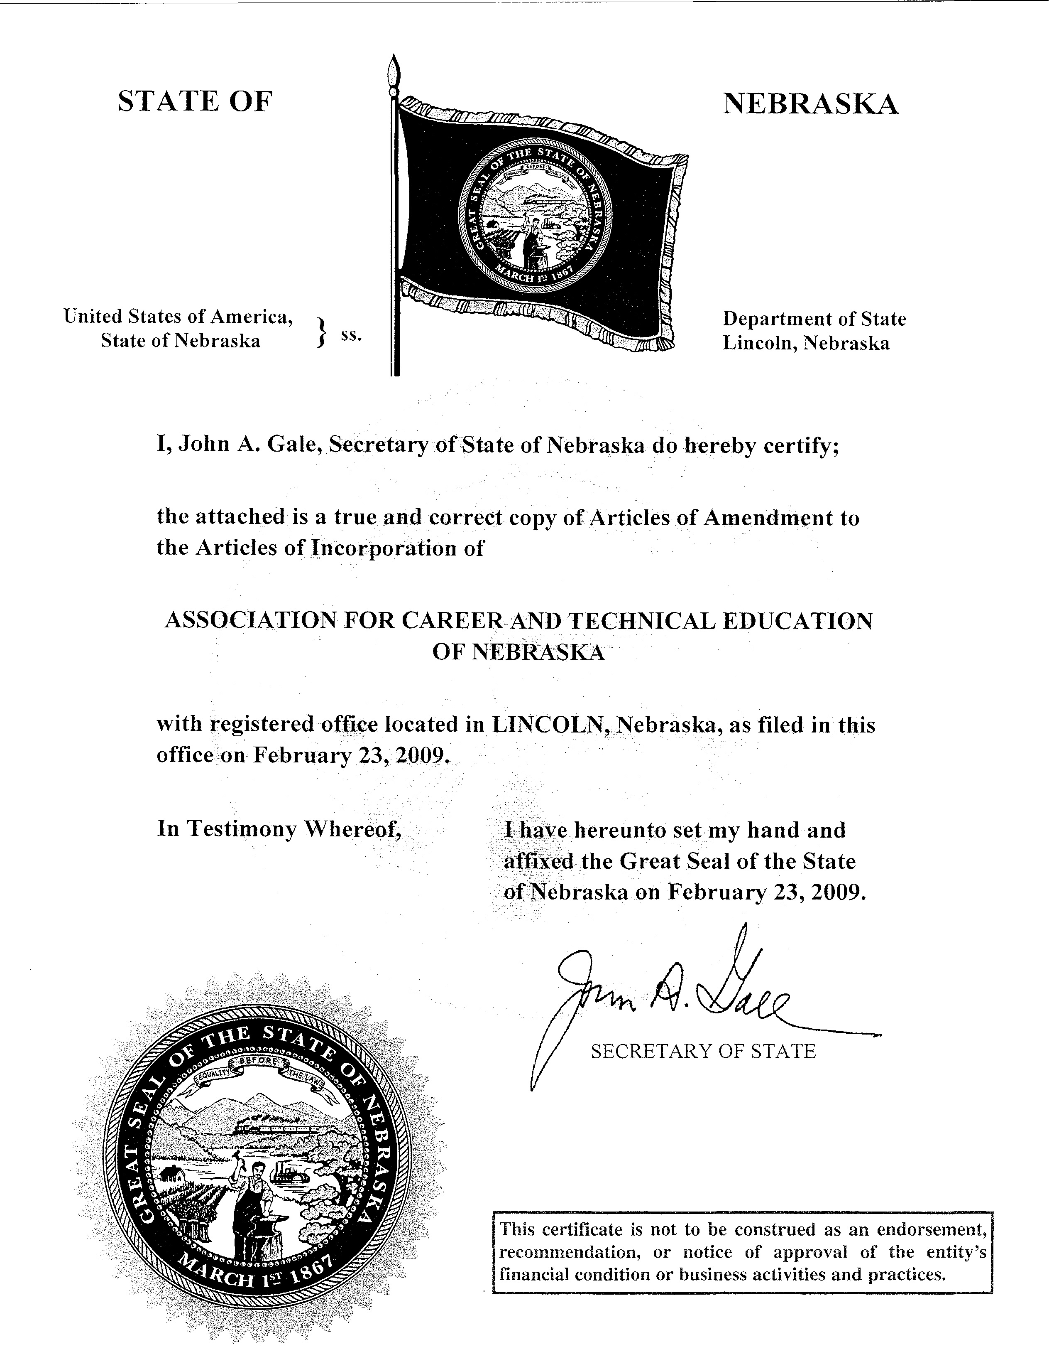
Articles of Amendment to Articles of Incorporation
to add language required by the IRS for 501(c)(3) organizations
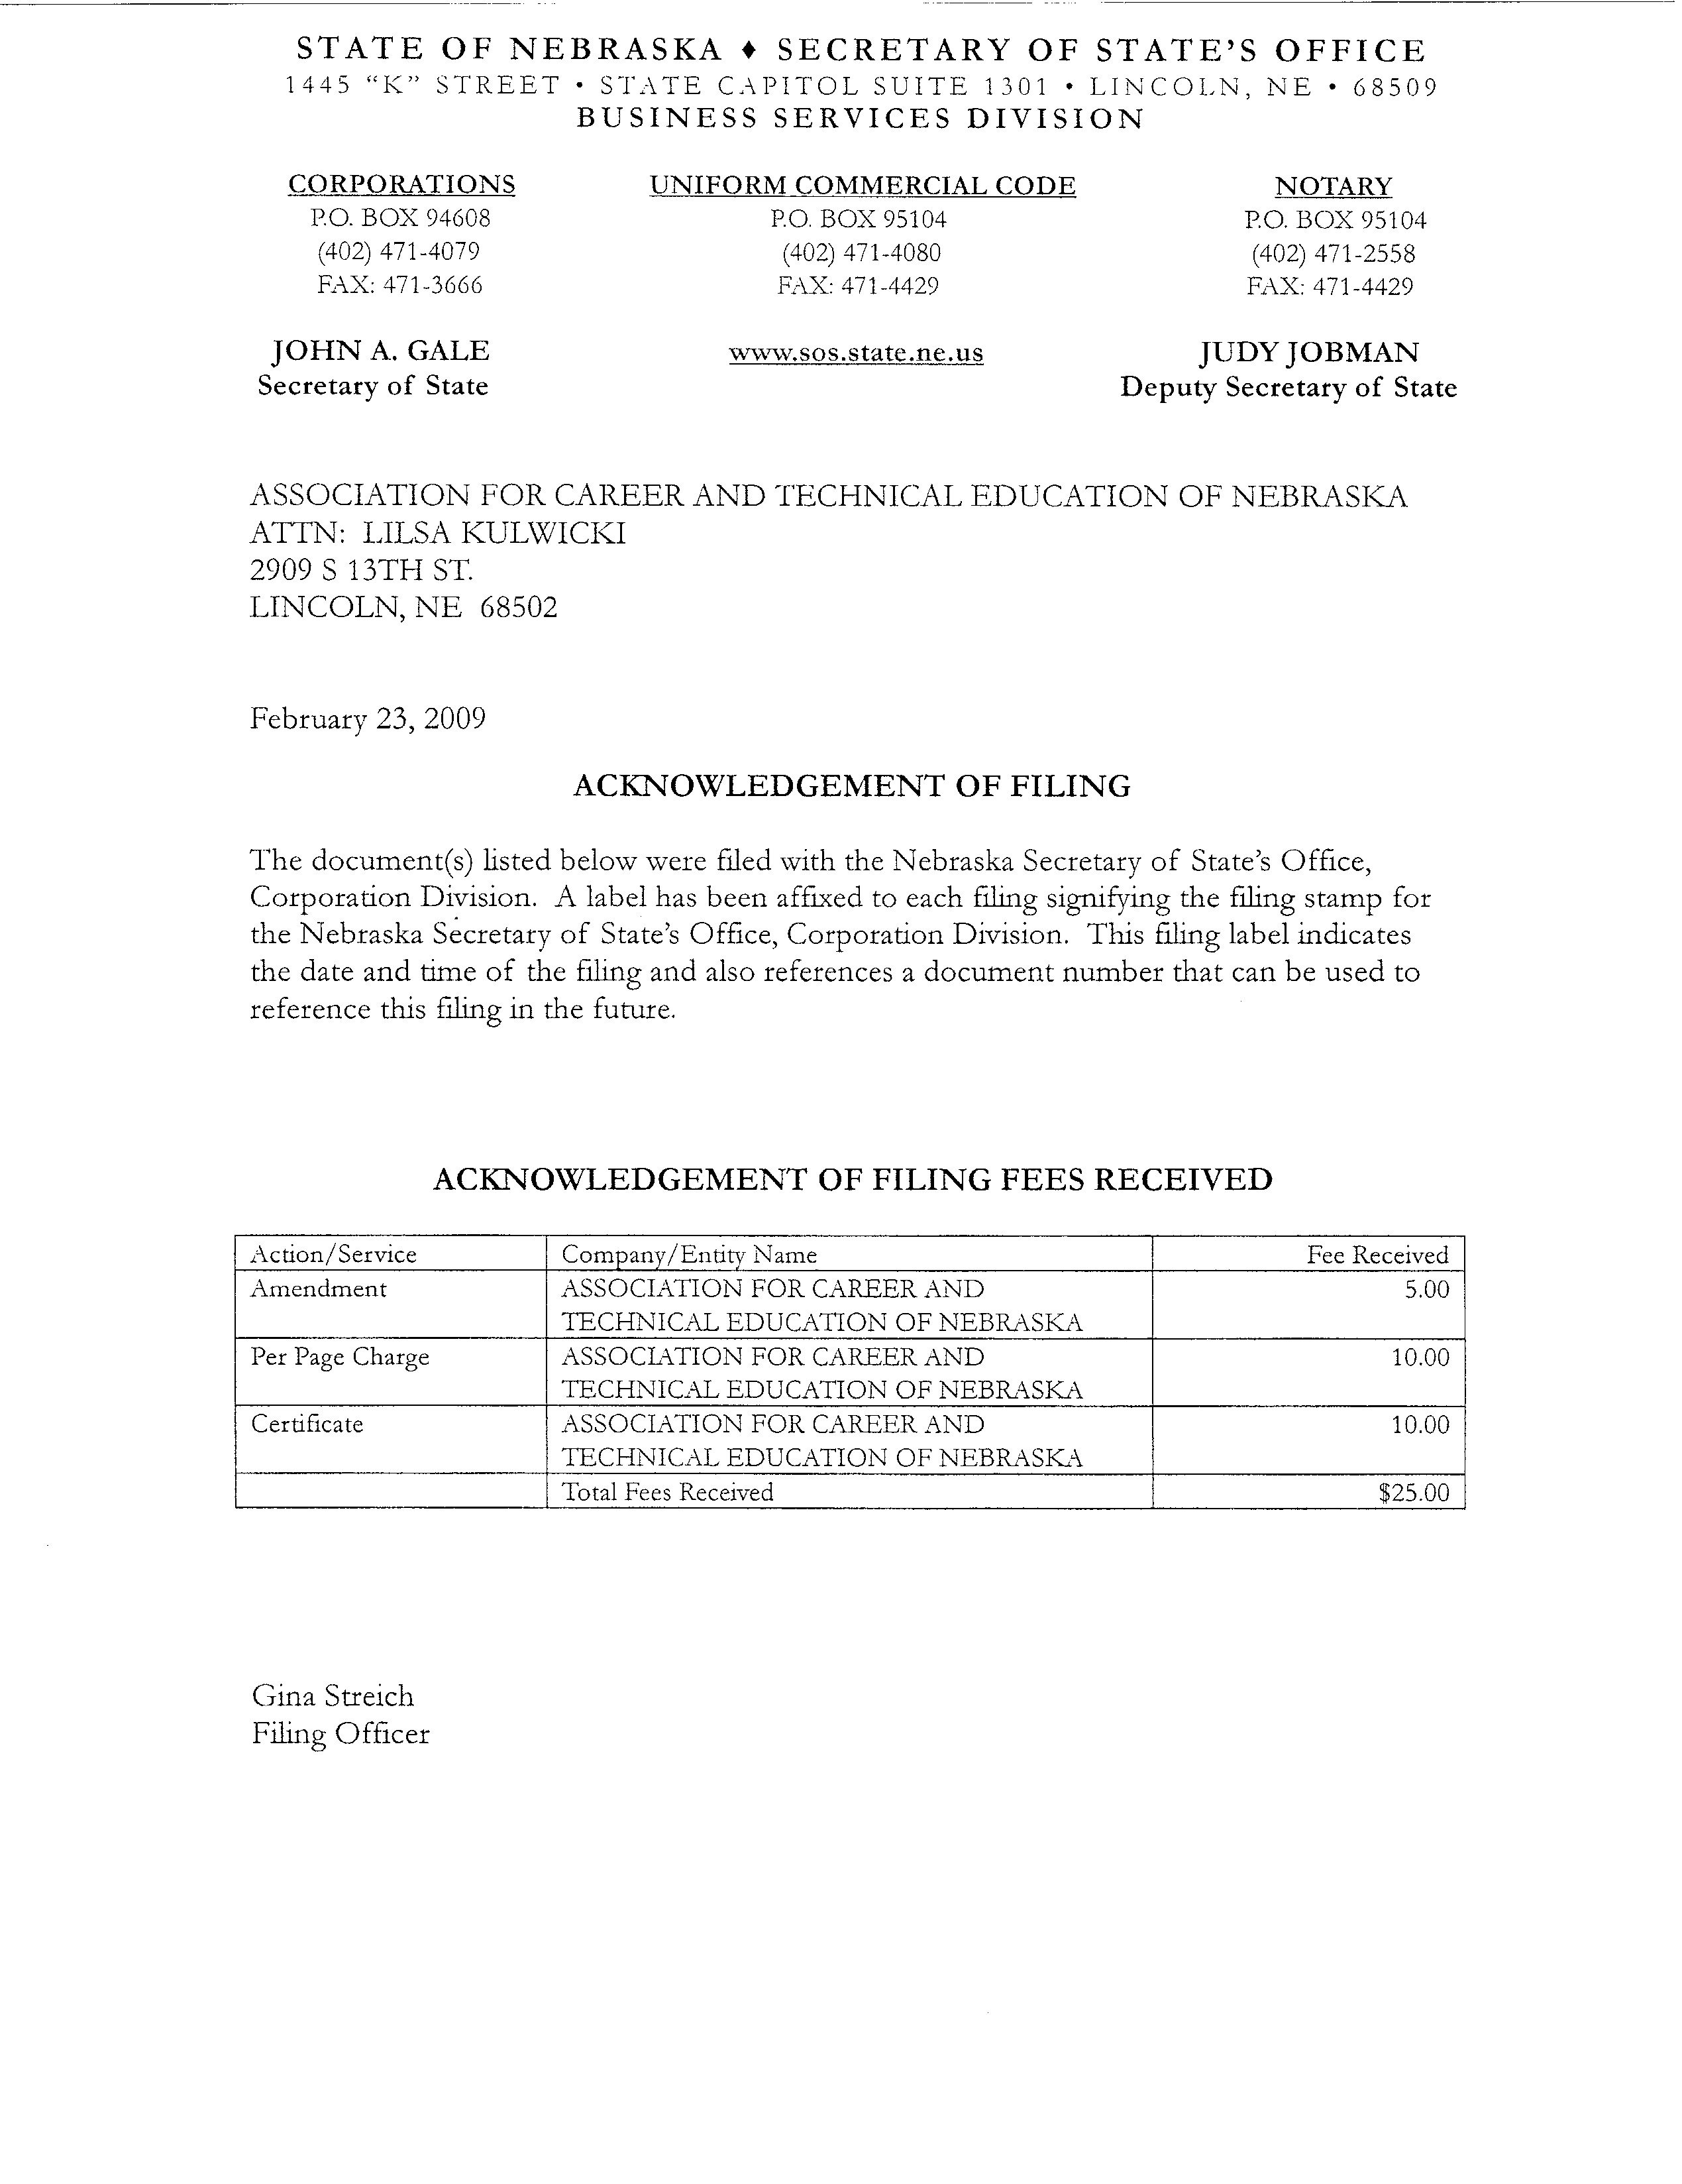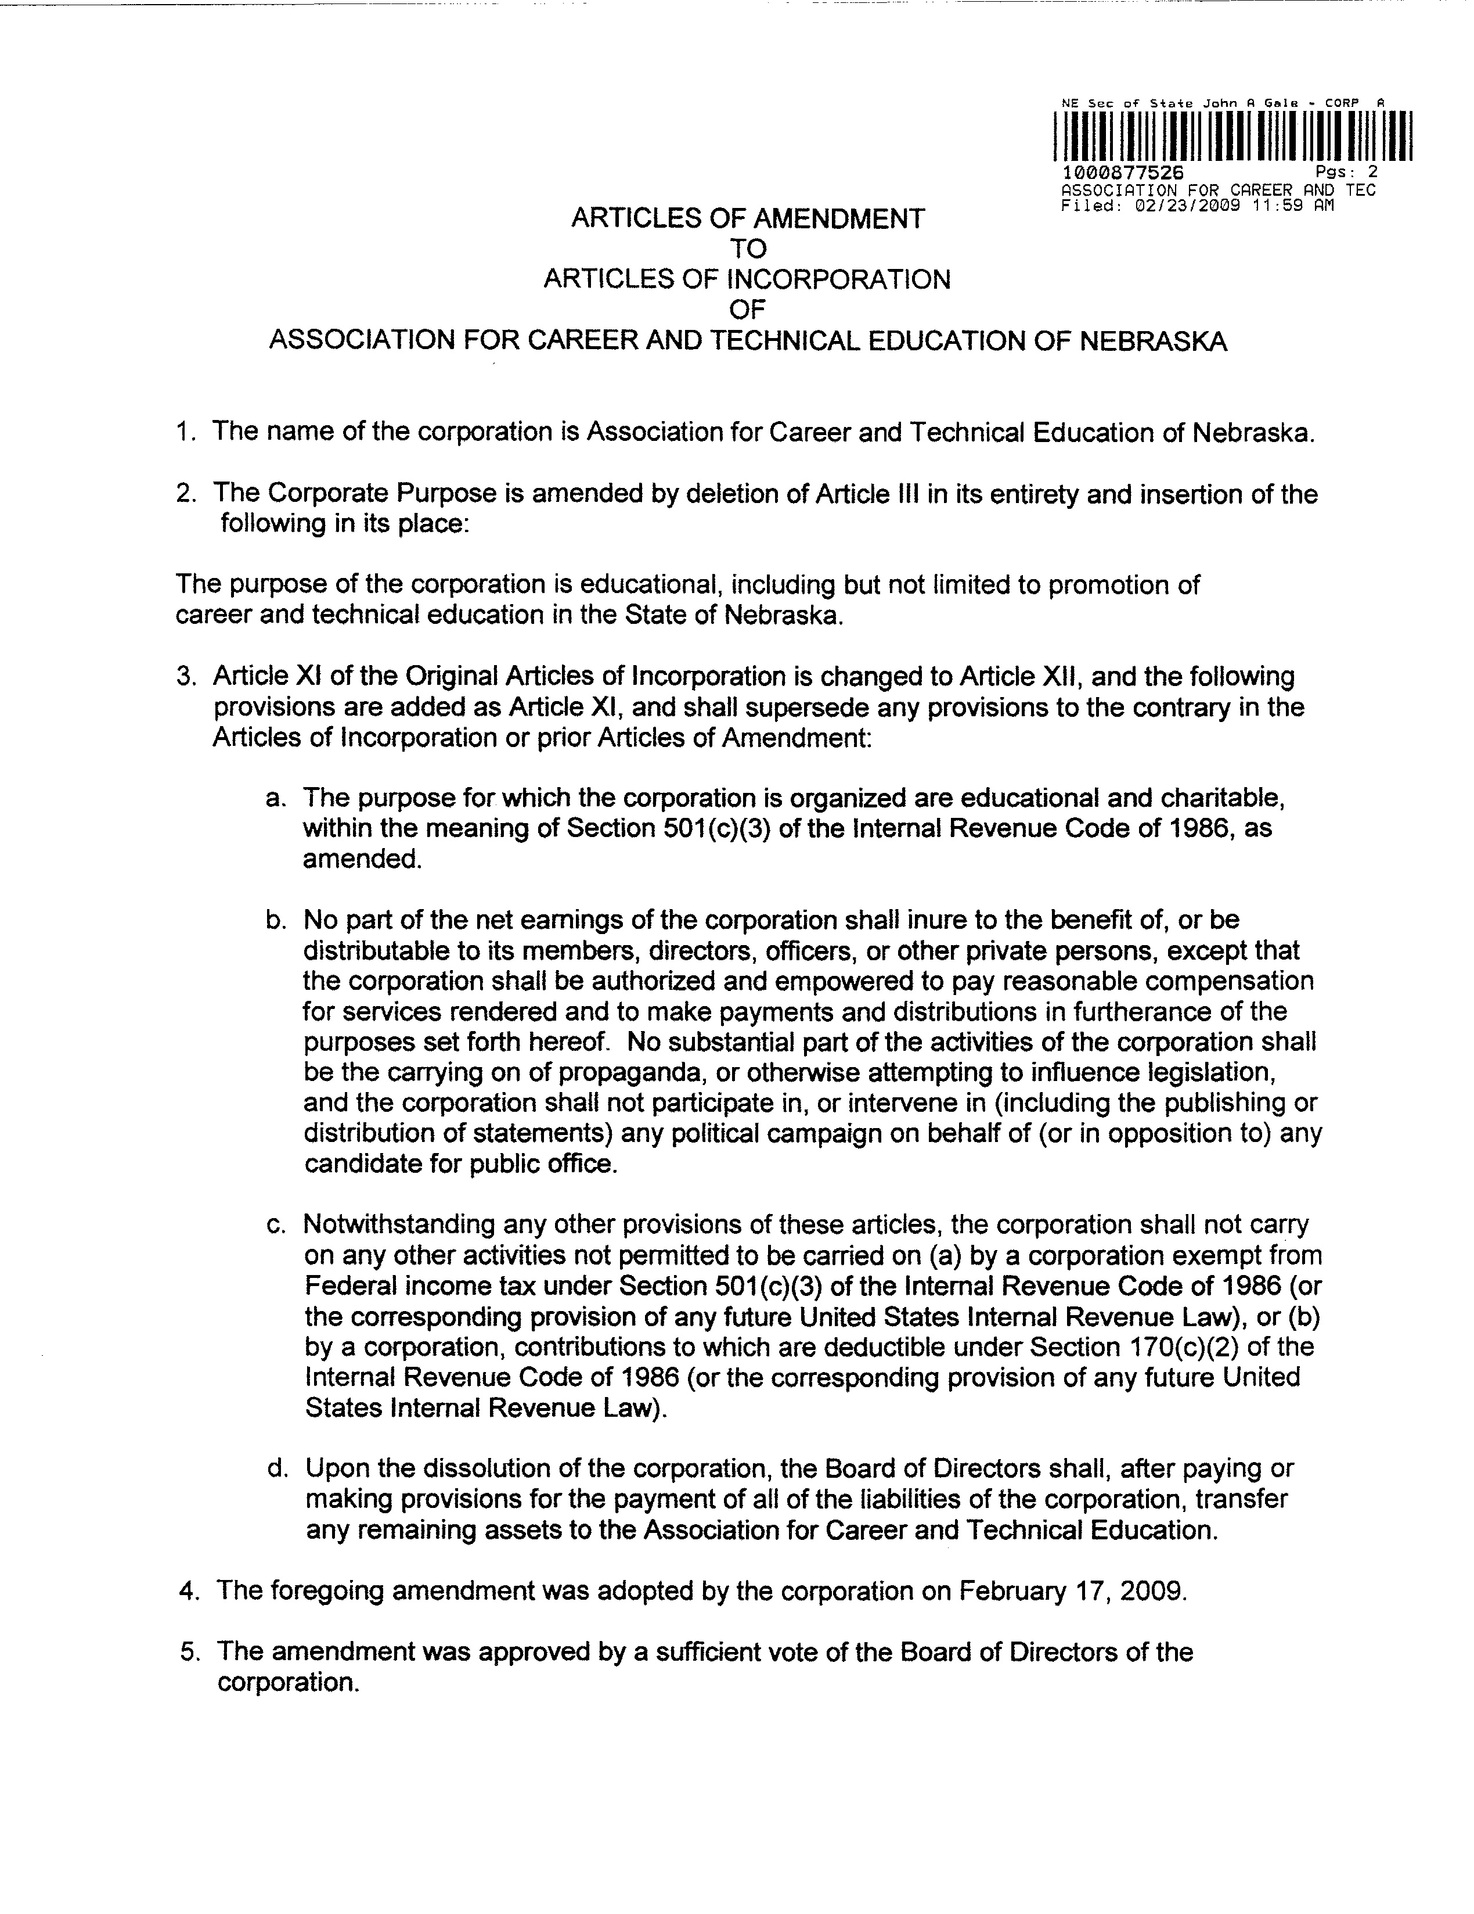
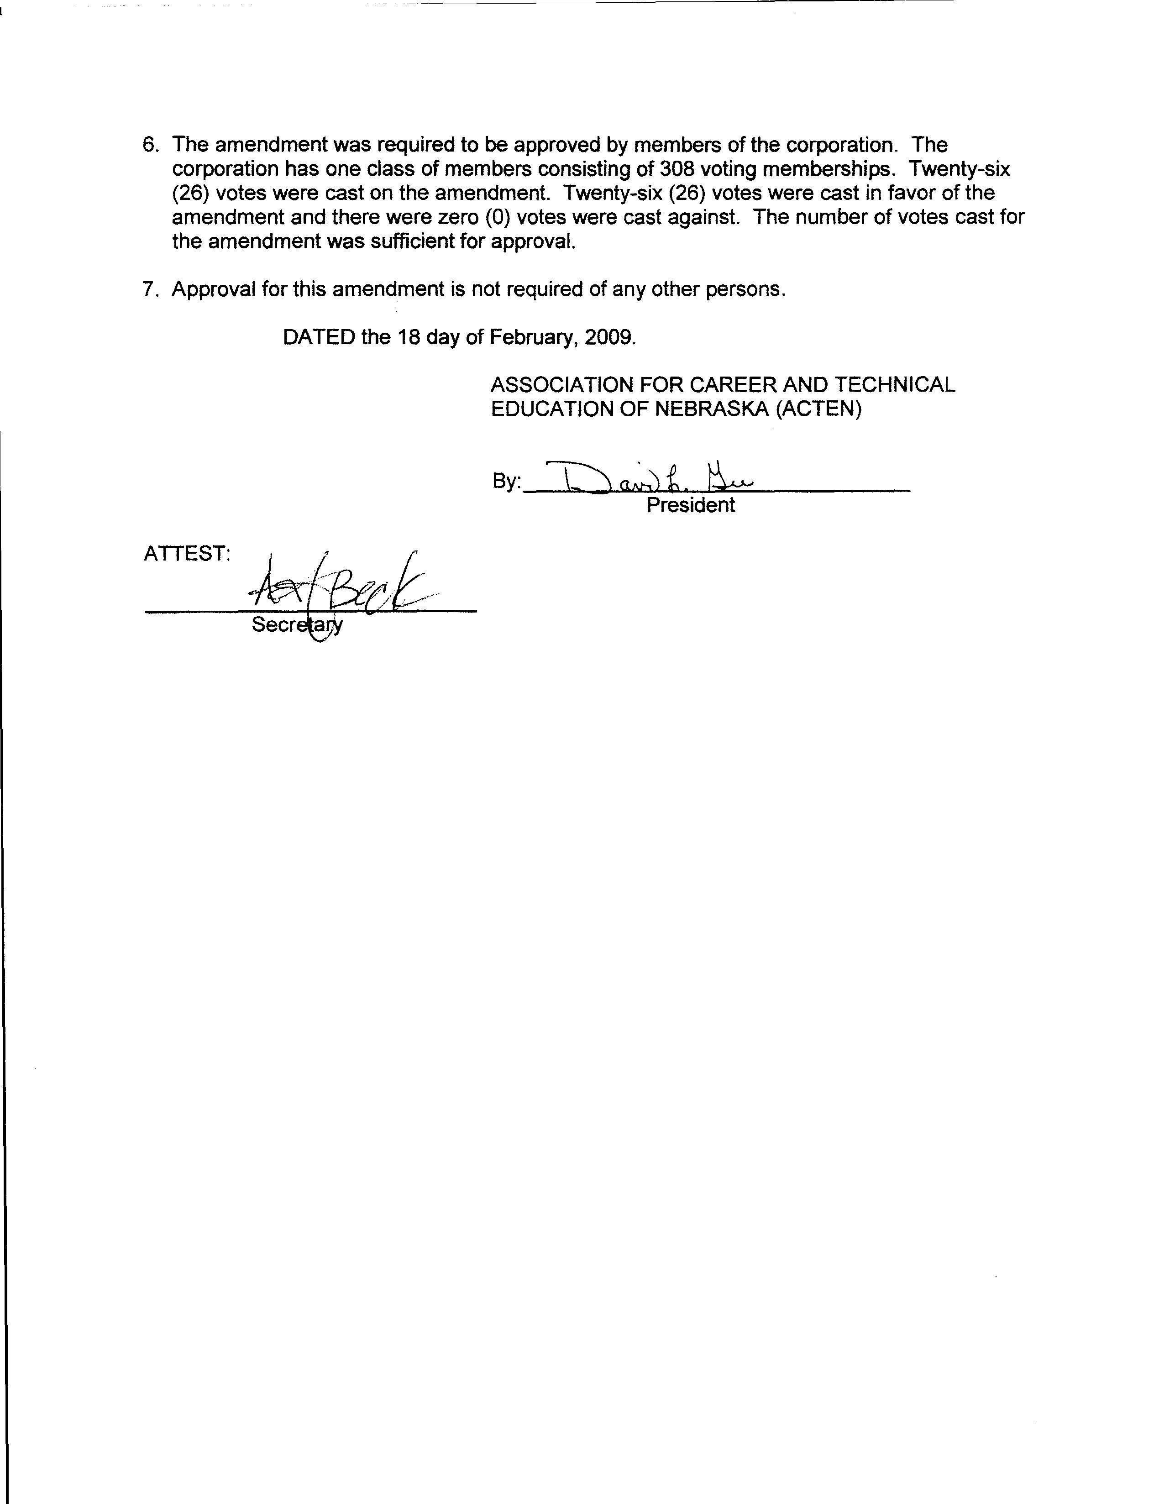
ASSOCIATION FOR CAREER AND TECHNICAL EDUCATION OF NEBRASKA

BYLAWS
(Revised and Adopted by the Assembly of Delegates on June 8, 2022)

ARTICLE I

NAME AND FUNCTION OF BYLAWS

A. The name of this organization shall be the Association for Career and Technical Education of Nebraska.

B. These Bylaws shall be the governing policies for the organization.

ARTICLE II

PURPOSES

The purposes of ACTEN shall be those purposes set forth in the current Program of Work, as adopted by the Board of Directors and Assembly of Delegates each year; provided that such Purposes shall not be inconsistent with nor contradict the Purposes set forth in the Articles of Incorporation. In the event such purposes do conflict with the Articles of Incorporation, the purposes set forth in the Articles of Incorporation shall control.

ARTICLE III

MEMBERSHIP

Sec. 1: Membership in this association is open to all persons interested in career, vocational, and technical education in the State of Nebraska. Membership classification shall be active, student, loyalty, and other categories as defined by the Association for Career and Technical Education.

A. Active membership shall be defined as persons actively employed in the teaching or administration of programs of career, vocational, technical, counseling, and practical arts education.

B. Student memberships are for students preparing for a career in counseling or teaching career, vocational, technical and practical arts subjects.

C. Loyalty memberships are for individuals who have retired from active duty in vocational education and career and technical education.

D. Other membership categories shall be those as defined in the Bylaws of the
Association for Career and Technical Education.

E. New members are persons actively employed in teaching or administration of programs of career, vocational, technical, counseling, and practical arts education who have just joined the Association for Career and Technical Education of Nebraska and were not previously affiliated with the organization as an active member.

Sec. 2: Only active members shall have the right to hold office, act as delegates, or vote in a business meeting of the Association for Career and Technical Education of Nebraska.

Sec. 3: Dues shall be as follows:

A. Active membership dues shall be that amount necessary to cover an affiliated membership in the Association for Career and Technical Education, plus an amount per member to be retained by the Association for Career and Technical Education of Nebraska as recommended annually by the Board of Directors and approved by the Assembly of Delegates.

B. Loyalty membership dues shall be that amount necessary for membership in the Association for Career and Technical Education plus the dues per member to be retained by the ACTEN.

C. All dues shall be paid to the treasurer of the organization.

D. Membership shall begin with the receipt of dues by the ACTEN treasurer and terminate one year from that date.

E. Student membership shall be those enrolled in career, and technical education programs and approved as student members by the Association for Career and Technical Education.

ARTICLE IV

ELECTION OF OFFICERS AND DIVISION REPRESENTATIVES
(BOARD OF DIRECTORS)

Sec. 1: The officers of this association shall consist of the President, President-Elect, Secretary, Treasurer and Past-President. These officers and the Division Representatives representing the career and technical divisions shall constitute the voting members of the Board of Directors. The Career and Technical Divisions include:

Administration
Agriculture Education
Business Education
Counseling and Career Development
Health Science Education
Family and Consumer Sciences Education
Engineering and Technology Education
New and Related Services
Postsecondary, Adult and Career Education
Trade and Industrial Education

Sec. 2: All active members of ACTEN shall be eligible for any elective office of the Board of Directors.

No division may seek office of President-Elect for more than one consecutive term.

Sec. 3: The Board of Directors shall consist of members from each career and technical division as recognized by the Association for Career and Technical Education.

A. Any division of career and technical education having one to seventy-five members of ACTEN shall be represented by one Division Representative.

B. Any division of career and technical education having more than seventy-five members of ACTEN shall be represented by two Division Representatives.

C. Membership on the Board of Directors shall be determined on the basis of a division's membership in the ACTEN at the end of the previous fiscal year.

Sec. 4: Officers
A. President - one year term.

Candidates for elected office and their terms of office shall be:

B. President-Elect - one year prior to assuming the duties of President.
C. Secretary - two years.
D. Treasurer - two years.
E. Division Representatives - three years.

Division Representatives shall be elected annually on a rotation basis. No two Division Representatives from the same division of career and technical education shall complete their terms in the same year. Each division shall
elect, by vote from ACTEN members within their own division, their respective Division Representative. If 100% of the members in a division of ACTEN are also members of a separate or affiliated division association then the division representatives for that division may be elected or appointed as determined by that division association and submitted in writing to the ACTEN President prior to the delegate assembly.
Sec. 5: Election of persons for the elected offices shown in Section 4 shall be by mail or electronic ballot. The nominating committee shall prepare a ballot listing two (2) candidates for each office to be filled and provide a space under each office for write-ins except President-Elect.

Sec. 6: The election procedure shall be:

A. Candidates for elected offices shall be approved by the Board of Directors and announced sixty (60) days prior to the annual meeting.

B. Mail ballots or electronic ballots should be sent to ACTEN members forty-five (45) days prior to the annual meeting. Only ballots postmarked or received electronically at the ACTEN Office at least fifteen (15) days prior to the annual Assembly of Delegates meeting shall be considered as valid ballots.

Sec. 7: The President-Elect shall be installed as President at the annual meeting and shall assume the duties at the beginning of the fiscal year. Other newly elected officers shall also take office at the start of the fiscal year.

Sec. 8: In the event that the office of President is declared vacant during the interval, the President-Elect will assume the position of President for the remaining portion of that interval and shall retain the office of President for the ensuing year. Other offices which shall become vacant during any interval shall be filled for the remaining portion of that interval by action of the Board of Directors. In the event of a vacancy in the office of President-Elect, the Board of Directors, pursuant to majority vote, will appoint an eligible member of the Association to fill such vacancy and occupy the position of such office.

ARTICLE V

DUTIES OF OFFICERS AND DIVISION REPRESENTATIVES (BOARD OF DIRECTORS)

Sec. 1: The President shall be the chief executive officer of the ACTEN and shall exercise general supervision over the interest and welfare of the organization. The President shall be chairperson of the Assembly of Delegates and Board of Directors. The President shall:

A. Be responsible for implementing and directing the Program of Work Committee.

B. Appoint chairpersons to committees from the Board of Directors.

C. Instruct committee chairpersons about their assignments, assist them in carrying out their tasks, and check with the committee during the year to make certain that progress is being made.

D. Serve as ACTEN delegate to the ACTE Assembly of Delegates.

E. Participate or appoint a representative to participate in Region V activities.

F. Meet with newly elected members of the Board of Directors to acquaint them with their responsibilities.

G. Provide articles for each ACTEN Newsletter.

H. Act as an ex-officio member of all committees except nominating.

I. Collect committee reports and keep on file.

J. Attend one yearly function of each division or send a representative. The representative may be the Past-President, President-Elect, Secretary or Treasurer.

Sec. 2: The President-Elect shall:

A. Be chairperson of Program of Work Committee.
B. Assume the duties of the President when the President is absent.
C. Serve as a member of the Bylaws Committee.
D. Serve as ACTEN delegate to the ACTE Assembly of Delegates.
E. Assist the President in carrying out the Program of Work.
F. Provide articles for each of the ACTEN Newsletters.

Sec. 3: The Past-President shall:

A. Assist and guide the President and President-Elect in carrying out their duties.
B. Act as consultant to the Program of Work Committee.
C. Select and obtain appropriate plaque for the outgoing ACTEN President.
D. Serve as chairperson for the Nominating and Awards Committee.
E. Serve as consultant to the Legislative Committee.
F. Serve as Co-chair of the Annual Career and Technical Conference Planning Committee.

Sec. 4. The Secretary shall:

A. Be responsible for the minutes of all business meetings.
B. Keep all minutes and committee reports on file.
C. Send out minutes of every meeting within fifteen (15) days following the meeting and notice of upcoming meeting to the Board of Directors and state affiliate organization presidents at least ten (10) days in advance of the upcoming meeting.
D. Keep records and handle correspondence of all ACTEN business.
E. Serve as an ACTEN representative to an ACTE function.

Sec. 5. The Treasurer shall:

A. Arrange for the collection of dues.
B. Provide a list of members to the Board of Directors.

C. Serve as financial custodian of all ACTEN funds and prepare an annual financial report.
D. Serve as an ACTEN representative to an ACTE function.

Sec. 6: Communications (Newsletter Editor and Webmaster)
A. The Newsletter Editor shall:
(a) Plan and arrange for the publication of the ACTEN Newsletter.
(b) Attend ACTEN Board meetings as an ex officio member, when possible.
B. The Webmaster shall:
(a) Maintain the ACTEN website by posting new information, remove outdated
information and suggest changes that will keep the site fresh and interesting for our members.
(b) Provide basic training to other board members so they will be able to
update the website when their assistance is needed.
(c) Attend ACTEN Board meetings as an ex officio member, when
possible.

Sec. 7: The Division Representative shall:

A. Attend Board of Directors meetings and Assembly of Delegates as voting delegates for the Board of Directors. Division Representatives will be required to resign their position after two unexcused board meeting absences per year. An excused absence can be granted prior to the meeting by the ACTEN President.

B. Provide leadership and promote membership in their respective divisions.

C. Serve as chairpersons and assist in carrying out the responsibilities of the various committees.

D. Have a responsibility to provide articles for ACTEN newsletter.

E. Communicate information to their divisions concerning ACTEN matters.

F. Appoint and notify members of their respective divisions to serve as delegates to the annual Assembly of Delegates.

G. Appoint a voting representative in the event the elected Division Representative cannot attend a Board of Directors meeting.

H. Have a responsibility to secure applicants, from their division, for ACTEN/ACTE awards.

Sec. 8: Affiliate Organization Presidents shall:

A. Be encouraged to attend all scheduled Board of Directors meetings as an ex-officio member.

B. Inform the ACTEN Board of Directors of their respective affiliate organization functions.

ARTICLE VI

BOARD OF DIRECTORS

Sec. 1: The elected officers and Division Representatives shall constitute the voting members of the Board of Directors. Designated ex-officio members shall serve on the Board of Directors as non-voting members, and shall include, but not be limited to, a representative of the Nebraska Department of Education as designated by said department, the Newsletter Editor, and any Nebraskan who is a member of the ACTE Board of Directors

Sec. 2: The duties of the Board of Directors shall be:

A. To look after the general welfare of Vocational and Career and Technical Education within the state.

B. To give special emphasis to educating the public with respect to the value and need of such education.

C. To assume the authority to conduct business and take necessary action between meetings of the ACTEN Assembly of Delegates.

D. To annually appoint the Newsletter Editor.

E. To have voting privileges at the ACTEN Assembly of Delegates representing the ACTEN and not their respective divisions.

ARTICLE VII

COMMITTEES

The committees shall consist of active ACTEN members. The chair of each committee shall be a Board of Directors member who will prepare a summary report for each meeting and a yearly report on activities of each committee for the ACTEN Assembly of Delegates, to be given to the new Chairperson, the President-Elect, and the Secretary.

Sec. 1: Audit

A. The Audit Committee shall annually audit the financial records of the Association and submit a written report to the Assembly of Delegates.

Sec. 2: Budget

A. The Budget Committee shall assess the operational needs of the Association and submit a proposed budget for the ensuing year to the Assembly of Delegates.

Sec. 3: Legislation and Resolutions

A. The Legislative and Resolutions Committee shall maintain the state and national level legislative networks in each career and technical division for:

(1) Informing legislators of needs and accomplishments of vocational, career and technical education.

(2) Establishing and maintaining a good relationship with legislators.

B. Monitor state and national legislation and notify appropriate network members when action is required. Follow through to see that action is taken.

C. Keep members informed of all legislation, state and national, which would affect vocational, career and technical education, via regular articles in the ACTEN Newsletter.

D. Contact representatives of each ACTEN division and standing committees for resolutions vital to ACTEN.

E. Solicit resolutions prior to the annual Assembly of Delegates.

F. Upon recommendations of the Board of Directors, present resolutions to the Assembly of Delegates for action.

Sec. 4: Membership

A. The Membership Committee shall consist of a representative from each career and technical education division, and they shall solicit membership from their respective division.

Sec. 5: Nominating and Awards

This committee shall be chaired by the Past-President. It shall consist of one representative from the members of each division. It shall:

A. Serve in an advisory capacity to the President.

- Select candidates for elected offices and report to the Board of Directors.

C. Be responsible for selecting suitable recipients for each ACTEN award to be presented at a time decided by the Board of Directors.

Sec. 6: Program of Work

A. The Program of Work Committee shall consist of the chairpersons from each standing committee. It shall develop specific goals, activities on how to reach them, and provisions for evaluation. The Program of Work shall be based on a strategic plan developed by the ACTEN Board of Directors. The Program of Work shall be submitted to the Board of Directors at least sixty (60) days before being submitted to the Assembly of Delegates for final approval.

Sec. 7: Public Relations

A. The Public Relations Committee shall arrange ways and means of interpreting vocational, career and technical education to the public and to leaders in general education.

Sec. 8: Bylaws

A. The Bylaws Committee shall receive proposed Bylaws changes from ACTEN members sixty (60) days prior to the Assembly of Delegates and shall evaluate the Bylaws for any proposed changes.

ARTICLE VIII

MEETINGS

Sec. 1: The annual meeting of the Assembly of Delegates shall be held each year at such time and place as the Board of Directors may select.

Sec. 2: Each career and technical education division shall be represented in the
Assembly of Delegates by one delegate for each ten active members or major part thereof, based on the division membership of the preceding fiscal year. Divisions with less than fifteen (15) active members shall be entitled to two delegates.

Sec. 3: All business shall be transacted by the Assembly of Delegates members
present at the annual meeting or at any special meeting officially called by the Board of Directors. A minimum of fifty-one (51) percent of those active members registered at the Assembly of Delegates constitute a quorum.

Sec. 4: All board meetings shall be open and all interested parties privileged to
attend, but voting shall be limited to officers of their voting representatives.

ARTICLE IX

FISCAL YEAR

The fiscal year of this organization shall be October 1 to September 30.

ARTICLE X

AMENDMENTS

Sec. 1: The Bylaws may be amended by a two-thirds (2/3) majority of the votes cast
by the Assembly of Delegates. Proposed changes must be submitted in
writing to the Board of Directors at least sixty (60) days prior to the Assembly of Delegates. ACTEN members shall be notified of proposed changes at least thirty (30) days prior to the Assembly of Delegates. Adopted amendments shall become effective following the Assembly of Delegates.

ARTICLE XI

PARLIAMENTARY AUTHORITY

Sec. 1: Robert's Rules of Order, Newly Revised will govern any provision not
covered by the Bylaws of the Association for Career and Technical Education of Nebraska.

ACTEN
Association for Career and Technical Education of Nebraska
Anti-Harassment /Discrimination Policy
==================================================================================

As a professional organization, ACTEN encourages collegial dialogue and ongoing professional development in Career and Technical Education for Nebraska. It shall be the policy of ACTEN to take all necessary and appropriate steps to encourage members to promote and deliver career and technical education programs that are free of any form of harassment/discrimination. Professional educators, support staff and students are valued patrons of Career and Technical Education in Nebraska and must not be subjected to such actions. Harassment/discrimination undermines the integrity of the Association's dedication to professionalism and service to its membership and the students of Nebraska Career and Technical Education programs.

The ACTEN Board of Directors acknowledges all regulations, requirements and responsibilities as defined by the equal rights legislation regarding harassment/discrimination. Under these regulations, a person may not be harassed/discriminated against based on their age, race, sex, creed, religion, national origin, disability, sexual orientation, arrest/conviction record or marital/parental status.

Harassment is defined as any unwanted, deliberate or repeated unsolicited comments, gestures, graphic materials, physical contacts, or solicitation of favors which is based upon one's group members when:

a) Submission to the conduct is made either explicitly or implicitly as a term or condition of an individual's status or role within the classroom and /or organization.
b) Submission to or rejection of the conduct by an individual is used as the basis for decisions affecting the individual, or as a factor in decisions affecting a person's status or role within the classroom and/or organization.
c) The conduct has the purpose or effect of substantially interfering with an individual's performance within the classroom and/or organization or creating an intimidating, hostile or offensive environment within the classroom and/or organization.

Any ACTEN member who feels that he/she has been subjected to any of the above-described behaviors should report the situation in accordance with the Association's established harassment/discrimination complaint procedures.

(to be developed once the policy is approved)

All harassment/discrimination complaints shall be taken seriously and investigated. Appropriate corrective action shall be taken as necessary. Association membership found to be in violation of this policy will be dismissed from the association.

It is further the policy of ACTEN that a sexual relationship between an ACTEN member and a student is not permissible in any form or under any circumstances, in our out of the work place, in that it interferes with educational process and involves elements of coercion by reason of the relative status of the member to a student.

Members of ACTEN who witness, overhear, or are told about harassment should report such incidents to the association president. Additionally any member who witnesses harassment has a duty to intervene and stop the harassment. If a member of ACTEN witnesses or hears about harassment and fails to intervene and report it to the association president may be dismissed from the organization.

The Association for Career and Technical Education of Nebraska will not tolerate any conduct that fails to comply with the letter and spirit of this policy. All members of ACTEN are required to abide by this policy. Retaliation in any form against a member of ACTEN who reports an incident of harassment/discrimination or participates in any investigation of alleged harassment/discrimination is prohibited.

{Policy was adopted by vote of delegates on June 6, 2006 at the Assembly of Delegates.}

Association for Career and Technical Education of Nebraska
Conflict of Interest Policy

Article I - Purpose

The purpose of the conflict of interest policy is to protect the interests of this tax-exempt organization, (the “Organization”), when it is contemplating entering into a transaction or arrangement that might benefit the private interest of an officer or director of the Organization or might result in a possible excess benefit transaction. This policy is intended to supplement but not replace any applicable state and federal laws governing conflict of interest applicable to nonprofit and charitable organizations.

Article II - Definitions

1. Interested Person
Any director, principal officer, or member of a committee with governing board delegated powers, who has a direct or indirect financial interest, as defined below, is an interested person.
2. Financial Interest
A person has a financial interest if the person has, directly or indirectly, through business, investment, or family:
- An ownership or investment interest in any entity with which the Organization has a transaction or arrangement,
- A compensation arrangement with any entity or individual with which the Organization has a transaction or arrangement, or
- A proposal ownership or investment interest in, or compensation arrangement with, any entity or individual with which the Organization is negotiating a transaction or arrangement. Compensation includes direct and indirect remuneration as well as gifts or favors that are not insubstantial.

A financial interest is not necessarily a conflict of interest. Under Article III, Section 2, a person who has a financial interest may have a conflict of interest only if the appropriate governing board or committee decides that a conflict of interest exists.

Article III - Procedures

- In connection with any actual or possible conflict of interest, an interested person must disclose the existence of the financial interest and be given the opportunity to disclose all material facts to the directors and members of committees with governing board delegated powers considering the proposed transaction or arrangement.
- The remaining board or committee members shall decide if a conflict of interest exists.
- After disclosure of the financial interest and all material facts, and after any discussion with the interested person, he/she shall leave the governing board or committee meeting while the determination of a conflict of interest is discussed and voted upon.

Adopted by Delegates on June 10, 2009
Association for Career and Technical Education of Nebraska
Whistleblower Policy

General
As representatives of ACTE of Nebraska, the Board of Directors and Executive Secretary must practice honesty and integrity in fulfilling our responsibilities and comply with all applicable laws and regulations.
Reporting Responsibility
It is the responsibility of all officers, directors, ex officio members to report wrong doing or suspected wrong doing in accordance with this Whistleblower Policy.
No Retaliation
No director, officer or ex officio member who in good faith reports suspected wrong doing shall suffer harassment, retaliation or adverse consequence. This Whistleblower Policy is intended to encourage and enable ACTEN Board members and ex officio members to raise serious concerns within the Organization prior to seeking resolution outside the Organization.
Reporting Violations
Questions, concerns, suggestions or allegations of wrong doing, including suspected fraud, shall be brought directly to the attention of the Compliance Officer.
Compliance Officer
The Organization’s Compliance Officer is responsible for investigating and resolving all reported complaints and allegations of wrong doing and, at his/her discretion, shall advise the Executive Director and/or the audit committee. The Compliance Officer has direct access to the audit committee of the board of directors and is required to report to the audit committee at least annually on compliance activity. The Organization’s Compliance Officer is the chair of the audit committee.
Accounting and Auditing Matters
The audit committee of the board of directors shall address all reported concerns or complaints regarding corporate accounting practices, internal controls or auditing. The Compliance Officer shall immediately notify the audit committee of any such complaint and work with the committee until the matter is resolved.
Acting in Good Faith
Anyone filing a complaint concerning suspected wrong doing must be acting in good faith and have reasonable grounds for believing the information disclosed indicates wrong doing. Any allegations that prove not to be substantiated and which prove to have been made maliciously or knowingly to be false will be viewed as a serious disciplinary offense.
Confidentiality
Violations or suspected violations may be submitted on a confidential basis by the complainant or may be submitted anonymously. Reports of violations or suspected violations will be kept confidential to the extent possible, consistent with the need to conduct an adequate investigation.
Handling of Reported Violations
The Compliance Officer will notify the sender and acknowledge receipt of the reported violation or suspected violation within five business days. All reports will be promptly investigated and appropriate corrective action will be taken if warranted by the investigation.
Audit Committee Compliance Officer
ACTEN Officers, Directors and Ex Officio Members
Policy Adopted by Delegates on June 10, 2009

Association for Career and Technical Education of Nebraska
Document Retention Policy

ACTE of Nebraska will retain records for the period of their immediate or current use, unless longer retention is necessary for historical reference, or to comply with contractual or legal requirements, or for other purposes as described below. The purpose of this policy is to ensure that necessary records and documents are adequately protected and maintained and to ensure that records that are no longer needed or of no value are discarded at the appropriate time.

Permanent Retention: Records that are permanent or essential shall be retained and preserved indefinitely.

Current Records: Records for which convenience, ready reference or other reasons are retained in the office space and equipment of the association’s executive secretary.

Institutional and Legal Records
Articles of Incorporation | Permanent
By-Laws | Permanent
Minutes | Permanent
Tax Exemption Documents | Permanent
Federal Tax Records
Form 990 and 990-E with support | Permanent
Financial Records
Original A/P Invoices | 7 years
Expense Reports | 7 years
1099 & Sales and Use Tax Reports | 7 years
A/P Check Registers | 7 years
Bank Statements | 7 years
Deposit Records | 7 years
Bank Reconciliations | 7 years
Canceled Checks | 7 years
General Ledgers | Current plus 7 years
Journal Entries | 7 years
Annual Audited Financial Report | Permanent
Insurance Records
Liability Insurance Policies | Permanent
Insurance Claim Documents | 7 years
Litigation Records
Claims/Court Documents | Current

Policy Adopted by Delegates on June 10, 2009
