VIRTUAL LOCAL OFFICER INTERVIEWS

Though the circumstances surrounding the 2020 Local Officer Election provide an unprecedented challenge some of the processes can remain the same. Zoom provides you with the option to use the waiting zoom feature similar to how you would ask your candidates to wait as each were interviewed. The waiting room zoom feature allows the host to control when the candidate joins the meeting. The waiting room feature allows the host to admit candidates to the meeting one by one, or all at once. Further, you can record each candidate’s interview, which you can upload to Dropbox, Google Drive, or YouTube. You can include your voting delegates in the process by using Election Runner. Please see below for the step-by-step processes on how to implement these tools to create a virtual Local Officer Election.

Enabling Zoom Waiting Room

To enable the waiting room for all users, please follow the below instructions:

Step 1: Sign into the Zoom web portal as an administrator with the privilege to edit account settings.

Step 2: In the navigation menu, click Account Management then Account Settings.

Step 3: Navigate to the Waiting Room option on the Meeting tab and verify that the setting is enabled.

Please note: If this setting is disabled, click the Status toggle to enable it. If a verification dialog displays, choose the Turn On option to verify the change.

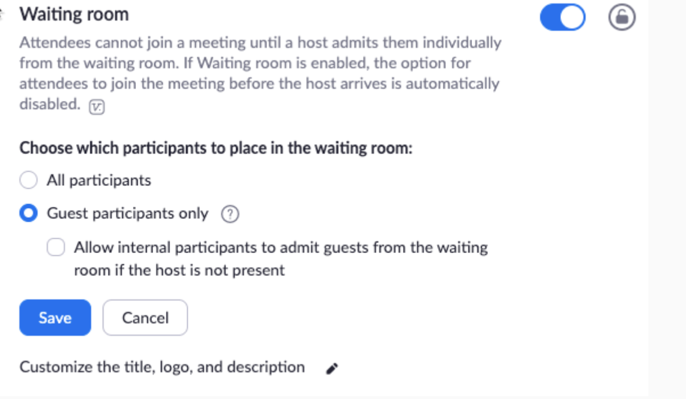

Step 4: Select “all participants” which will allow all participants joining the interview to be admitted to the waiting room.

Enabling Waiting Room for a Specific Group

To enable Waiting Room for all member of a specific group, please follow the below steps:

Step 1: Sign in to the Zoom web portal as an administrator with the privilege to edit groups.

Step 2: In the navigation, click User Management then Group Management.

Step 3: Click the Group Name, then click the Settings tab.

Step 4: On the Meeting tab, navigate to the Waiting Room option under In-Meeting (Advanced) and verify that the setting is enabled.

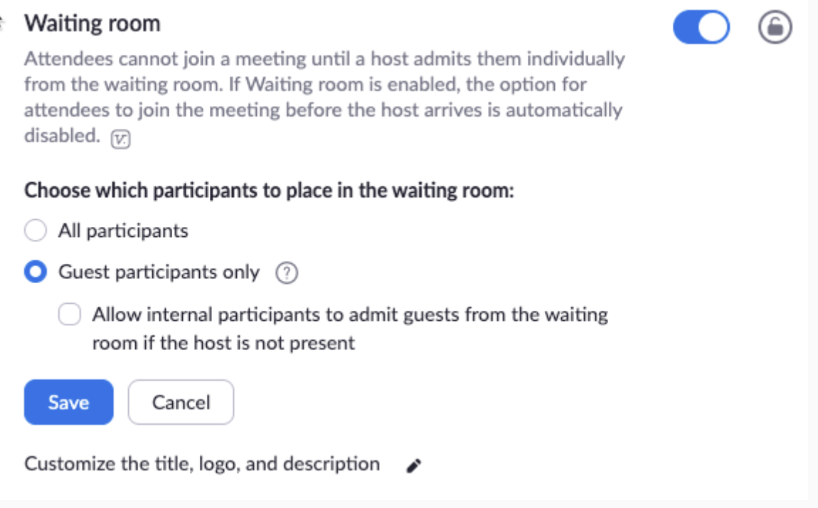

Please note:
- If the setting is disabled, click the Status toggle to enable it. If a verification dialog displays, choose Turn On to verify the change.
- If the option is grayed out, it has been locked at the Account level, and needs to be changed at that level.

Step 5: Select who you want to admit to the waiting room.
- All participants: All participants joining your meeting will be admitted to the waiting room.
- Guest participants only: Only participants who are not on your Zoom account or are not logged in will be admitted to the waiting room. If not logged in, they will have an option to log in.

Please note: If Guest participants only is enabled, you can also enable the option to allow internal participants (users on the account), to admit guests from the waiting room if the host is not in the meeting.

Step 6: If you want to make this setting mandatory for all users in this group, click the lock icon, and then click Lock to confirm the setting.

Customizing the Waiting Room

After enabling the waiting room setting, you can customize the waiting room title, logo, and description at an account, group, or user level.

Step 1: After enabling waiting room, navigate to the Waiting Room option under In Meeting (Advanced).

Step 2: Click the pencil icon below the Waiting Room option.

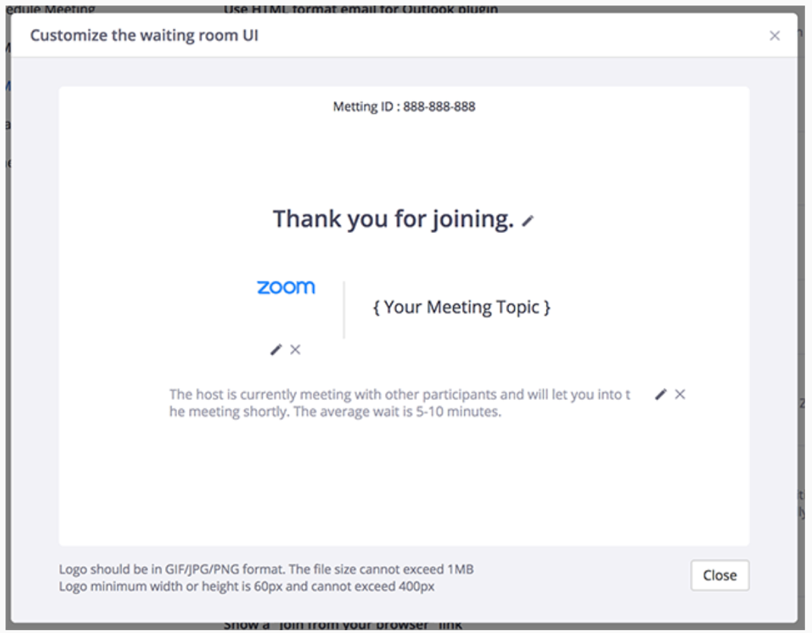
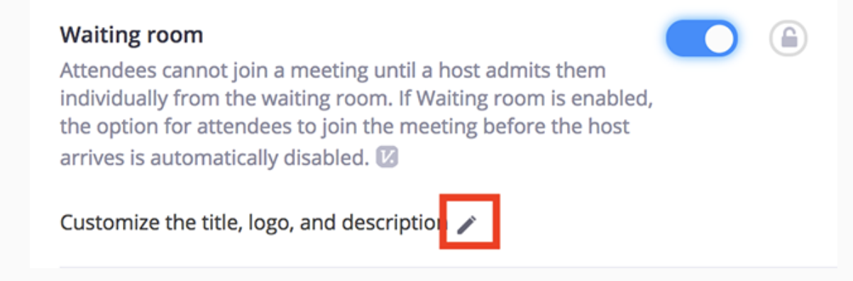Completing step 2 will allow access to the waiting room customization options.

- Title: Click the pencil next to “Please wait, the meeting host will let you in soon” to update the meeting title. Click the check when you are done.
- Logo: To upload a logo, click the pencil icon.
- Description: Click “Add waiting room description” to add a description to the waiting room. Click the check when you are done.

Step 3: Click “Close” when you are done.

Step 4: The Local Officer Candidates will see your custom waiting room branding when they join the meeting.

Below are step-by-step instructions on how to use the Waiting Room feature on zoom with your Local Officer Candidiates. First are instruction on how to use this feature on a Mac computer, and second are how to use this feature on a Windows computer.

Using Waiting Room on A Mac Computer

Enabling or Disabling Waiting Room During a Meeting

Step 1: As the meeting host, you will need to click Manage Participants.

Step 2: Click More and choose Put Attendee in Waiting Room on Entry to enable or disable the feature.

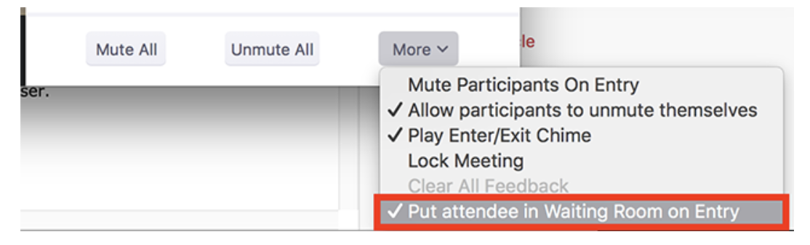

Admitting Participants During a Meeting

Step 1: As the meeting host, click Manage Participants.

Step 2: Click Admit to have the participant join the meeting.

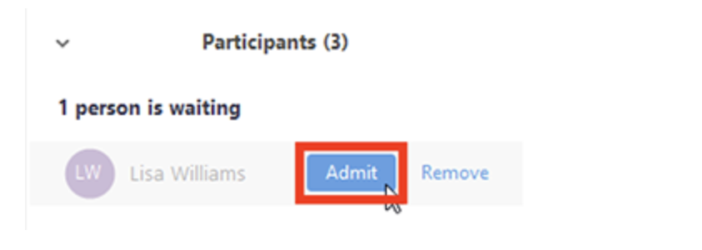

Admit All Participants from the Waiting Room

Step 1: As the meeting host, click Manage Participants.

Step 2: Click Admit all.

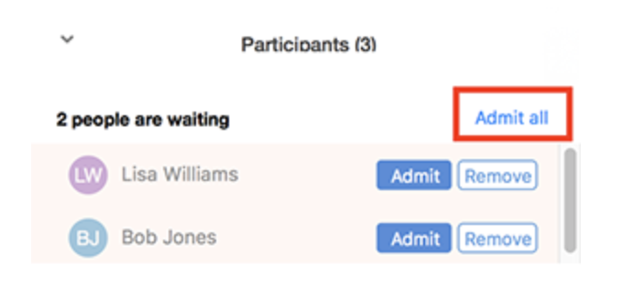

Sending Participants to the Waiting Room During a Meeting

Step 1: As the meeting host, click Manage Participants.

Step 2: Click More next to the participant’s name and choose Put in Waiting Room.

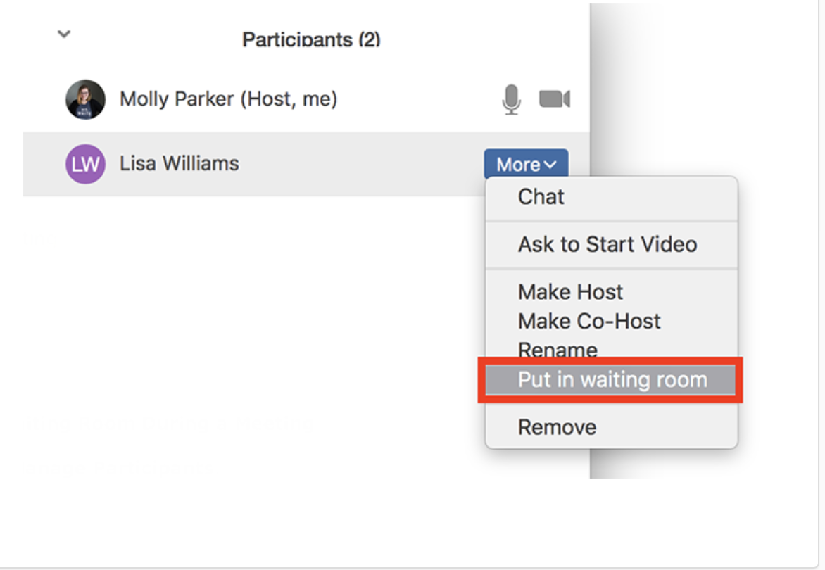

Using Waiting Room on A Windows Computer

Enabling or Disabling Waiting Room During a Meeting

Step 1: As the meeting host, click Manage Participants.

Step 2: Click More at the bottom of the participants’ window and choose “Put Attendee in Waiting Room on Entry” to enable or disable the feature.

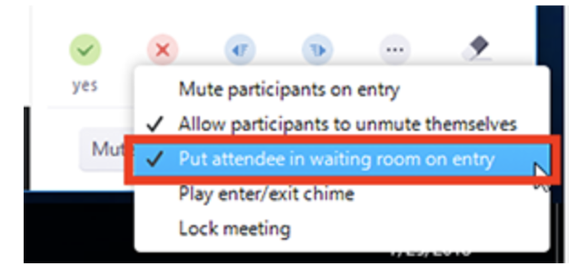

Admitting Participants During A Meeting

Step 1: As the meeting host, click Manage Participants.

Step 2: Click Admit to have the participant join the meeting.
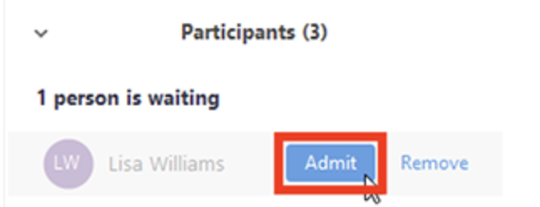

Admit all Participants from the Waiting Room

Step 1: As the meeting host, click Manage Participants.

Step 2: Click Admit all.

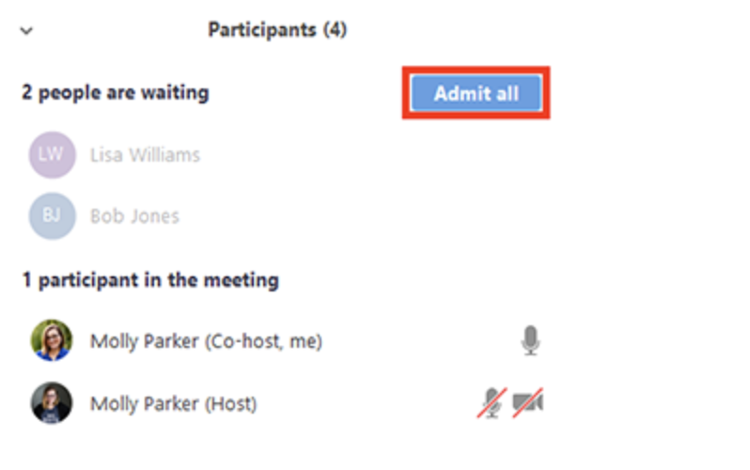

Sending Participants to the Waiting Room During a Meeting

Step 1: As the meeting host, click Manage Participants.

Step 2: Click More next to the participant’s name and choose Put in Waiting Room.

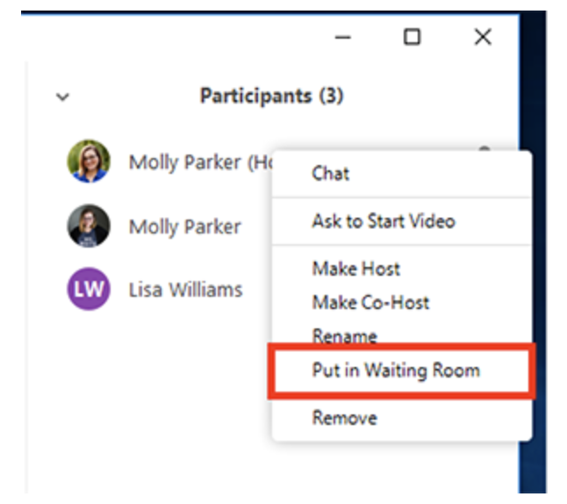

RECORDING LOCAL OFFICER INTERVIEWS

You can record each Local Officer Candidate interviews in the Waiting Room and upload the recordings to Dropbox, Google Drive, or YouTube.

Enabling Local Recording: For all members of your organization

Step 1: Sign in to the Zoom web portal as an administrator with the privilege to edit account settings.

Step 2: Click Account Settings.

Step 3: In the Recording tab, navigate to the Local Recording option and verify that the setting is enabled. If the setting is disabled, click the toggle to enable it. If a verification dialog displays, choose Turn On to verify the change.

Step 4: If you want to make this setting mandatory for all users in your account, click the lock icon, and then click Lock to confirm the setting.

Enable Local Recording: For a group

Step 1: Sign in to the Zoom web portal as an administrator with the privilege to edit user groups.

Step 2: Click Group Management.

Step 3: Click the name of the group, then click the Settings tab.

Step 4: In the Recording tab, navigate to the Local Recording option on the Recording tab and verify that the setting is enabled.

If the setting is disabled, click the toggle to enable it. If a verification dialog displays, choose Turn On to verify the change.

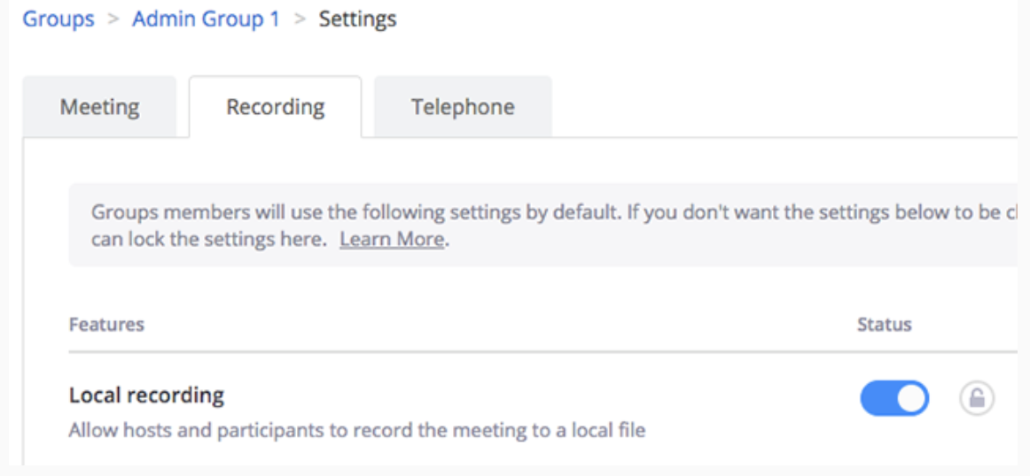

Please note: If the option is grayed out, it has been locked at the account level, and needs to be changed at that level.

Step 5: If you want to make this setting mandatory for all users in this group, click the lock icon, and then click Lock to confirm the setting.

Enabling Local Recording: For Your Own Use

Step 1: Sign in to the Zoom web portal and click My Meeting Settings (if you are an account administrator) or Meeting Settings (if you are an account member).

Step 2: In the Recording tab, navigate to the Local Recording option and verify that the setting is enable.

If the setting is disabled, click the toggle to enable it. If a verification dialog display, choose Turn On to verify the change.

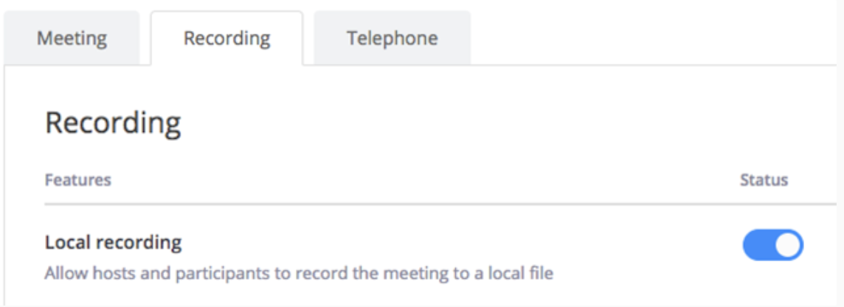

Please note: If the option is grayed out, it has been locked at either the group or account level, and you will need to contact your Zoom administrator.

Starting a Local Recording

The host must record the meeting or grant the ability to record to a participant.

Step 1: Start a Zoom meeting as the host.

Step 2: Click the option to Record.

Step 3: If there is a menu, select Record on this Computer.

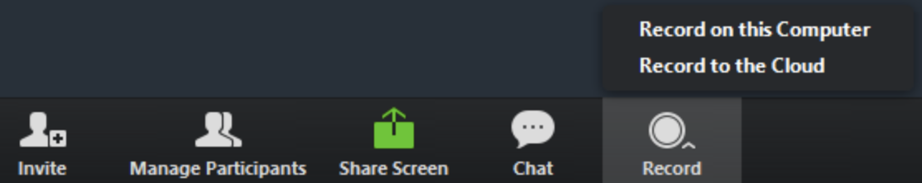

Hosts will see the following recording indicator in the top-left corner while recording is active.

Participants will see the following indicator in the top-left corner while the recording is active.

Step 4: Click Participants to see which users are currently recording.

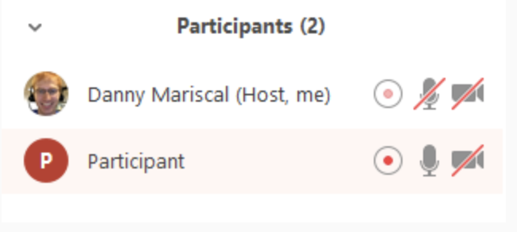

Step 5: After the meeting has ended, Zoom will convert the recording so you can access the files.

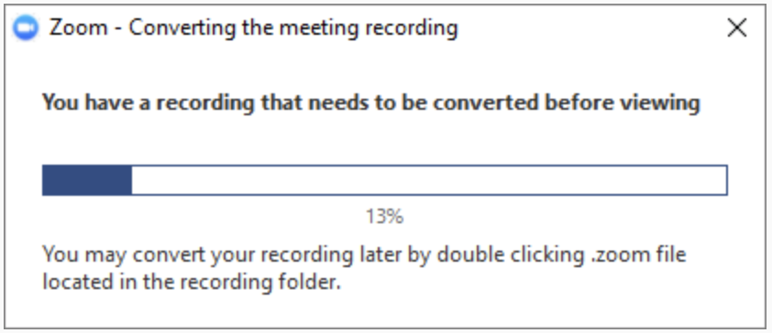

Step 6: Once the conversion process is complete, the folder containing the recording files will open.

Please note: By default, the audio/video file (MP4) will be named Zoom_0.mp4. The audio only file (M4A) is named audio_only.m4a.

Stopping or Pausing a Local Recording

During a Zoom recording, a user can Stop or Pause the recording. If a user stops the recording and starts it again, a new video file will be created for the next recording segment. If a user pauses the recording and starts it again, Zoom will record to the same video file for the recording segment.

Step 1: After a recording has been started, click Pause or Stop Recording at the bottom.

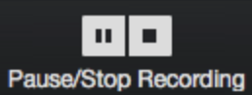

The recording can also be stopped or paused by clicking the indicator in the top left corner.

Step 2: When a recording is paused, the following indicator will be displayed in the meeting.

Step 3: To resume the recording, click Resume Recording at the bottom.
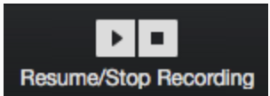

The recording can also be resumed by clicking the indicator in the top left corner.

Assigning Record Privileges to a Participant

Step 1: In a Zoom Meeting click on Manage Participants.

Step 2: In the Participants menu navigate to the user who will be granted recording privileges.

Click More next to their name.

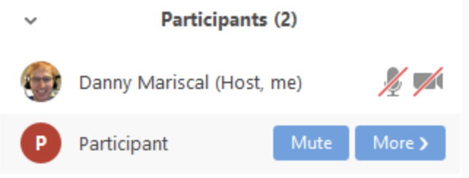

Step 3: Select the option to Allow Record.

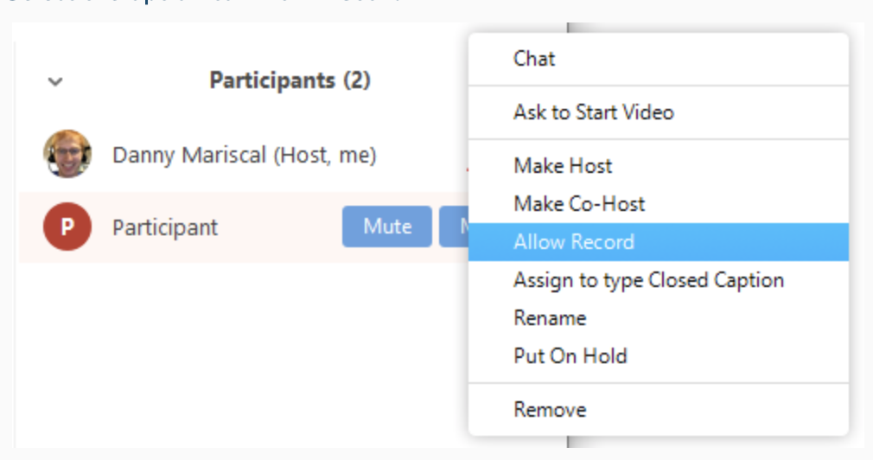

The participant will receive the following notification:
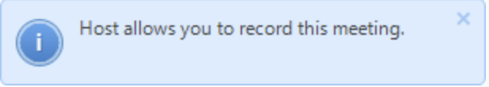

Step 4: When a participant is recording, the participant menu will display a recording icon next to the user’s name.

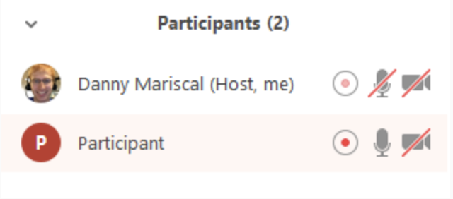

Step 5: To disable the participant’s ability to record, click More next to the name, then click Forbid Record.

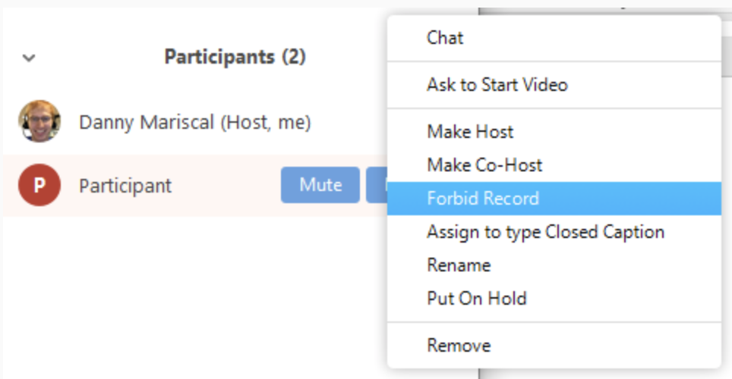

The participant will receive the following notification.
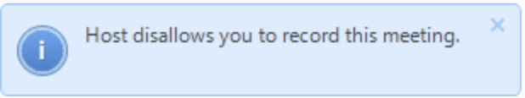

Accessing Local Recording Files

By default, all recordings will be placed in a Zoom folder found in the following file path on these devices:

- PC: C:\Users\User Name\Documents\Zoom
- Mac: /Users/User Name/Documents/Zoom

To access recording files:

Step 1: Open the Zoom desktop client and click Meetings.

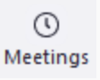

Step 2: Click the Recorded tab and select the meeting with a local recording.

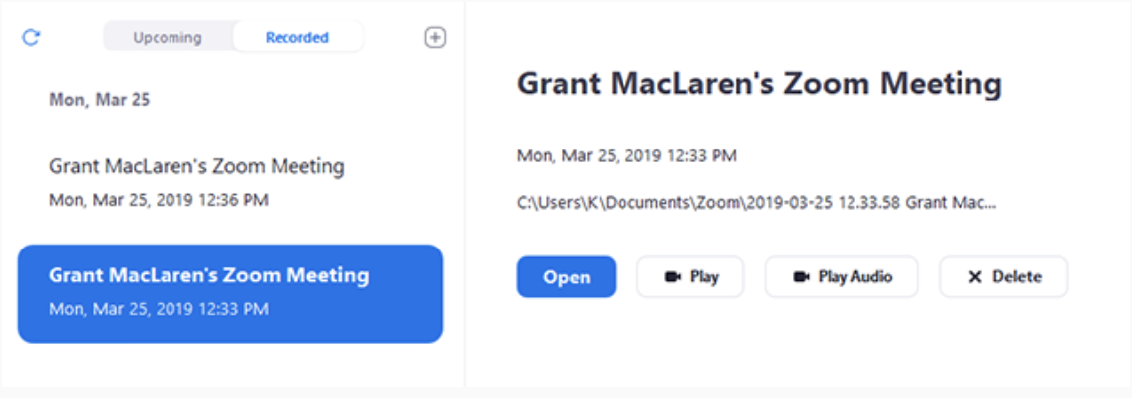

Step 3: You can access these options to manage your local recordings:

- Open: Open the folder that contains the recording files.
- Play Video: Play the recorded meeting using your computer’s default media player.
- Play Audio: Play the recorded meeting audio with your computer’s default media player.
- Delete: Remove the meeting from the recording list on the Zoom client. This does not delete it from the computer.
- Refresh icon : Refresh the recording list if you don’t see your recording.

Recording Multiple Audio Files

When recording locally, the host can record all participants’ audio streams as separate audio files, one file for each participant. To enable this option:

Step 1: Open the Zoom client and click Settings.

Step 2: Click the Recording tab.

Step 3: Enable Record a separate audio file for each participant.

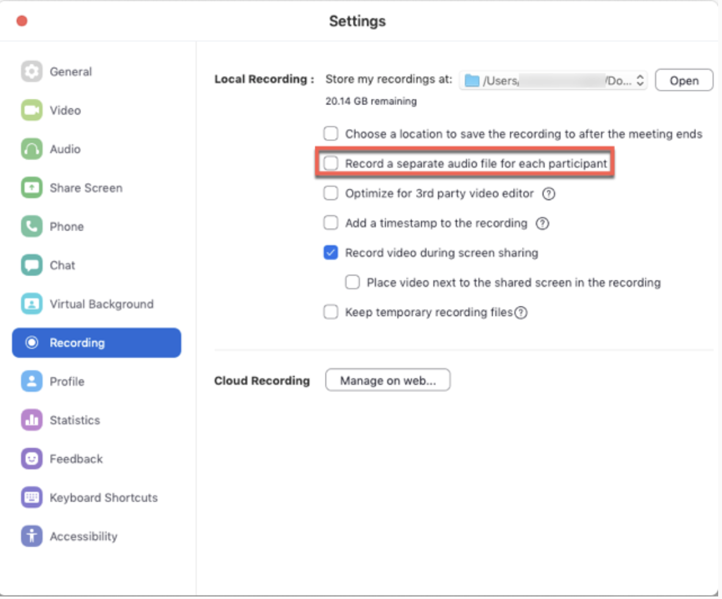

Step 4: Record and save the meeting to your computer.

Step 5: Once the meeting is over and the recording has processed, open the recording folder.

Step 6: Within the folder, open Audio Record.

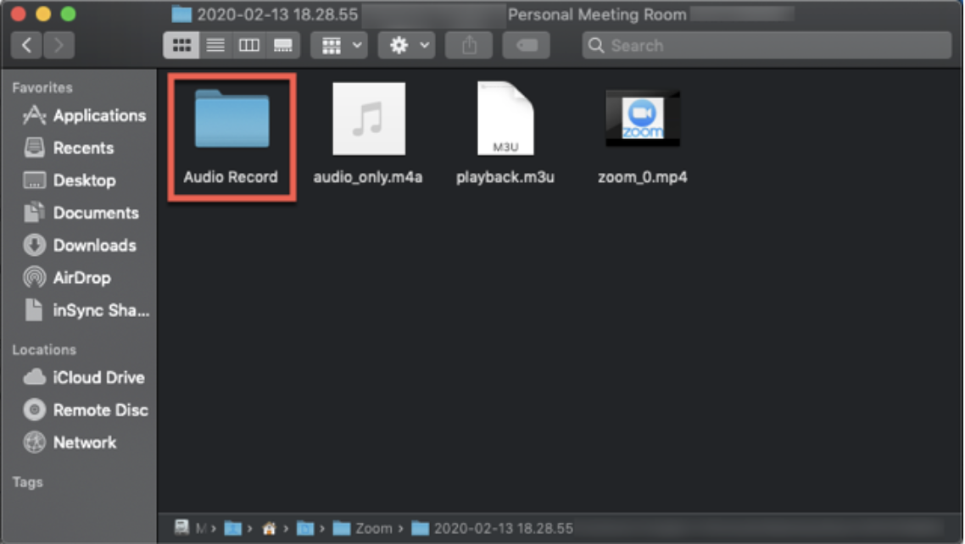

Step 7: Once in the Audio Record folder, each participant’s audio track will be listed as its own file in with the file name ending in the participant’s name.
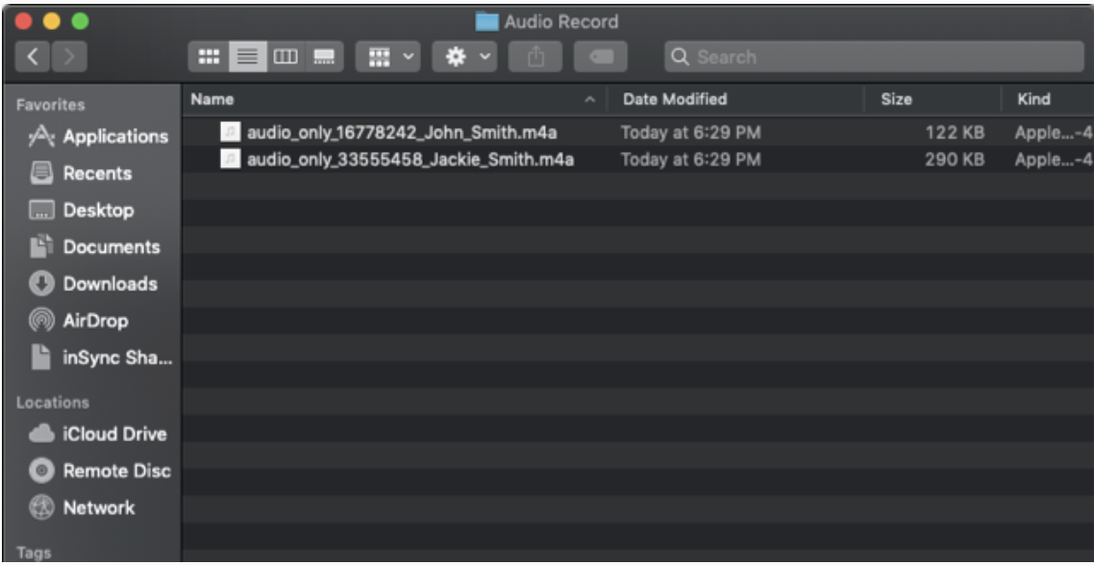

UNLISTED YOUTUBE VIDEO

If you would like to share the Local Officer Candidate’s interview, you can upload the zoom recording as an unlisted YouTube video.

How to Create an Unlisted YouTube Video

Step 1: Go to your YouTube channel and add a video
- Begin by making sure you are logged in to your YouTube channel.
- Once you’re on your YouTube homepage, click the add video button in the upper-right corner (It looks like a little video camera.)
- From the drop-down button that appears, choose “Upload video.”

Step 2: Choose “unlisted” in your YouTube video setting
- You will need to go to YouTube’s privacy settings
- You will need to click on the word “Public,” then, on the drop-down menu that appears, choose the word “Unlisted.”

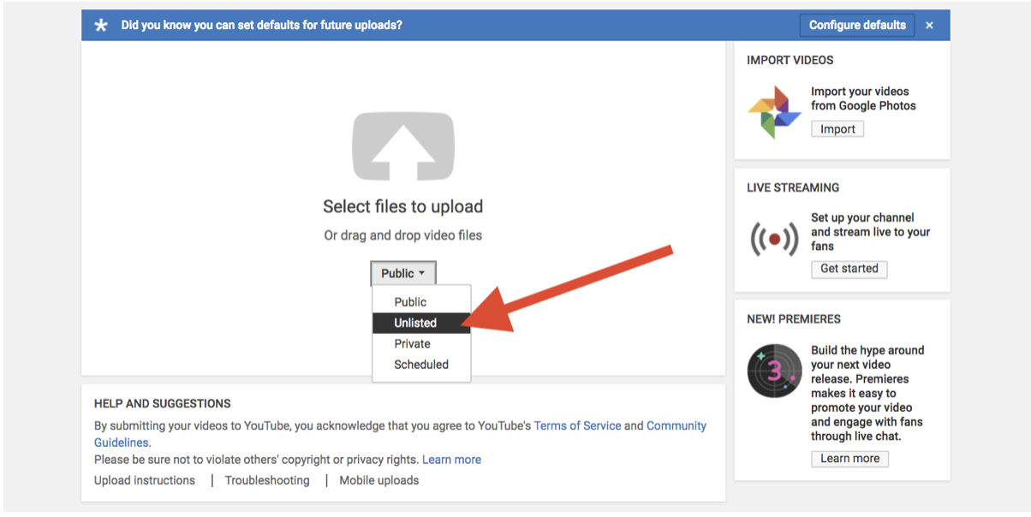

Step 3: Upload your YouTube video
- Upload your video where the screen says, “Select files to upload.”
- If you missed step two, and uploaded your video first, you can still ensure your video is unlisted before publishing.
- Once you begin uploading your video, you’ll see a screen that looks like the image shown here.
- On the right side, you’ll find a menu that starts with the word “Public.”

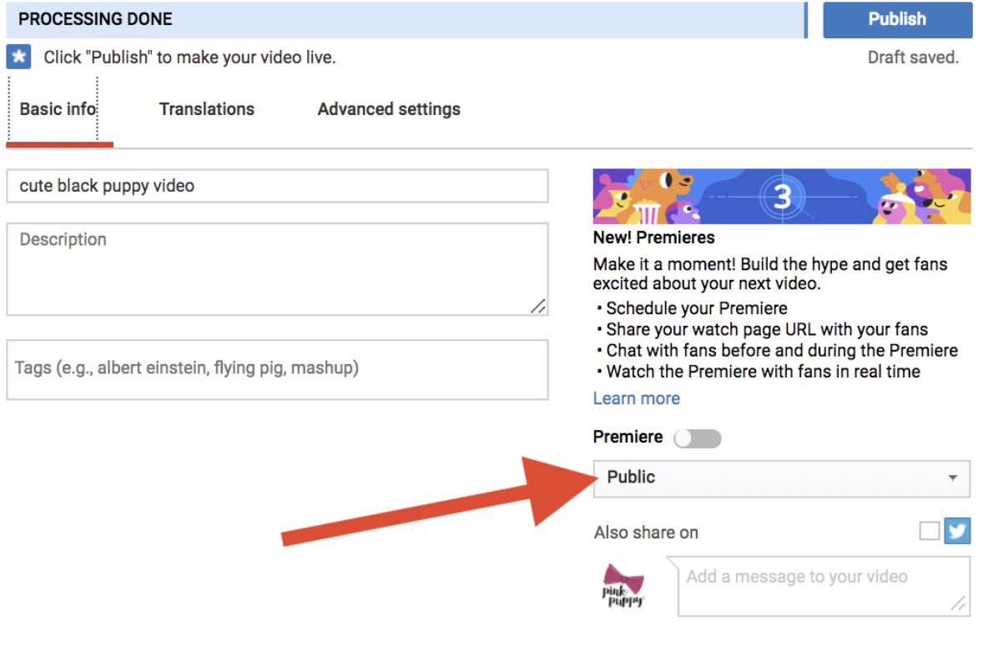

After clicking on the word “Public,” choose “unlisted” in the drop-down menu that appears.

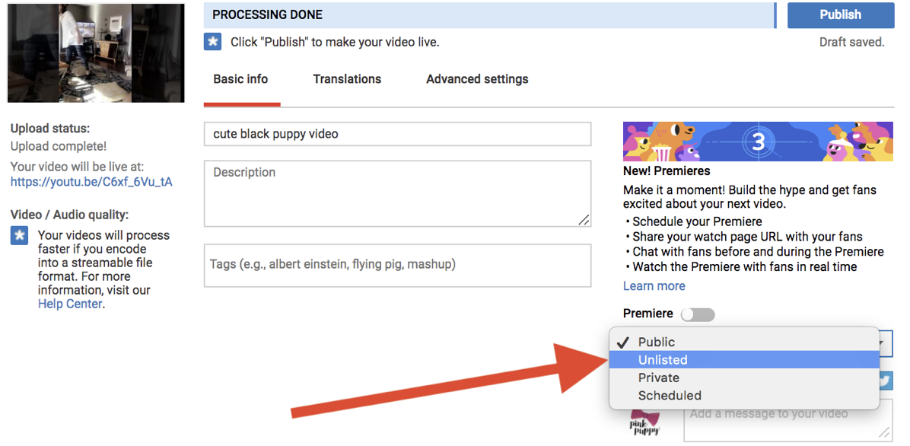

Step 4: Publish your video to YouTube
- Once you ensure that the drop-down menu says “Unlisted,” please click the “Done” button in the upper-right corner of the video.

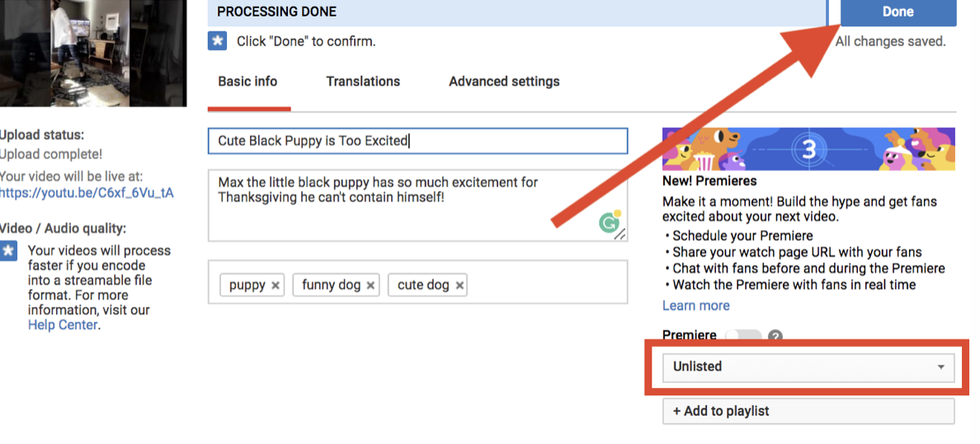

Step 5: Share your video’s link
- As soon as you’ve published your video, a page that looks like this will appear.
- Simply copy the URL provided and share it with anyone you’d like to see your video.

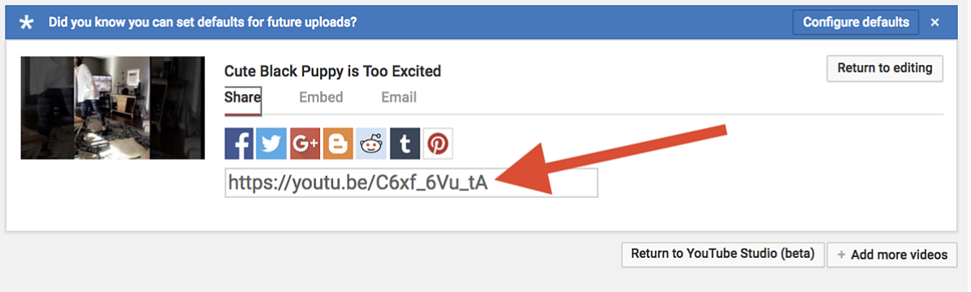

How to Share a Video That’s Unlisted on YouTube

To share the recording with an interview committee, please follow the below steps.

Step 1: Go to YouTube Studio and view all of your videos.
- Begin by viewing all of your videos. You’ll find the video manager in your YouTube Studio.

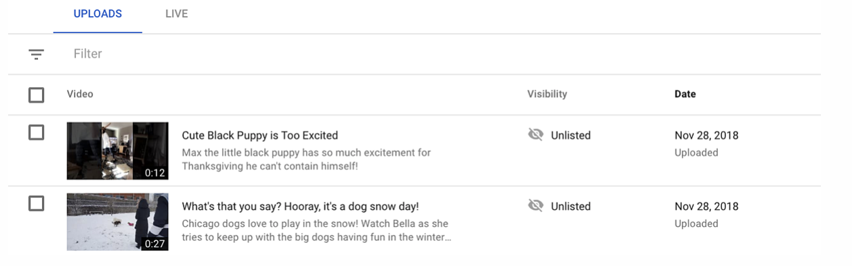

Step 2: View the unlisted video on YouTube
- Click on the row of the video you plan to share. Then, hover your mouse near the video’s title.
- You will see a small YouTube icon appear. When you hover over that icon, the words “View on YouTube” will appear.

Click on this icon:

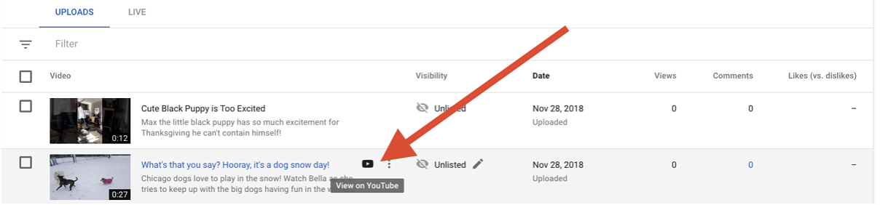

Step 3: Click on the share button

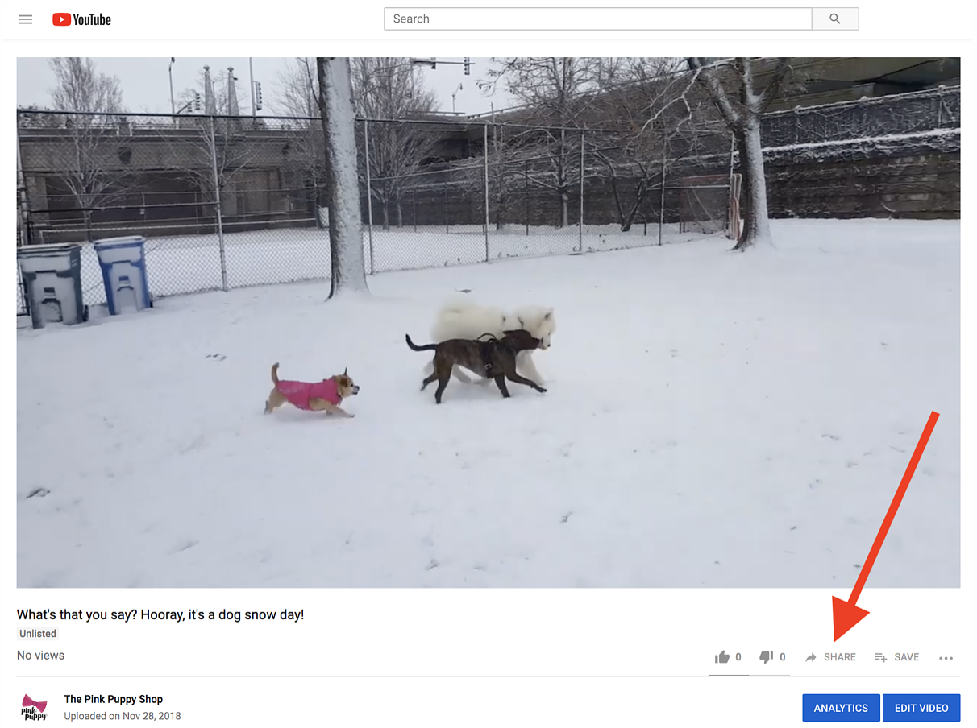

Step 4: Once you click the button, you’ll find all the options you need:
- Link sharing: To text or email your video, copy the link the arrow is pointing to.
- Embedding: To embed your video, click on the first button pictured under “Share a link.” There you’ll find the video code you need.
- Social media shares: Use any of the buttons pictured to share on Facebook, Twitter, or other platforms.

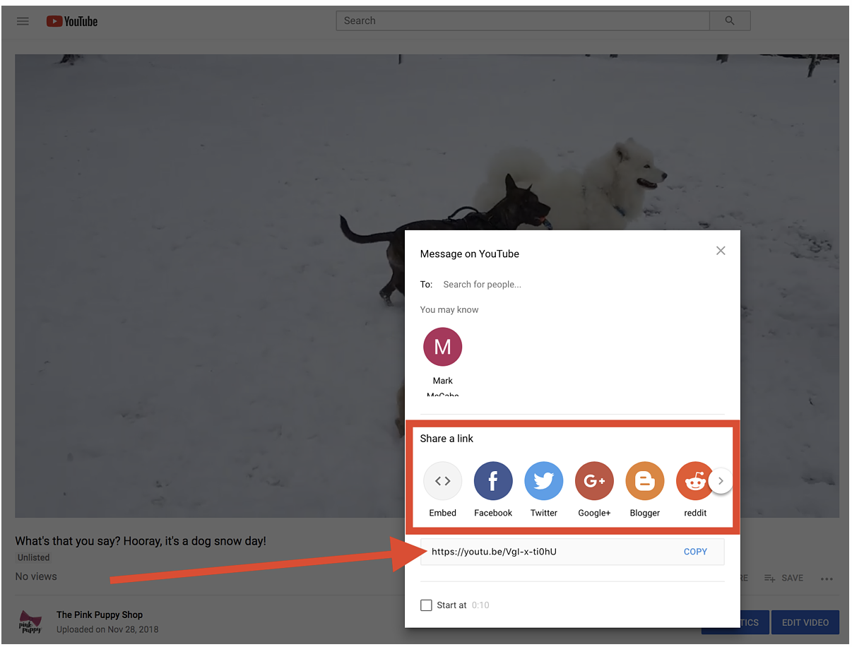
How To See Your Unlisted Videos On YouTube

Unlisted videos don’t appear on your YouTube channel, so they can be difficult to find. However, you can see your unlisted videos without committing a lengthy URL to memory.

Step 1: Go to your YouTube Studio
- Click on your channel icon in the upper-right corner of your screen.
- On the drop-down menu that appears, choose “YouTube Studio.”

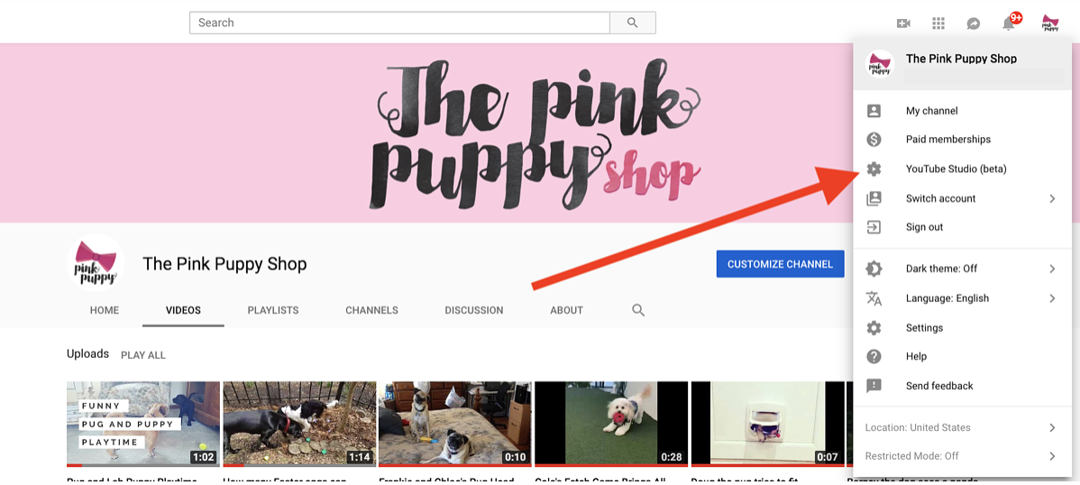

Step 2: Select “Videos” on your YouTube dashboard
- Using the menu on the left side of the screen, choose the option that says “Videos.”

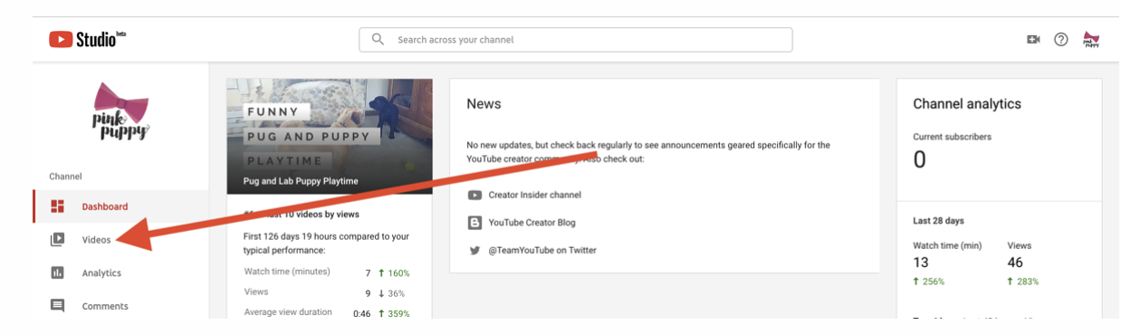

- The page that appears is your YouTube video manager; here, you can see all videos you have uploaded to YouTube.
- Use the “Visibility” column to see which videos you have set to public, private, or unlisted.

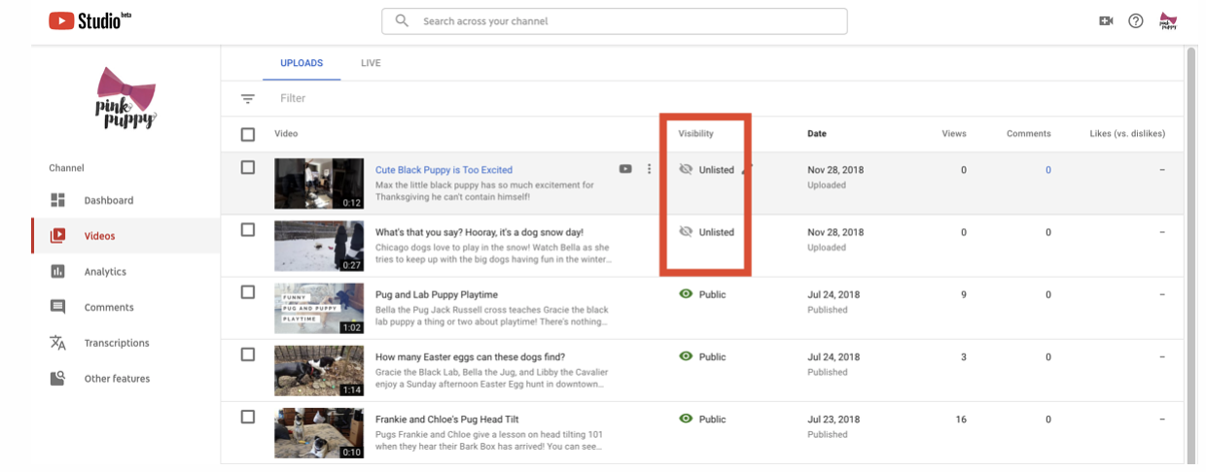

Voting Delegate Process Using Election Runner

You can create an online election process for your voting delegates by using Election Runner.

How to Launch an Election

All elections created on Election Runner will start in the “Building” Local and will not start until the election administrator launches the election by going through the launch process. The launch process consists of 4 steps:

Step 1: Confirm Election Details
Step 2: Check Election Ballot
Step 3: Terms of Service
Step 4: Election Checkout

To start the election launch process, click on “Launch” on the election sidebar. Elections can only be launched if they’re in the “Building” Local.

Confirm Election Details
The first step of the launch process is used to verify that the election’s details (title, dates, time zone, settings, etc.) are correct. Reference the permissions matrix to see which settings can be modified once the election can be launched.

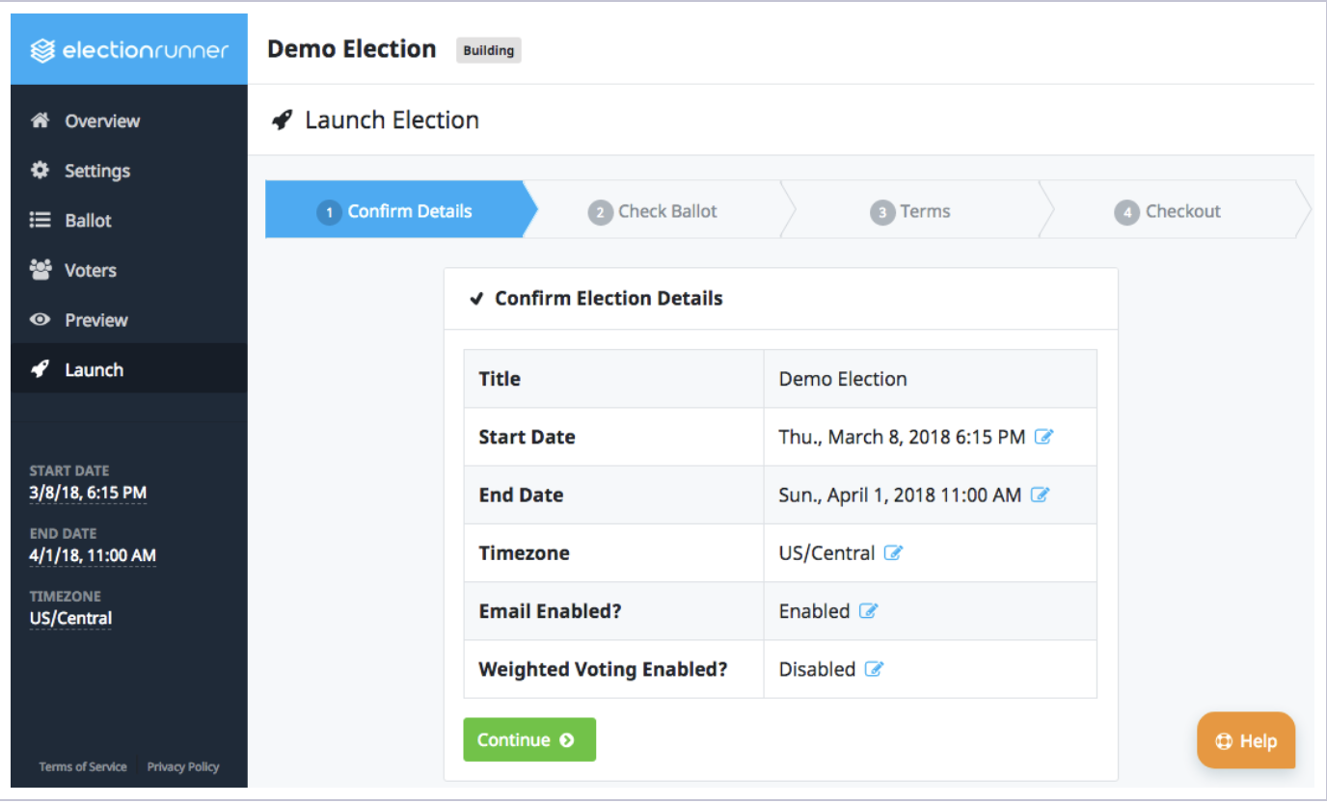

Launch Requirements

Elections must meet the following requirements before they can move to step 2 of the launch process.

- The ballot must have at least one question with at least one option.
- The election must have at least 1 voter.
- The election’s end date must be in the future.
- An account fewer than 5 free elections in the “Running” Local

Click “Continue” after verifying the election’s details and the launch requirements have been met.

Check Election Ballot

Assuming the launch requirements have been met, the next step is the launch process requires that the election administrator confirms that the ballot is set up correctly. This step is crucial because the ballot of an election cannot be modified once the election has been launched. This is to protect the integrity of the election and no exceptions will be made.

After verifying the ballot details, check the “I understand…” checkbox (1) and click “Continue” (2).
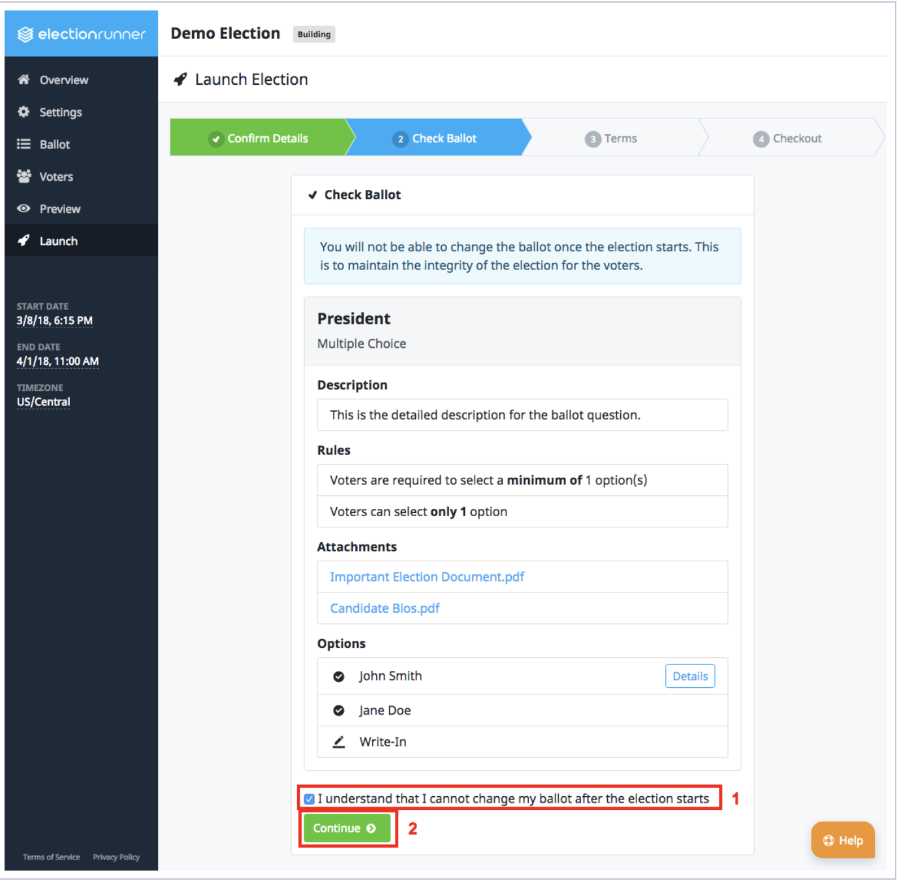

Terms of Service

The third step of the launch process requires that the election administrator agrees to Election Runner’s Terms of Service, Private Policy, and that it understood which changes can and cannot be made to a running election.

To continue to the final step of the launch process, check the “I understand…” checkbox (1) and click “Continue” (2).

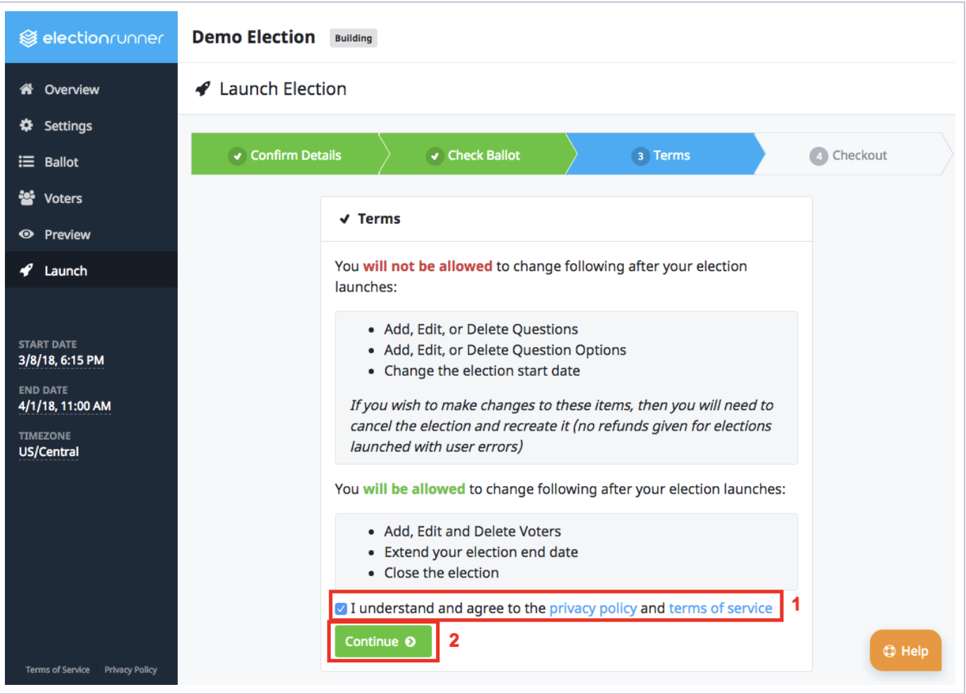

Election Checkout

The final step of the launch process is the checkout. This is where the election administrator will provide payment information based on Election Runner’s Pricing.

Pay-Per-Election Election Checkout

For those subscribed to the pay-per-election plan, the election checkout will display the total price of the election and a “Pay by Credit Card” button. Click this button to open a modal with a secure credit card form.

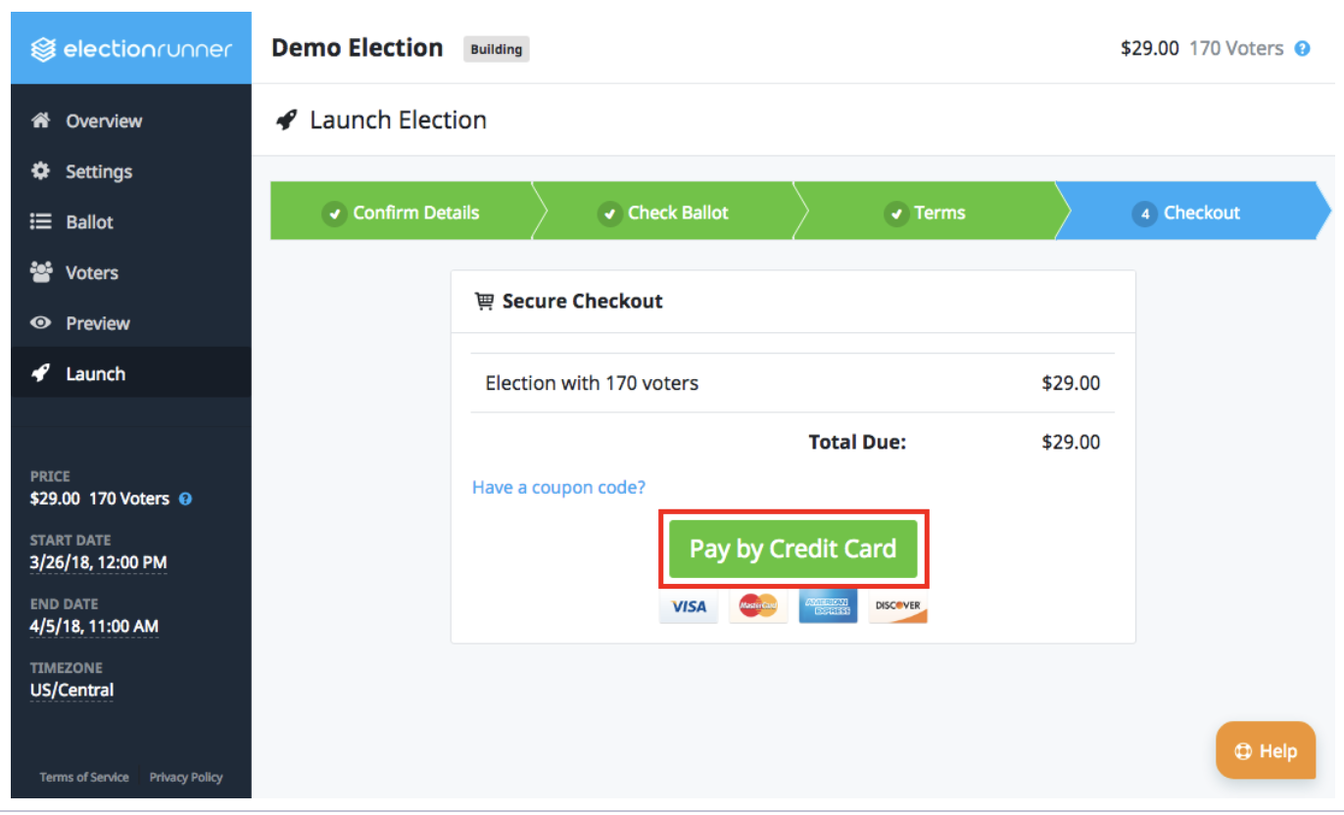

Step 1: When the credit card form appears, enter the credit card number.
Step 2: Enter the card’s expiration date.
Step 3: Enter the card’s CVC.
Step 4: Click the “Pay $XX.XX” button to process the payment.

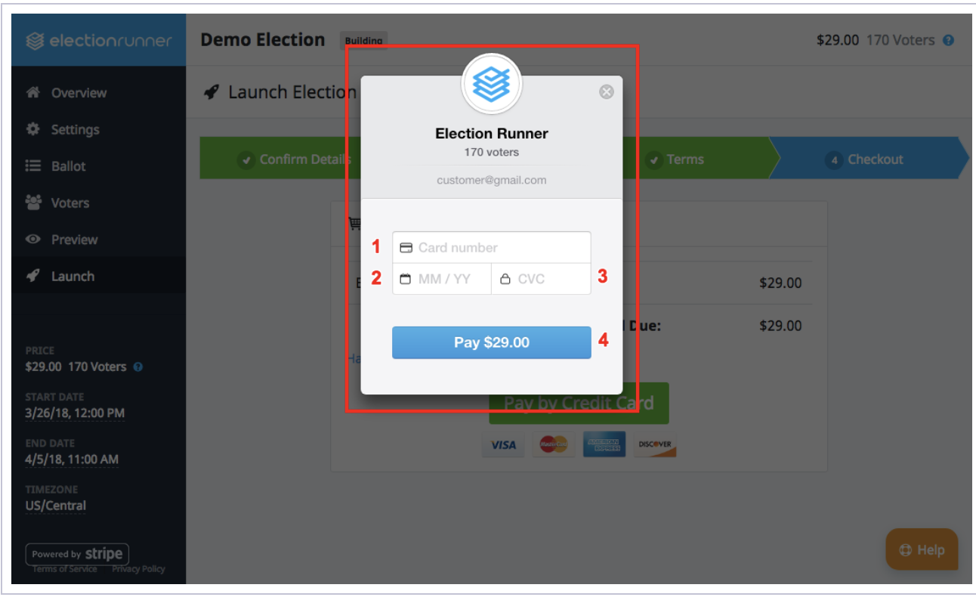

If the payment succeeds, the election will change from the “Building” Local to the “Scheduled” Local.
Subscription Election Checkout

For those with a subscription, the election checkout will consist of a “Launch Election” button that when clicked will result in the election changing from the “Building” Local to the “Scheduled” Local.

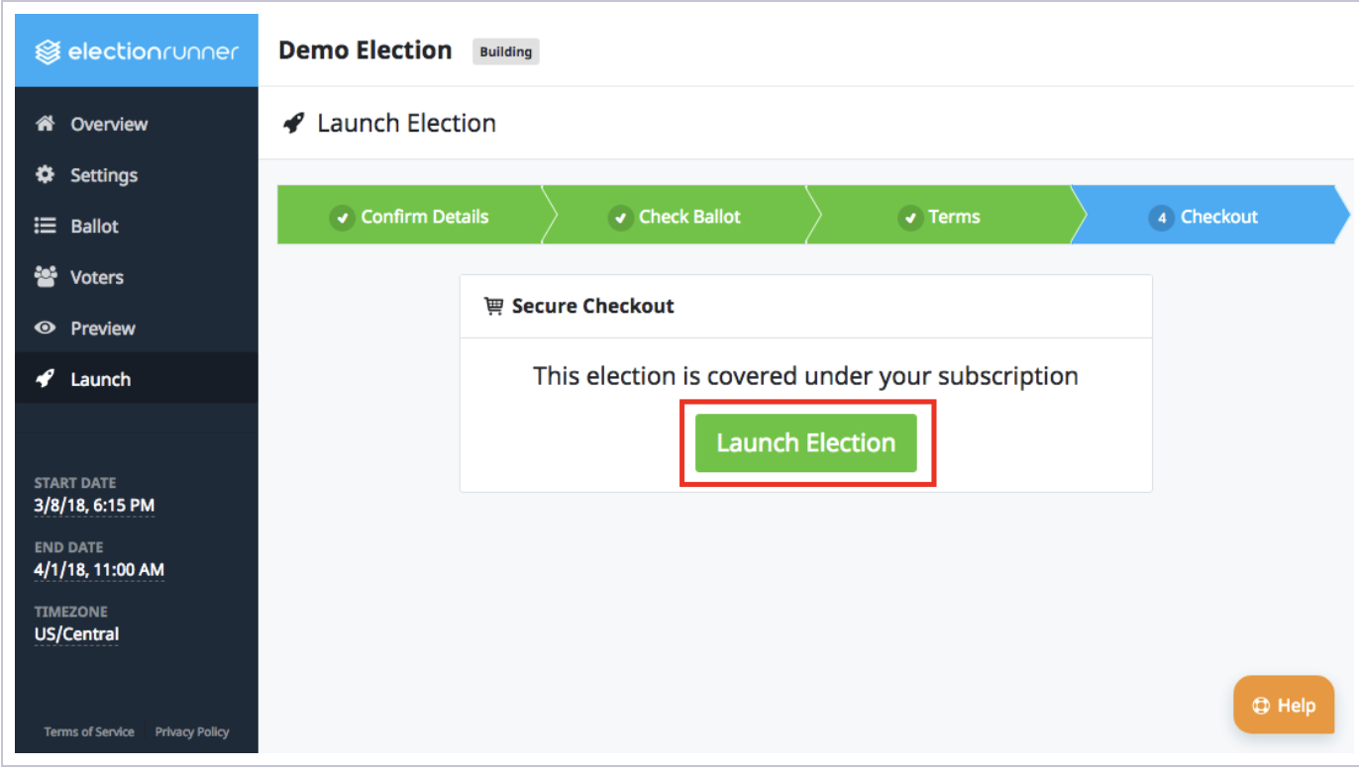
Please note:
- Elections that have a start date in the past will start within 2 minutes of completing the launch process.
- Elections will automatically start on the start date/time in the time zone specified in the election settings.
- There are no refunds given for mistakes that require creating a new election.

Adding Voters to Your Election

How Voter IDs/Keys Work

When you add a voter, you have the option of specifying a Voter ID and Voter Key. These two fields can be thought of as a unique username and password that is assigned to each voter to login using this ID/Key before they can see the ballot and submit their vote.

Voter Email Addresses

Adding an email address for a voter provides them with an alternative way of accessing/voting in your election. If you specify an email address for your voters, they will be notified via email when your election starts. The email will provide instructions on how to vote and a direct link to the voting page where they can enter their “Voter Key” and login to vote.

Importing Voters

If you have a lot of voters, then you may find it easier to bulk import them into your election.

The quickest and easiest way to get started with the voter import process is to download the voter import template by clicking here:
https://electionrunner.com/support/kb/voters/how-to-import-your-voters/

This template file is in the CSV format which can be opened by all popular spreadsheet applications (Excel, Numbers, Google Spreadsheet). Starting from or using the template file is not required, but Election Runner will only accept valid CSV files with the first row containing the following columns:
- Name
- voter_identifier
- voter_key
- email
- vote_weight
If the first row does not have the above listed columns in the exact order and spelling, then the import will fail.

Column Info/Fields

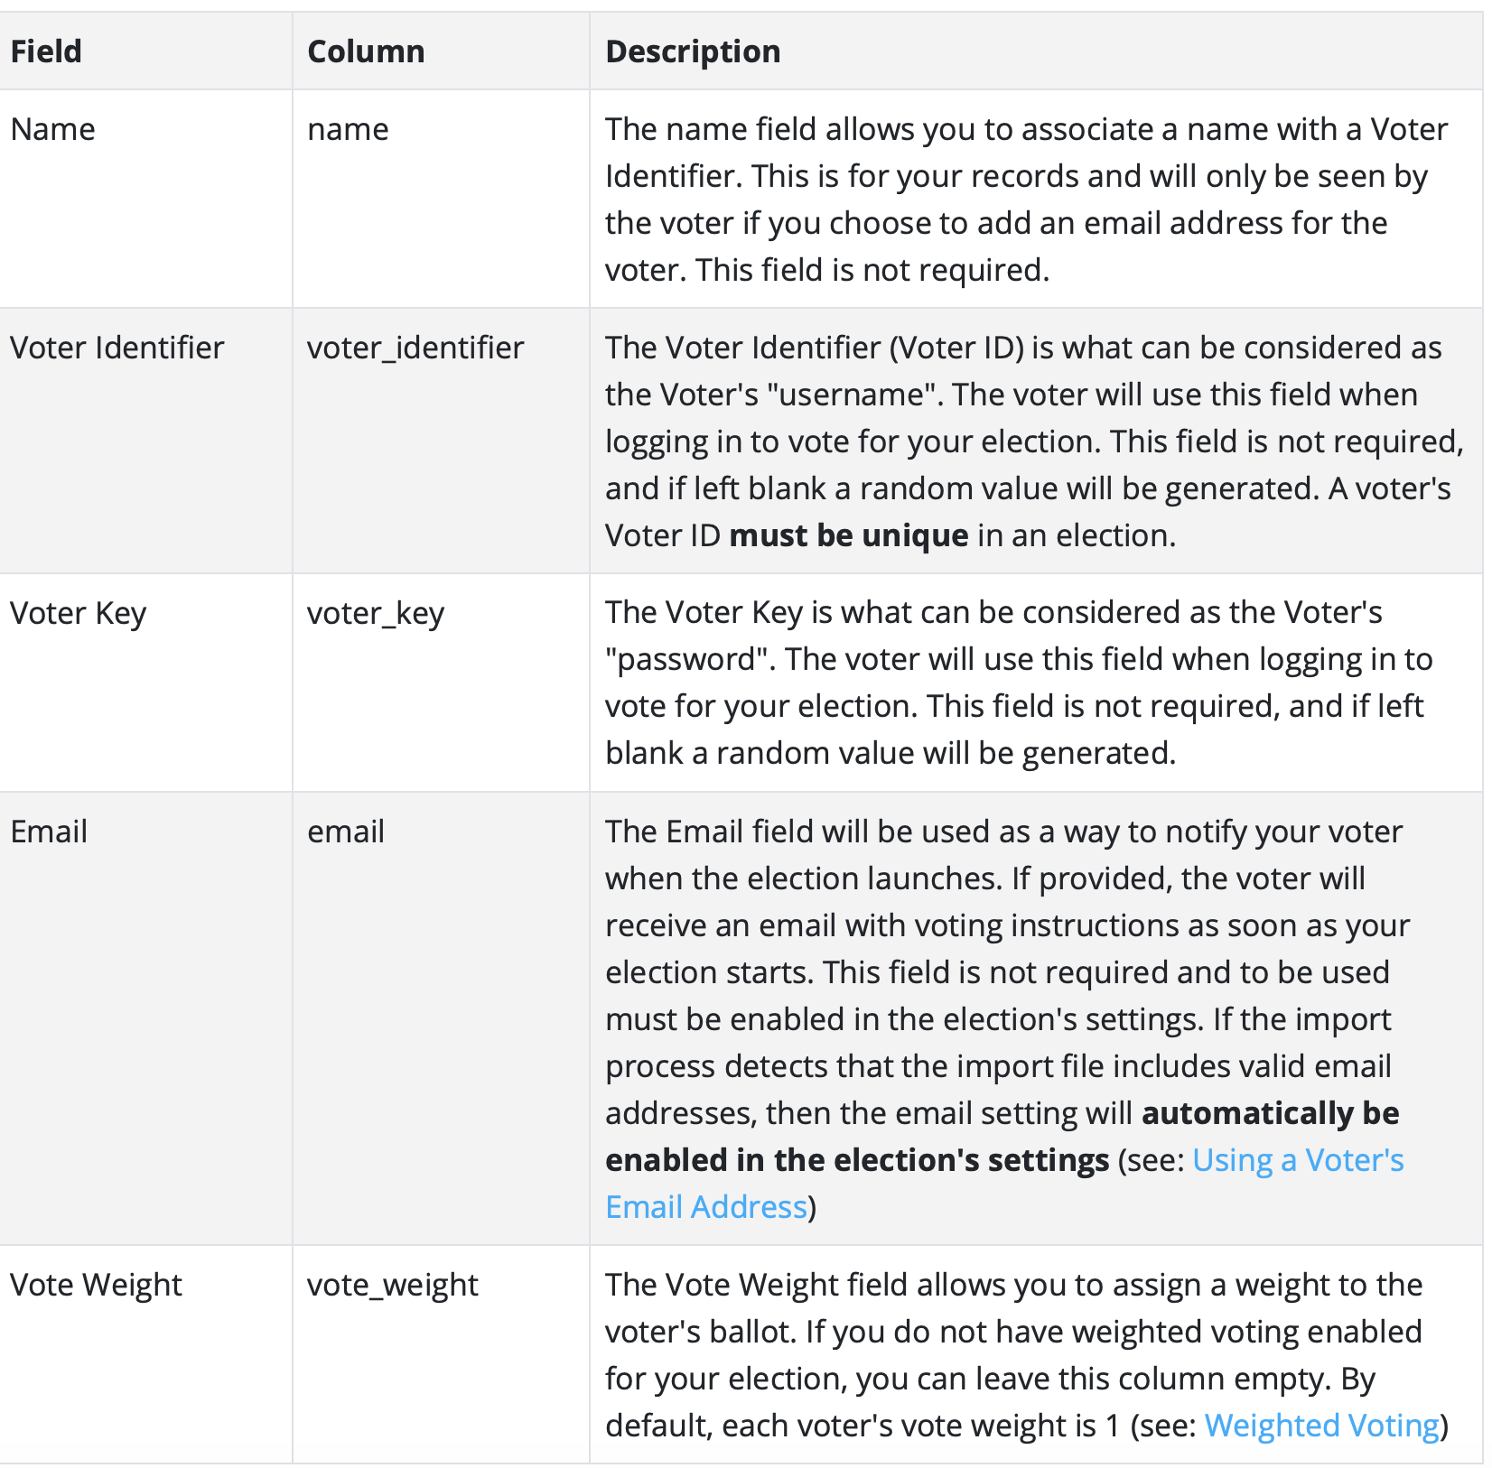

How to Import

To import a list of voters on a correctly formatted CSV file to an election, follow the steps below:

Step 1: Click on “Voters” on the election sidebar.
Step 2: Click on the “Import” button

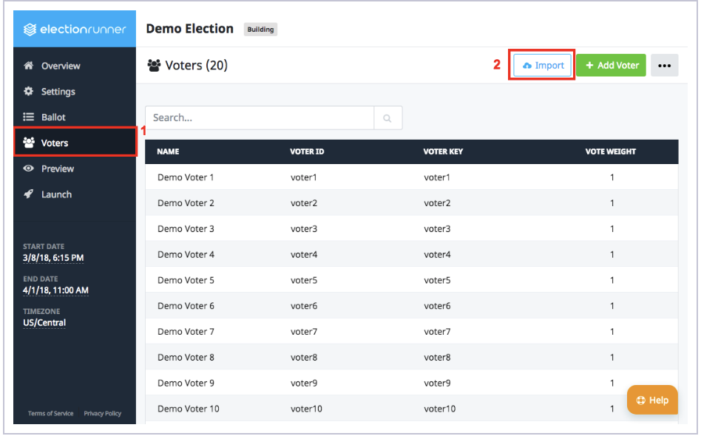

Step 3: The “Import Voters” modal will open and provide instructions for importing a spreadsheet.
Step 4: Click “Choose File” and select the import file from the device.

The import process will display any errors with the import file.

Please note:
- Importing a list of voters will append the list to the existing list of voters in the election. For example, importing the same list of voters twice will result in each voter being duplicated.
- The import file must be a valid CSV file.
- The default import limit is 15,000 voters. If your election has more than 15,000 eligible voters, please contact support.
- If the import process detects that the import file includes valid email addresses, then the email setting will automatically be enabled in the election’s setting.

How to Export Voters from an Election

You can easily export a list of your voters as a CSV file that can be opened in Microsoft Excel or Google Spreadsheets. You can export your list of voters at any point before, during or after your election. Here’s how you do it:

Step 1: Click on “Voters” on the election sidebar.
Step 2: Click on the “…” button at the top right of the Voters page to open a dropdown menu.
Step 3: Select “Export Voters” from the dropdown menu. A CSV file will be downloaded to your device that can be opened in the Microsoft Excel or Google Spreadsheets.

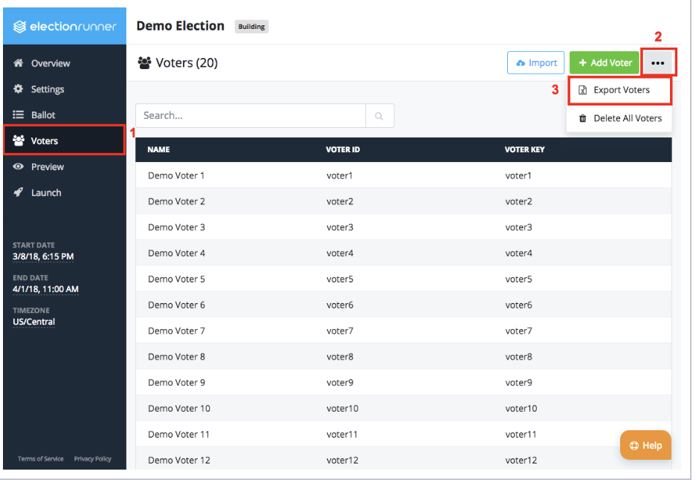

Voters Export File Columns

The voters export file will have the following columns:
- Voted?
- Name
- Email Address
- Voter ID
- Voter Key
- Vote Weight
- Voting URL – A unique URL that when visited automatically logs in the voter

Election Results

Election administrators can see results of an election as soon as voters start to vote. Results are available during the election stages: Running, Completed, and Archived.

During the election, results are randomly updated every one to five minutes. This is done to prevent a scenario where the election administrator sees that Voter A has voted and then sees that Candidate C’s vote count increased by 1.

At the conclusion of the election, administrators have the option to:
- Download the election’s results as a spreadsheet
- Download a voter-audit report
- View the fraud analysis report
- Publish/share the election results.

The results of your election will be available on your Election Runner account until you delete the election.

Please see the links below for more information and to watch video tutorials:

Waiting Room: https://support.zoom.us/hc/en-us/articles/115000332726-Waiting-Room

Local Recording: https://support.zoom.us/hc/en-us/articles/201362473-Local-Recording

YouTube Privacy Setting: https://learn.g2.com/what-does-unlisted-mean-on-youtube

Election Runner Support Center: https://electionrunner.com/support/kb/election/how-to-launch-an-election/

