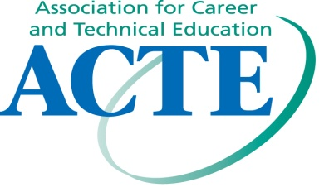
Postsecondary, Adult & Career Education Division
Policy Committee & Business Meeting
Date: Wednesday, November 16, 2011
Location: America’s Center, Room 121
Time: 2:30 PM – 4:00 PM

Minutes:
VP of PACE Division, Harry Snyder, called the meeting to order at 2:30 PM.

Attendance: Steve McCaskey (Indiana), Gerry Andrews (Alaska), Cathy Thomas (Penn), Michael Wood (Penn), Gay Simpson (Oklahoma), Molly Kyler (Oklahoma), Candice Beasley (Oklahoma), Tom Harris (Ohio), Bob Perry (Oklahoma), & Harry Snyder (Ohio)

Committee Reports:
  - Membership: Cathy Thomas; discussion on our present membership size of 970 as of October 2011 down from 986 as of June 30, 2011. Concern on maintaining present levels due to tight budgets and retirements.
  - New Ideas: Connie Cunningham; committee did not meet, no report
  - Professional Development: Candice Beasley; committee did not meet, no report
  - Bylaws: Stephen McCaskey; committee met and the only bylaw change was lowering membership for Division representation from 1000 to 750. The Bylaws committee recommended approval of the bylaw change. (note: Board of Delegates did approve the bylaw change on Friday, November 18, 2011)
  - Resolutions: Carol Farabee; committee did not meet, no report
  - Nominating: Tom Harris; committee met and approved the candidates submitted. Reminder that the PACE Division had their election last year. Andrea Pogue is the VP-Elect and will begin her term July 1, 2012.
  - Legislative: Andrea Pogue; committee did not meet, no report

Old Business:
- Membership (2nd year of probation): if membership fails to reach 1000 member at the close of fiscal year, ending June 30, 2012, the PACE Division will lose a seat on the ACTE Board.

New Business:
- Harry reviewed the ACTE Preferred Future document that highlighted the four areas:
  - Builds networks for strengthening public/private partnerships to create a skilled workforce and identify new and emerging occupations (relationships)
  - Integrates disciplines across the education continuum to meet employers needs and student aspirations. (connectivity)
  - Is the resource for data and research in the skills development field (information)
  - Is the recognized voice of technical and career education among policy makers, education decision makers and employers (advocacy/leadership)
- Harry shared the Career Tech VISION 2012 talking points with the members.

- Harry informed the members that the PACE Leadership Manual will be updated and placed on the division website.
Adjourn: The group adjourned at 3:15 PM so committee members could attend other meetings. Gerry, Cathy, Mike and Harry attended the Postsecondary Education Membership Task Force meeting,Rm#126.
“Educate. Advocate. Lead.”

