Press Release
Curtis Youngman For release immediately
State DECA Collegiate DECA Advisor
curtis.youngman@slcc.edu
801.510.3036

Be assured that Career & Technical Education is working
Opportunities are almost limitless for students involved in higher education today. As students jump into their journey, there are many directions they can become involved in to help prepare for their career. Students need to plan ahead so they can move smoothly in the desired direction. Let's address a couple of opportunities, and then show how those opportunities are successfully helping students reach their goals.
Career and Technical Education (CTE) is alive and progressing in the State of Utah. CTE show students a direct connection between doing well in high school and a smooth transition to post-secondary opportunities or to getting a good job when they graduate. CTE Pathways are rigorous programs of study that assure strong technical and academic preparation that provides students with critical hand-on skills. Concurrent Enrollment (CE) is one essential strategy that assists in this rigorous training.
Concurrent Enrollment augments the CTE Program objectives and provides challenging college-level experiences for high school students. More than 27,444 Utah students earned over 188,000 credit hours of post-secondary learning last year.
The Marketing/Management Program at Salt Lake Community College is an active experiential program that is highly engaged in Concurrent Enrollment. Faculty members work with high school faculty at Alta, Cottonwood, Riverton, Herriman, Jordan, Skyline, Copper Hills, Kearns and Taylorsville High Schools.
SLCC's Concurrent Enrollment Marketing courses taught on high school campuses include:
MKTG 1030-Introduction to Marketing
MKTG 1070-Promotion
MKTG 1010-Customer Service
MKTG 2000- Cooperative Education (Academy of Finance participants only)

During Mr. Youngman's Concurrent Enrollment visit, he talked about the AS/AAS degree option at SLCC, the hands-on educational experiences provided in the classroom, SLCC's Collegiate DECA experiences (a continuation of high school DECA) the opportunity for tuition waivers to assist students in their college journey, of which Emily took full advantage over the next two years at SLCC.
Emily Dzaitlik is a recent successful example of a Concurrent Enrollment programs along with the Career & Technical Student Organizations (CTSO). Ms Dziatlik who was a senior at Jordan High School when SLCC's Concurrent Enrollment liaison Curtis Youngman met her during one of his visits to that campus. That year, Emily was president of the Jordan High DECA Organization. DECA involvement prepares emerging leaders and entrepreneurs for careers in marketing, finance, hospitality and management. Emily had participated in Fall Leadership Conferences, both State and International Career Development Conferences, and many community and campus service activities. She saw first-hand the value of leadership opportunities and the competitive nature of the business world.
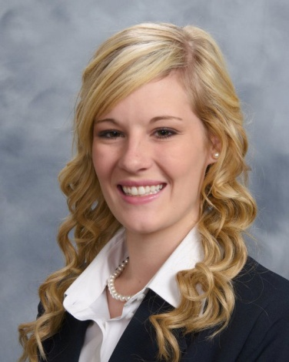
That following year after high school graduation, Emily was chosen as the Collegiate DECA State Vice President for Communication. She was a key player on the state leadership team, she effectively communicated with advisors, charter leadership teams and the business community. Emily's competitive nature rose again as she entered the Advertising Campaign Event and placed 1st in state and 2nd at the International Career Development Conference in Orlando, Florida.
Being a state leader was not enough for Emily, while at the ICDC in Orlando she ran for an International position, and was selected to be one of the five student leaders representing the total international delegation. She has been a valued player with the national student officer team. It is exciting to watch. Seeing Emily step into positions that spur team building activities and critical thinking, and then displaying her leadership skills to others or delegating assignments and ensuring that the individual understands, shows the skills Emily has developed through her educational training.
What a journey Emily has been on! One of her key points is to make sure the 2012 Collegiate DECA International Career Development Conference (ICDC) is a very memorable and successful DECA experience for the our 1500-1600 students who attend that conference.
Utah's educational experiences help our students grow and prepare for successful careers. Yes, the CTE program is showing that direct connection between high school and the smooth transition to post-secondary education and careers. Emily's transition could not have been any smoother. The challenging and rigorous training from Concurrent Enrollment provides experiential activities that assist students in their future opportunities. The key training that DECA and Collegiate DECA offers our students ties the training together and prepares students for their future.
There is a great need for students to engage in Career and Technical Education programs, and in Concurrent Enrollment to help them progress in career training and degree offerings; the value that the CTSO's provide to make a positive difference in the lives of our students. Bringing all of those skills into a complete and successful package is why we are all in the educational field.
CTE program integrates student leadership elements, it complements student participation in these course programs. CTE - A working educational program ; let's continue enhancing the results it offers.
###

