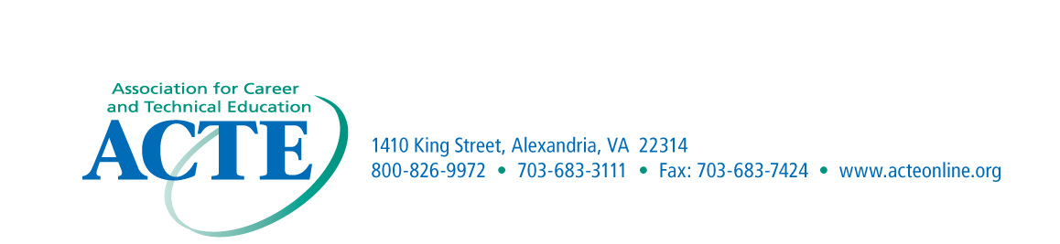
NOMINATION
MATERIALS DUE
September 30th

ACTE Region I – School Board Recognition Award Nomination Form

Purpose
This award is presented to recognize a member of a local school board for outstanding contributions within career and technical education.
Eligibility
The award is limited to members of a local school board within Region I.
Criteria
The award is presented to a board member who has made the most significant contribution supporting career and technical education.
Application Procedures
Nominations may come from Region I members. Each nominee must be endorsed by the State Association. The nomination should include a cover letter describing the nominee’s contributions and achievements that have supported career and technical education. Letters of endorsement are encouraged; however, no more than three letters are to be submitted with the nomination form and cover letter.
Recognition
The award winners will be recognized at the ACTE Conference.

Nomination Information

Name______________________________________________________________________

District/School______________________________________________________________

Address____________________________________________________________________

Phone Number______________________________________________________________

Significant contributions_________________________________________________________________

Nominated by________________________________________________________________

Address_____________________________________________________________________

Email Address________________________________________________________________

