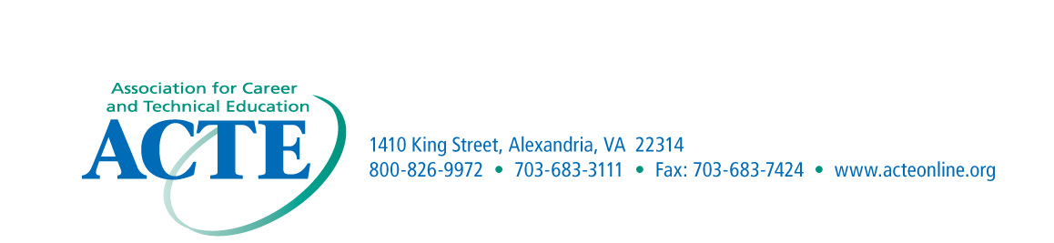
NOMINATION
MATERIALS DUE
September 30th

ACTE Region I – Outstanding Business/Education Partnership Nomination Form

Purpose
This award is presented to recognize a supportive partnership that has made a contribution of significance to career and technical education.
Eligibility
The award is limited to business/educational partnerships that have been established to improve career and technical education.
Criteria
The award is presented to the partnerships that are determined to have made the most significant impact related to career and technical education.
Application Procedures
Nominations may come from Region I members. Each business/education partnership must be endorsed by the State Association. The nomination should include a cover letter explaining the (1) Description of the Partnership; (2) Purpose of the Partnership; (3) Successes and/or achievements of the Partnership. The cover letter should not exceed one typewritten page with single spacing.
Recognition
The award winners will be recognized at the ACTE Conference.

Nomination Information
Participating Business Partner______________________________________________________________________

Business Address____________________________________________________________

Business Contact Name_______________________________________________________

Contact Phone Number_______________________________________________________

District/School______________________________________________________________

District/School Address_____________________________Phone:____________________

Target Population____________________________________________________________

Nominated by_______________________________________________________________

Address_____________________________________________________________________

Email Address________________________________________________________________

