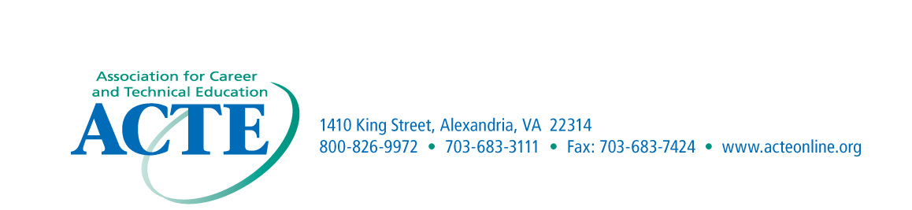
NOMINATION
MATERIALS DUE
September 30th

ACTE Region I – Innovative Career and Technical Education Program Nomination Form

Purpose
This award is presented to recognize an innovative program that has made a contribution of significance to career and technical education.
Eligibility
The award is limited to innovative programs that have been established within the last three years.
Criteria
The award is presented to the high school or college that is determined to have made the most significant impact related to career and technical education within the last three years.
Application Procedures
Nominations may come from Region I members. Each innovative program must be endorsed by the State Association. The nomination should include a cover letter explaining the (1) Description of the Program; (2) Purpose of the Program; (3) Innovative feature of the Program; and (4) Successes and/or achievements of the Program.
The cover letter should not exceed one typewritten page with single spacing.
Recognition
The award winners will be recognized at the ACTE Conference.

Nomination Information

Name______________________________________________________________________

District/School______________________________________________________________

Address____________________________________________________________________

Phone Number______________________________________________________________

Instructor___________________________________________________________________

Program Administrator_______________________________________________________

Student Enrollment________________________Grade Level________________________

Nominated by________________________________________________________________

Address_____________________________________________________________________

Email Address________________________________________________________________

