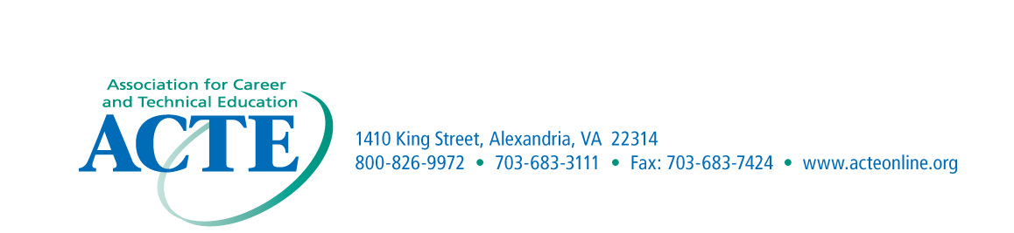
NOMINATION
MATERIALS DUE
September 30th

ACTE Region I – Advisory Committee Member of the Year Nomination Form

Purpose
This award is presented to recognize an advisory committee member that has made a contribution of significance to career and technical education.
Eligibility
The award is limited to advisory committee members for career and technical education programs.
Criteria
The award is presented to the advisory committee member that is determined to have made the most significant contribution related to career and technical education.
Application Procedures
Nominations may come from Region I members. Each advisory committee nominee must be designated by the State Association. The nomination should include a cover letter describing the nominees contributions to career and technical education at the local, regional, or state level due to the nominee’s service on the advisory committee.
The cover letter should not exceed one typewritten page with single spacing. Letters of endorsement are encouraged, however, no more than three letters are to be submitted with the nomination form and cover letter.
Recognition
The award winners will be recognized at the ACTE Conference.

Nomination Information

Name______________________________________________________________________

Organization and/or Business_________________________________________________

Business Address____________________________________________________________

Phone Number______________________________________________________________

District/School______________________________________________________________

Advisory Committee Program_____________________________Years_______________

Nominated by_______________________________________________________________

Address_____________________________________________________________________

Email Address________________________________________________________________

