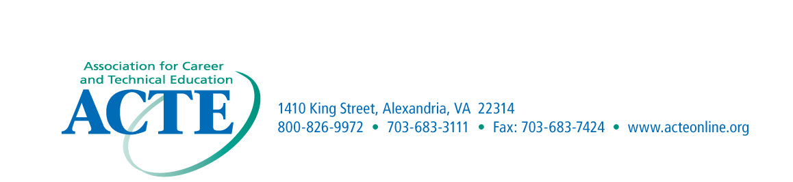

ACTE Region I – Scott Westbrook III Humanitarian Award Nomination Form

Purpose
This award is presented to recognize individuals who have made an outstanding contribution to the improvement, promotion, development and progress of career and technical education within the Region. The award was established in 1998 in honor of the late Scott Westbrook III and is designed to recognize individuals who have demonstrated the same humanitarian concerns exemplified by Mr. Westbrook. Eligibility
The award may be presented to persons either in or outside the field of career and technical education. The individual may be an educator or any person who has rendered outstanding service to career and technical education. This also includes educators who, through exemplary service, have improved career and technical education.
Criteria
The award is presented to individuals who have made the most outstanding contributions to career and technical education.
Application Procedures
Nominations may come from Region I members. Each nominee must be endorsed by the State Association. The nomination should include a cover letter describing the nominee’s contributions and achievements that have supported career and technical education. Letters of endorsement are encouraged; however, no more than three letters are to be submitted with the nomination form and cover letter.
Recognition
The award winners will be recognized at the ACTE Conference.

Nomination Information

Name______________________________________________________________________

Address____________________________________________________________________

Phone Number_______________________________________________________________

Significant Contributions______________________________________________________
____________________________________________________________________________

Nominated by_______________________________________________________________

Address_____________________________________________________________________

Email Address________________________________________________________________

Submission due September 30th
Nominations for Region I Awards should be submitted by email to:
Chet Wichoswki at chet.w@temple.edu

