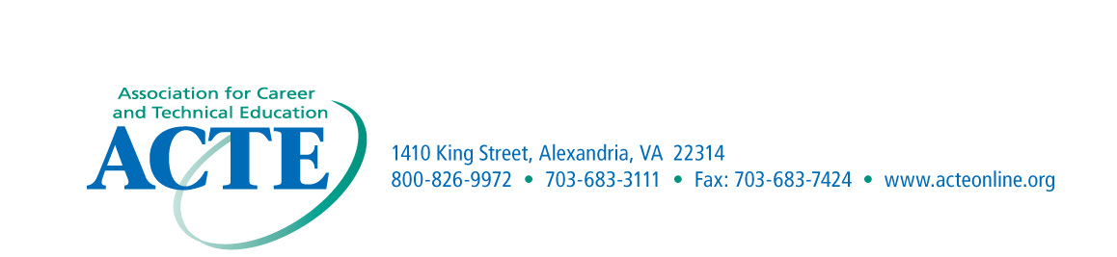

ACTE Region I – Jim Hannemann Memorial Award Nomination Form

Purpose
This award is presented to recognize individuals who have made an outstanding contribution to the improvement, promotion, development and progress of career and technical education within the Region.
Eligibility
The award may be presented to persons who are currently serving or who have served on the ACTE Region I Policy Committee. The individual may be an educator or any person who has rendered outstanding service to career and technical education. This also includes educators, who, through exemplary service, have improved career and technical education.
Criteria
The award is presented to a Region I Policy Committee member who has demonstrated outstanding commitment to career and technical education.
Application Procedures
Nominations may come from Region I members. Each advisory committee nominee must be designated by the State Association. The nomination should include a cover letter describing the nominee’s contributions and achievements that have supported career and technical education. Letters of endorsement are encouraged; however, no more than three letters are to be submitted with the nomination form and cover letter.
Recognition
The award winners will be recognized at the ACTE Conference.

Nomination Information

Name______________________________________________________________________

Address____________________________________________________________________

Phone Number_______________________________________________________________

Significant Contributions______________________________________________________

____________________________________________________________________________

Nominated by_______________________________________________________________

Address_____________________________________________________________________

Email Address________________________________________________________________

Submission due September 30th
Nominations for Region I Awards should be submitted by email to:
Chet Wichowski at chet.w@temple.edu

